Increasing flagellin solubility by filC modification
Masoumeh Bagheri, Razi Vaccine and Serum Research Institute, Iran
Mohammad-hosein Khani, Razi Vaccine and Serum Research Institute, Iran
Azadeh Zahmatkesh, Razi Vaccine and Serum Research Institute, Iran

Abstract
Statement of the Problem: Flagellin is the major structural protein of bacterial flagella which is the ligand of toll like receptor5 (TLR5). Chicken cells respond to bacterial ﬂagellin (as an adjuvant) and increase production of cytokines and chemokines. Flagellin can shape the adaptive immune system by changing the status of innate immune system via cytokine productions. The major problem with using flagellin is its low efficacy production. So, protein engineering by amino acid substitution and deletion can be a logical way for making custom built protein derivatives of flagellin for overcoming this problem. Methodology & Theoretical Orientation: We performed a bioinformatic study to find the best model for gene manipulation for flagellin by using protein modelling which was carried out by SWISS-MODEL and I-TASSER servers and also comparing by MATRAS server and Chimera 1.11.2. Gene modification was carried out by side-directed mutagenesis and reducing C-terminus of interested gene. Consequently, manipulated gene, truncated modified fliC [tmFliC], was cloned and expressed in pET-21 vector and then expressed protein was purified to determine its properties. Findings: Model compression showed aimed modification preserved 3D structure. In lab experiments, results shown a high purification efficacy comparison with other reported. Conclusion & Significance: This finding resulted from reduction of the hydrophobicity in C-terminus which may express a more soluble Flagellin. Also, reducing hydrophobicity in C-terminus and deleting necessary amino acids for filament formation may increase protein solubility.

Image
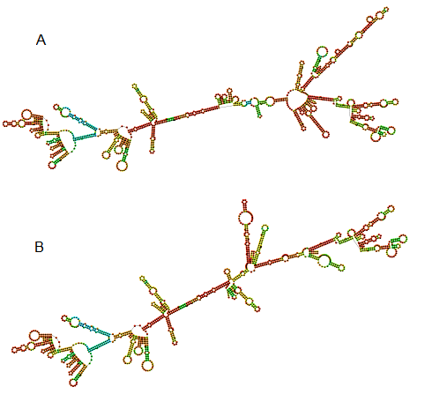
Figure 1. Secondary structure of full fliC mRNA (A) and truncated modified mRNA (B). Similar secondary structure in initial nucleotide despite shortening the terminus site.
Recent Publications
- de Zoete, MR, Keestra AM, Wagenaar JA, van Putten JP (2010) Reconstitution of a functional Toll-like receptor 5 binding site in Campylobacter jejuni flagellin. Journal of Biological Chemistry 285:12149-12158.
- Gasteiger E, Hoogland C, Gattiker A, Duvaud SE, Wilkins MR, Appel RD, Bairoch A (2005) Protein identification and analysis tools on the ExPASy server. Humana Press 571-607.
- Gruber AR, Lorenz R, Bernhart SH, Neuböck R, Hofacker IL (2008) The vienna RNA websuite. Nucleic Acids Research 36: 70-74.
- Iwasaki A, Medzhitov R (2015) Control of adaptive immunity by the innate immune system. Nature Immunology 16(4): 343-353.
- Mizel SB, Bates JT (2010) Flagellin as an adjuvant: cellular mechanisms and potential. Journal of Immunology 185: 5677-82.

Biography
Masoumeh Bagheri has expertise in molecular genetics and genetic engineering. She has worked on recombinant protein production for veterinary vaccine adjuvant applications. Since, recombinant proteins have a problem with low efficacy production, so she has modified flagellin gene sequence in order to improve its solubility and yield. The modified protein has overcome the problem of low efficacy of production. Therefore, this recombinant protein may be a potential alternative in adjuvant technologies which should be studied in future.
Email: m.bagheri@rvsri.ac.ir

Notes/Comments:

