Effect of ivermectin to control Mange mite (Sarcoptes scabiei) in rabbits
Kamal Niaz, DVM, PhD, Department of Animal Health, Faculty of animal husbandry and veterinary sciences, The University of Agriculture of Peshawar-Pakistan
Muhammad Shoaib, DVM, MPhil (Parasitology), PhD (In progress), Department of Animal Health, Faculty of animal husbandry and veterinary sciences, The University of Agriculture of Peshawar-Pakistan

Abstract

Sarcoptes mange is a significant disease of human, farm and wild animals. Sarcoptes scabiei is the agent which causes infestation and affects the ear, nose, feet and area around the genitalia which lead to dermatitis and itching ultimately animals lose body condition become weak and die. The ﬁrst cases of scabies in European wild rabbits (Oryctola-Gus cuniculus) were only reported. The aim of the present study was to evaluate the effect of ivermectin on infected rabbits with mange mites. Thirty rabbits of local varieties naturally infested with ear, nose and around the eye were divided into three different groups: Mild, Moderate and Severe base on their main lesions score. The lesions were scored according: +present, ++ low, +++ medium, and ++++severe. Diagnosis was accomplished by clinical signs and stereomicroscopic examination of skin lesions. Sarcoptes scabiei mite was identified as the cause of the lesions. Ivermectin subcutaneously was given to the naturally infested three groups. Ivermectin (1%) was use each week at the dose level 200 µg/kg. Microscopic examination of skin scrapings showed presence of adult parasites and egg with tissue debris till 10 days (+present) for mild, 15 days (+present) for medium and 20 days (++ low) for severe post-treatment. Mild, moderate and severe groups were completely recovered on the 15, 20 and 25 day respectively of post-treatment, however there were one rabbit of moderate group and two rabbits in severe group having present of mites eggs and some dead Sarcoptes scabiei in microscopic examination. So it was concluded that ivermectin can be used safely subcutaneously (200 µg/kg) on weekly base and its repeated doses were effective in control of ecto-parasite (Sarcoptes Scabiei) in rabbits.

Image A B
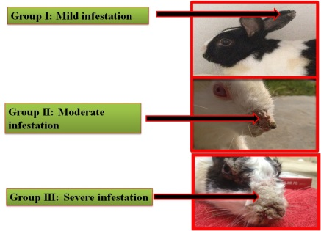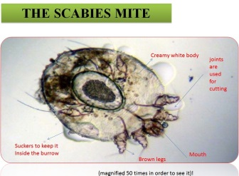
Figures A, illustrate mild, moderate and severe groups and figure B represent mite structure under stereomicroscope

Recent Publications
- Bernigaud C, Fang F, Fischer K, Lespine A, Aho LS, Dreau D., et al. (2016). Preclinical study of single-dose moxidectin, a new oral treatment for scabies: efficacy, safety, and pharmacokinetics compared to two-dose ivermectin in a porcine model. PLoS Neglected Tropical Diseases, 10(10), e0005030.
- Elhawary NM, Sorour SS, El-Abasy MA, Bazh EK, Sultan K (2017). A trial of doramectin injection and ivermectin spot-on for treatment of rabbits artificially infested with the ear mite “Psoroptes cuniculi”. Polish Journal of Veterinary sciences, 20(3), 521-525.
- Hamel D, Joachim A, Löwenstein M, Pfister K, Silaghi C, Visser M et al. (2015). Treatment and control of bovine sarcoptic and psoroptic mange infestation with ivermectin long-acting injectable (IVOMEC® GOLD). Parasitology Research, 114(2), 535-542.
- Mounsey KE, Walton SF, Innes A, Cash-Deans S, McCarthy JS (2017). In vitro efficacy of moxidectin versus ivermectin against Sarcoptes scabiei. Antimicrobial Agents and Chemotherapy, 61(8), e00381-17.
- Mounsey KE, Bernigaud C, Chosidow O, McCarthy JS (2016). Prospects for moxidectin as a new oral treatment for human scabies. PLoS Neglected Tropical Diseases, 10(3), e0004389.


Biography
Dr. Kamal Niaz did his Doctor of Veterinary Medicine (DVM) and then PhD in Pharmacology and Toxicology. Currently, he has published almost 30 articles in prestigious national and international journals along with conferences paper and proceeding abstracts within a short period of time with 80 plus cumulative impact factor. He is committed to further continue in area of expertise that includes but not limited to toxicants and epidemiology of disease, but also epigenetic alteration due to toxicants and role of these chemicals in diabetes with main focus on small and lab animals with molecular characterization of pesticides and chemicals in veterinary and public health importance particularly of domestic or wild-animal origin.
Email: kamalniaz1989@gmail.com

Notes/Comments:

