The efficacy of combination of sodium hypochlorite (NaOCL)/hypochlorous acid (HOCL) in wound management: a systematic review and network meta-analysis
Napaphat Poprom¹, Ph.D., Chairat Supsamutchai¹, M.D., Jakrapan Jirasiritham¹, M.D., Puvee Punmeechao¹, M.D., Chaowanun Pornwaragorn¹, M.D., Chumpon Wilasrusmeea¹, M.D., Ph.D.
¹Department of Surgery, Faculty of Medicine, Ramathibodi Hospital, Mahidol University, Thailand.

Abstract
Background: Antiseptic and antibacterial solutions are increasing used in the treatment of various types of wounds. The successful stabilization of the combination Sodium Hypochlorite/Hypochlorous acid (NaOCl/HOCl) or superoxidized solution (SOS) has been reported as an effective solution without irritating on mammal cell and no evidence that poses a carcinogenic hazard. There was no systematic review or meta-analysis to compare the effectiveness of these antiseptic solutions. In this study, we aim to investigate the role of NaOCl/HOCl in the treatment of wounds.
Methods: The systematic review with extended to network meta-analysis (NMA) was conducted with included NaOCl/HOCl, povidone iodine, octenidine dihydrochloride, polyhexamethylene biguanide, alcohol, and silver compared with normal saline. The primary outcome was wound healing. The direct and indirect comparisons were performed with probability being best of treatment using surface under the cumulative ranking curve (SUCRA).
Results: A total of 507 studies were identified from PUBMED and SCOPUS databases, and 64 articles were duplicates. Among 29 studies were included, there were 22 RCTs and 7 cohort studies met our inclusion criteria. NaOCl/HOCl had higher chance of wound healing from 1.07 to 1.30 compared with all of regimens. The probability of being the best treatment was NaOCl/HOCl, followed by silver and octenidine with SUCRAs of 36.9, 23.1, and 21.8, respectively.
Conclusions: Our evidence suggests that NaOCl/HOCl had highest efficacy. It was ranked first followed by silver, octenidine, and PHMB for treatment success. Further large scale RCTs should be conducted alongside with economic evaluations.

Image
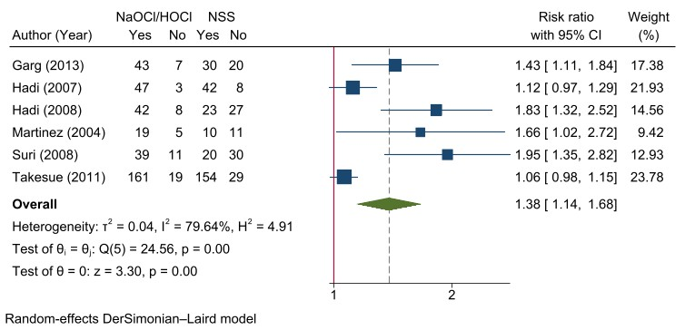
Direct meta-analysis between NaOCl/HOCl vs NSS

Recent Publications (minimum 5)
1. Norman G, Atkinson RA, Smith TA, Rowlands C, Rithalia AD, Crosbie EJ, Dumville JC. Intracavity lavage and wound irrigation for prevention of surgical site infection. Cochrane Database Syst Rev. 2017;10(10):Cd012234.
2. Axel K., Joachim D., Ibby Y. Granudacyn: wound cleansing and irrigation. Journal of Wound Care. 2020;29(10).

3. Thorn RM, Lee SW, Robinson GM, Greenman J, Reynolds DM. Electrochemically activated solutions: evidence for antimicrobial efficacy and applications in healthcare environments. Eur J Clin Microbiol Infect Dis. 2012;31(5):641-653.
4. Wang L, Bassiri M, Najafi R, Najafi K, Yang J, Khosrovi B, Hwong W, Barati E, Belisle B, Celeri C, et al. Hypochlorous acid as a potential wound care agent: part I. Stabilized hypochlorous acid: a component of the inorganic armamentarium of innate immunity. J Burns Wounds. 2007;6:e5.

Photograph


Biography
Dr Chumpon Wilasrusmee has his expertise in wound care and vascular surgery. His works based on constructed meta-analysis to creates new evidences for improving healthcare.
Email: chumpon.wil@mahidol.ac.th

