Type I endoleak after endovascular abdominal aortic aneurysm repair on a patient undergoing radiotherapy as treatment for prostate cancer: A Case Report

Dr. Z. Resurreccion¹, Dr. R. Gloria²

¹Department of Organ Transplant and Vascular Surgery (National Kidney and Transplant Institute, Philippines)
²Department of Organ Transplant and Vascular Surgery (National Kidney and Transplant Institute, Philippines)

Abstract

There is little information on the causality of radiotherapy and vascular injury, and even fewer for cases of endoleak after long term stable endovascular aneurysm repair (EVAR) graft undergoing radiotherapy. This case report aims to shed light in (1) the possible relationship between radiotherapy and its implications to the aortic wall, causing progression of aortic aneurysm even after endovascular repair (2) complexity of intervention for type I endoleak following repair of aneurysm considering decreased to absent proximal aortic neck size.
This is a case of a 79-year-old male, on his 32/39 session of radiotherapy for prostate cancer. He underwent EVAR 10 years ago, and presented with generalized body weakness and pallor, with associated episodes of hypotension and tachycardia. Computed Tomography Aortogram shows:
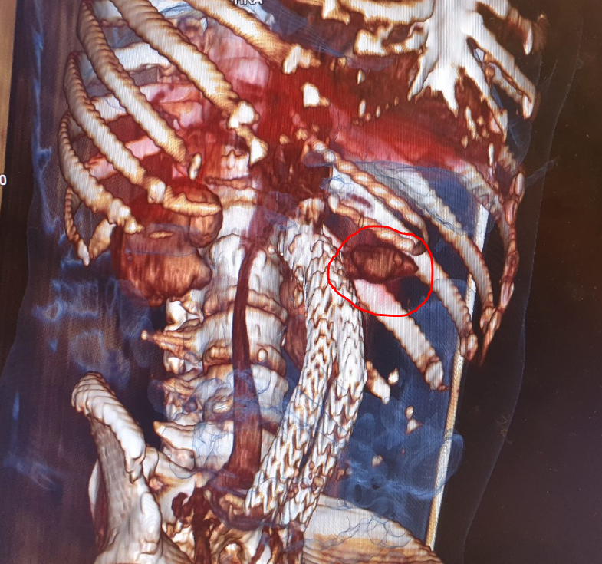
Fig. 1. Contrast flow in the lateral portion of the stent (proximal end) compatible with Endoleak Type I

Conventional Angiogram shows:
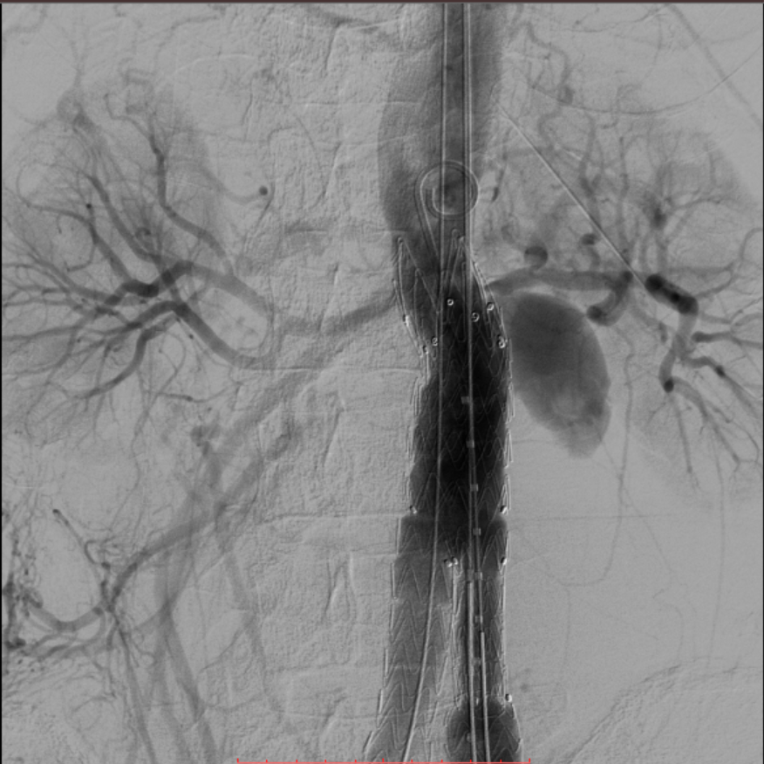
Fig. 2. Contrast extravasation on the lateral proximal border of the aortic stent just before the left renal artery

The patient underwent successful endovascular repair of aortic graft endoleak type I with right renal artery chimney and left renal artery periscope:
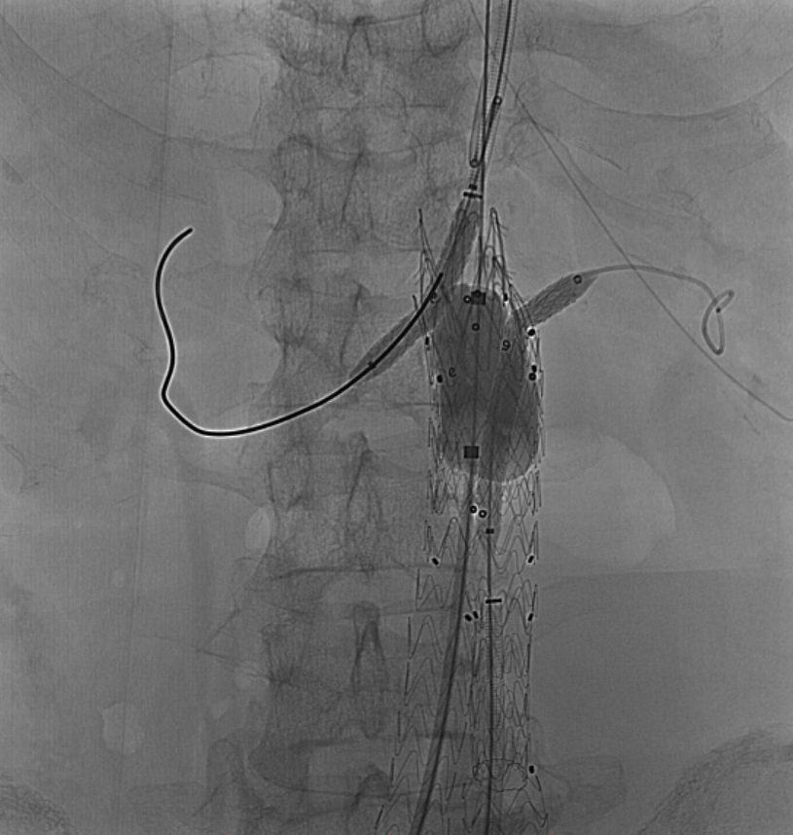
Fig. 3. Resolution of previously noted contrast extravasation. No other leaks noted
Vascular beds are prone to injury when ongoing exposure to radiation. Evidence shows that radiotherapy causes up regulation of pro-inflammatory cells causing endothelial injury. Chronic oxidative stress causing tissue injury is sustained even after 10 years of treatment.

Since very few reports causality between radiotherapy for cancer treatment, aortic wall damage in patients who underwent EVAR, there is still a need to continuously explore means in overcoming restrictions in endovascular aortic aneurysm repair/endoleak repair for these population while improving outcomes.

Keywords— Endovascular abdominal aortic aneurysm repair, Endoleak Type I, Periscope and chimney, Radiotherapy

Professional Biography

Dr. Zue Loraine R. Resurreccion finished both her Doctor of Medicine and Masters of Business Administration in the Ateneo School of Medicine and Public Health. After graduation, she was immediately accepted to the National Kidney and Transplant Institute for Straight Vascular Surgery Training. She is currently on her fifth and final year of training. Moving on to 2020, she is very excited to be starting her private practice as a Vascular Surgeon and to be going back to school as she was recently accepted in Harvard Medical School’s Leadership in Medicine: South East Asia Program.


Presenting author details
Full name: Zue Loraine R. Resurreccion, MD-MBA
Contact number: +639273139912
Email id: zue.resurreccion@gmail.com
Category: Poster presentation
Session name:
Research interest: Endovascular Surgery

