May Thurner Syndrome – Endovascular Treatment – 20 years of Experience

C.Hidasy ^{( 1,2,3)} , L.Faina ^{(1,2 )} , L.Bittencourt ⁽¹⁾ , M.Marques ⁽²⁾, G.Cordeiro ⁽²⁾ , LF.Lima ⁽²⁾

1 - Hospital Quinta D’Ór , Rio de Janeiro , RJ , Brazil
2 - Hospital das Clínicas de Volta Redonda , Volta Redonda , RJ , Brazil
3 – Hospital Unimed VR , Volta Redonda , RJ , Brazil

The objective of this work is to explain our experience at the treatment of May Thurner Syndrome whom results from the compression of the left common iliac vein by the right common iliac artery and the 5th vertebral body.
We do a retrospective analysis based on clinical and imagiological records related to patients diagnosed with MTS who underwent endovascular surgical treatment
We collected mean age , sex , symptoms , mean time between the beginning of the symptoms and the diagnosis , primary treatment , pattency and re-estenosis /occlusion .
The delayed diagnosis of the MTS may correspond to the lack of clinical knowledge and was associated with poor results

Keywords – Left Iliac Vein Compression Syndrome , Cockett Syndrome , pelvic congestion

Professional Biography

Cláudia Hidasy has completed her specialty on General Surgery in 1990 at Hospital Siderúrgica Nacional , Volta Redonda , RJ and Vascular Surgery in 1993 at Hospital dos Servidores do Estado , Rio de Janeiro , RJ. She worked 27 years at a Reference hospital for high complexity of the south of Rio de Janeiro state , more than 10 years like chief of the Vascular and Endovascular Service . She and her team presented various works at national and international congresses. Today she works at her private clinic – ProVasc , Rio de Janeiro e Volta Redonda and Hospital Quinta D`Ór , RiodeJaneiro , RJ.
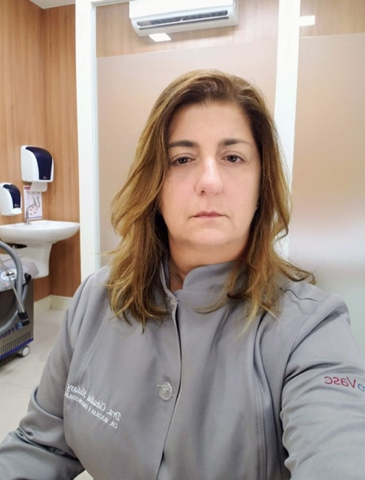
Cláudia Hidasy
+5521997151996
claudiahidasy@gmail.com
Oral presentation
Endovascular surgery
Venous Endovascular surgery

