Abstract Title: Results of 15 years circumferential suction-assisted lipectomy in the treatment of primary and secondary end-stage lymphoedema of the leg

D-A.A Lamprou, MD BSc FEBVS¹, H.G.J Voesten MD²

¹ First Author Affiliation (Vascular-/lymphatic surgeon, Department of surgery, Nij Smellinghe Hospital, Drachten, The Netherlands)
²Second Author Affiliation (Consulting Vascular-/lymphatic surgeon, Nij Smellinghe Hospital, Drachten, The Netherlands)

Abstract

The treatment of end-stage lymphoedema of the leg is challenging, especially when conservative treatment fails and there is a large volume difference between the affected and unaffected legs. Circumferential suction-assisted lipectomy (CSAL) has been described as a treatment option for end-stage lymphoedema of the leg. Here, the long-term results of CSAL in end-stage primary and secondary lymphoedema of the leg were analysed. This was a descriptive study of patients treated with CSAL for unilateral chronic irreversible lymphoedema of the leg. Compression therapy was resumed after surgery. Leg volumes were measured before surgery, and at 1, 6, 12 and 24 months after the procedure. A total of 47 patients with primary lymphoedema had a median preoperative volume difference between affected and unaffected legs of 3686 (i.q.r. 2851–5121) ml. Two years after surgery, this volume difference was reduced to 761ml, a 79 per cent reduction. In the 41 patients treated for secondary lymphoedema, the median preoperative volume difference was 3320 (i.q.r. 2533–4783)ml, decreasing after 2 years to −38 ml (101 per cent reduction). The preoperative volume difference and the sex of the patient significantly influenced the outcome after 2 years. The outcome was not related to BMI or other patient characteristics. CSAL is an effective method for treating both primary and secondary lymphoedema of the leg.

Keywords—CSAL, Primary lymphoedema, Secondary lymphoedema, Treatment

Professional Biography (100-150 words)

Alexander (D-A.A) Lamprou, MD, FEBVS

Born the 8th of august 1978 in Utrecht, The Netherlands

Alexander has been involved in clinical research regarding the surgical treatment of lymphoedema and lipoedema since his early years as a medical student. Following graduation, he was accepted to begin his surgical training at the Groningen University Hospital in The Netherlands aimed at pursuing a career as a vascular surgeon.
During this phase he also gained extensive practical experience in the surgical treatment and care of amputation patients as well as surgery in lymphoedema and lipoedema, both under supervision of Harry Voesten. Upon becoming a fellow of the European board of vascular surgery and receiving his certificate in vascular surgery Alexander entered the surgical practice in Nij Smellinghe Hospital, Drachten. In conjunction with the Expert Centre for Lymfo-Vascular Medicine he performs surgery to aid patients affected by lymph-/lipoedema and is involved in training becoming surgeons in amputation techniques in conjunction with Groningen University Hospital.

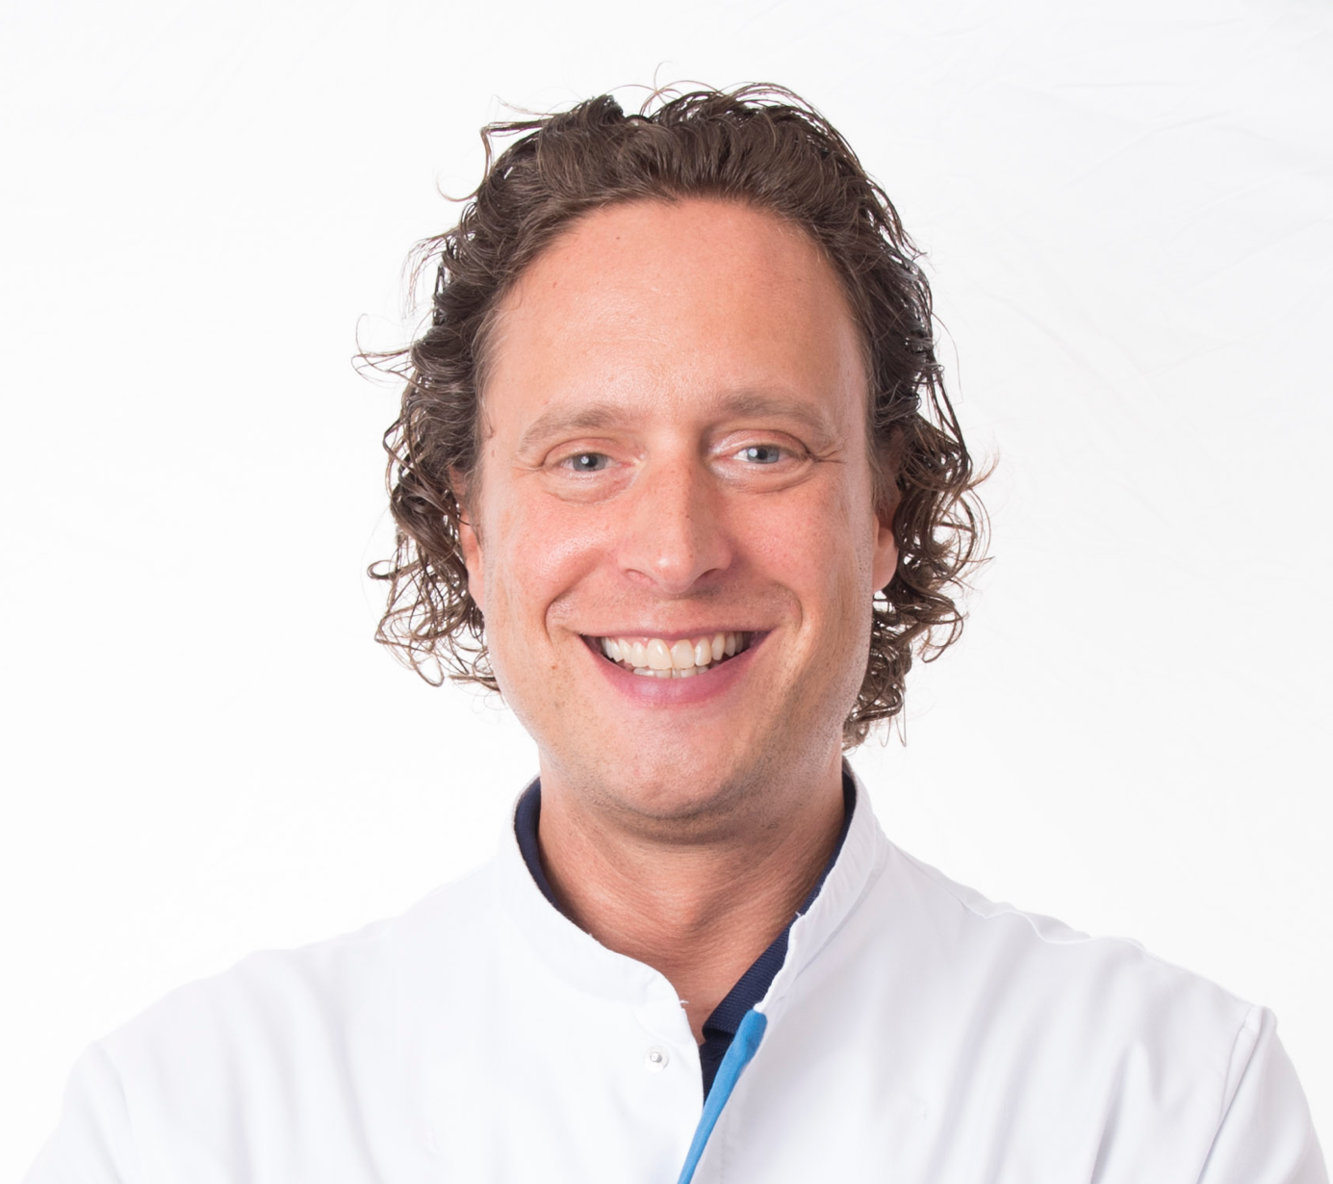

Email Id: Lamprou.daa@me.com

Any Comments:

