Abstract Title: Changing Concepts of Lymphatic Function
D-A.A Lamprou, MD BSc FEBVS¹, H.G.J Voesten MD²

¹ First Author Affiliation (Vascular-/lymphatic surgeon, Department of surgery, Nij Smellinghe Hospital, Drachten, The Netherlands)
²Second Author Affiliation (Consulting Vascular-/lymphatic surgeon, Nij Smellinghe Hospital, Drachten, The Netherlands)

Abstract

The lymphatic system has three basic functions; the reabsorption of interstitial fluid, uptake of nutrients (primarily fats in the intestinal lymphatics) and a route of transport for immune and antigen cells in order to provide for host defense.
Oedema is defined as a situation in which there exists an excess amount of interstitial fluid due to a disequilibrium between capillary filtration and interstitial fluid absorption where filtration is regulated via the Starling principle. The traditional Starling principle assumes that plasma filtration occurs at the arterial end of the capillaries. With this ultra-filtrate proteins are also filtrated. When pressure decreases absorption of almost all of the ultra-filtrate occurs at the venous end leaving only a residu (10%) and the large interstitial molecules to be absorbed by the lymphatics.
Direct measurements of the existing osmotic pressures in the interstitial space together with expanding knowledge on the endothelial glycocalix layer has proven this traditional principle to be inaccurate. It is now established that filtration generally occurs throughout the entire length of the capillaries. Without any venous absorption all of the interstitial fluid has to be drained by the lymphatics making this system not merely an additive but of vital importance.
A simplified model explaining lymphedema utilizes the concept of dynamic- or mechanic insufficiency. In this model dynamic insufficiency represents a situation in which the (remaining) lymphatics are overwhelmed by a increased production of interstitial fluid. Mechanic insufficiency represents mechanical obstruction due to surgery or pathogens (i.e. filariasis). This model however does not explain the vast variability in the development of lymphedema in patients. It is therefore reasonable to assume this view merely explains an initiating event leading to a cascade of events resulting in impaired lymphatic drainage.

Keywords—Development of lymphoedema, drainage, filtration, Starling principle

Professional Biography (100-150 words)

Alexander (D-A.A) Lamprou, MD, FEBVS

Born the 8th of august 1978 in Utrecht, The Netherlands

Alexander has been involved in clinical research regarding the surgical treatment of lymphoedema and lipoedema since his early years as a medical student. Following graduation, he was accepted to begin his surgical training at the Groningen University Hospital in The Netherlands aimed at pursuing a career as a vascular surgeon.
During this phase he also gained extensive practical experience in the surgical treatment and care of amputation patients as well as surgery in lymphoedema and lipoedema, both under supervision of Harry Voesten. Upon becoming a fellow of the European board of vascular surgery and receiving his certificate in vascular surgery Alexander entered the surgical practice in Nij Smellinghe Hospital, Drachten. In conjunction with the Expert Centre for Lymfo-Vascular Medicine he performs surgery to aid patients affected by lymph-/lipoedema and is involved in training becoming surgeons in amputation techniques in conjunction with Groningen University Hospital.

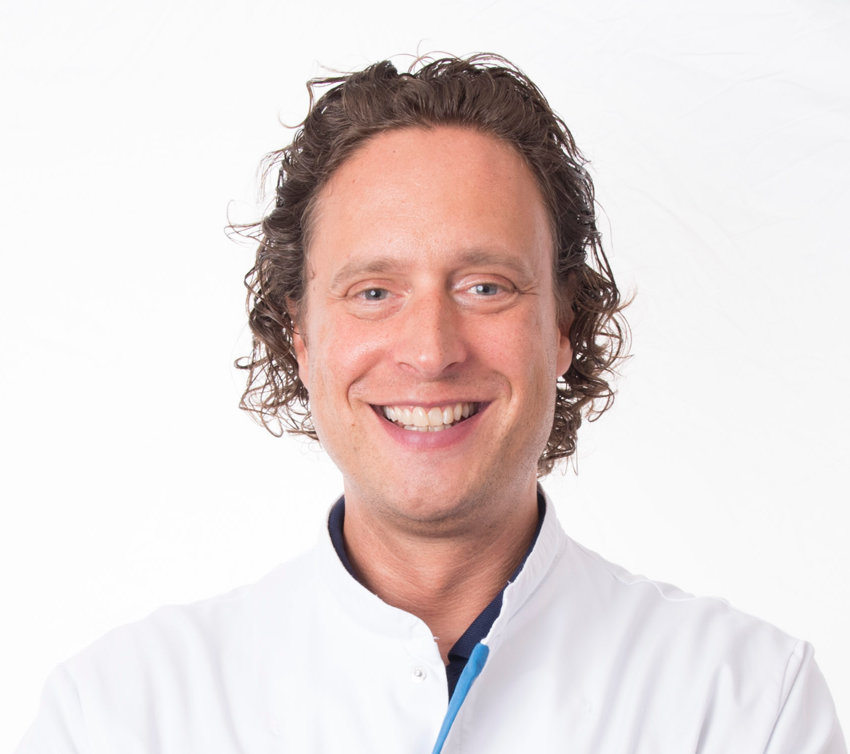

Email Id:

Any Comments:

