Happily EVAR After? – The truth about EVAR
Ziyan Kassam, King’s College London School of Medicine, United Kingdom

Abstract (300 word limit)
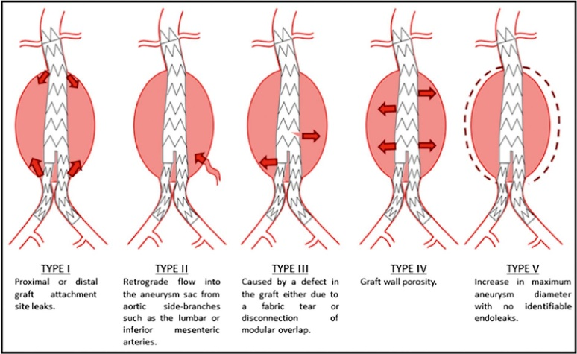
Endovascular aneurysm repair (EVAR) for abdominal aortic aneurysm (AAA) repair has been responsible for a seismic shift in the management of AAAs. Compared to traditional open surgical repair (OSR), EVAR is associated with significantly a improved peri-operative morbidity and mortality. As the technology and applications of EVAR continue to evolve, so does the literature investigating its outcomes. Recently, longer-term follow-up results of randomised controlled trials (RCTs) comparing EVAR and OSR have been published. In light of this new evidence, this review aimed to evaluate the long-term outcomes from such prospective multi-centre RCTs, assessing the effectiveness, advantages and disadvantages of EVAR and OSR, in terms of endograft-related complications, re-intervention rates, and longer-term mortality, to determine whether EVAR really is the better option. Following evaluation of the results, the early survival benefit of EVAR is not sustained, with longer-term life expectancy remaining poor regardless of operative modality. Additionally, the development of technical EVAR-related post-operative complications, predominantly endoleaks, stent-graft migration and stent-limb thrombosis requires further corrective re-intervention. Thus, lifelong imaging surveillance is crucial to determine the occurrence of such events, and plan timely intervention to prevent secondary sac rupture. However, this results in EVAR being costlier over a patient’s lifetime when compared to OSR. Despite the choice between OSR and EVAR for AAA repair remaining an individualised clinical decision, there is a greater tendency to choose EVAR, predominantly due to increased surgeon familiarity. Data from long-term trials however are based on initial EVAR device generations, thus newer stent-grafts are likely to improve safety and expand their applicability. As a result, further long-term RCTs are warranted to compare the relative benefits and disadvantages of modern EVAR devices..
Figure 1: Classification of Endoleaks:
Endoleaks transpire due to continued blood flow through the aneurysm site because of incomplete graft sealing, or back-filling from supplementary small vessels originating from the aneurysm wall. This peri-graft blood flow may lead to saccular enlargement and rupture.

Image
Recent Publications (minimum 5)
1. Brown,LC, et al. The UK Endovascular Aneurysm Repair (EVAR) Trials: Design, Methodology and Progress. European Journal of Vascular and Endovascular Surgery 2004 April 2004;27(4):372-381.
2. Prinssen M, Buskens E, Blankensteijn JD. The Dutch Randomised Endovascular Aneurysm Management (DREAM) trial. Background, design and methods. J Cardiovasc Surg (Torino) 2002 Jun;43(3):379-384.
3. Lederle FA, Freischlag JA, Kyriakides TC, al e. Outcomes following endovascular vs open repair of abdominal aortic aneurysm: A randomized trial. JAMA 2009 10/14;302(14):1535-1542.
4. Becquemin,J. The ACE trial: A randomized comparison of open versus endovascular repair in good risk patients with abdominal aortic aneurysm. Journal of Vascular Surgery 2009 July 2009;50(1):222-224.
5. IMPROVE Trial, Powell JT, Thompson SG, Thompson MM, Grieve R, Nicholson AA, et al. The Immediate Management of the Patient with Rupture: Open Versus Endovascular repair (IMPROVE) aneurysm trial--ISRCTN 48334791 IMPROVE trialists. Acta Chir Belg 2009 Nov-Dec;109(6):678-680.
6. Amsterdam Acute Aneurysm Trial Collaborators. Amsterdam Acute Aneurysm trial: background, design, and methods. Vascular 2006 May-Jun;14(3):130-135

Biography (150 word limit)
Ziyan Kassam is currently a medical student in her 5th year at King’s College London. She has a great interest in cardiothoracic and vascular surgery, and has participated in a number of research projects. Her interest in this project stemmed from reading about the controversy surrounding the long-term complications that followed endovascular repair
Email: zikassam@gmail.com

Notes/Comments:

