Endovenous Laser Ablation versus Conventional Surgery- long term comparative study in treating varicose veins
Ahmed M Morshed- Mansoura University- Egypt (Main Author)
Mohammed Farag – Mansoura University- Egypt
Ayman elnakeeb- Mansoura University- Egypt
Abdelsalam Megahed- Mansoura University- Egypt

Abstract
Chronic vein insufficiency of the lower extremities is one of the most common benign diseases. It is estimated that varicose veins in the distribution of the great saphenous vein (GSV) are present in about 25% of women and 15% of men. It seems that the appearance and evolution of the disease occur due to multiple factors but mainly the modern lifestyle, characterized by sedentarity, lack of exercise and obesity. Surgery was the gold standard in the treatment of varicose veins. For several decades high ligation at the saphenofemoral junction (SFJ) and stripping of the GSV was the treatment of choice in order to eradicate the diseased vein. Insufficiency of the small saphenous vein (SSV) is treated in a similar way, by ligation at the saphenopopliteal junction (SPJ) and stripping. In the last years, in the era of minimally invasive surgery, new techniques in the treatment of varicose veins, such as the endovenouslaser ablation (EVLA), have been introduced. In 1999, the first report on EVLA appeared in the literature. Using an 810 – nm diode laser, Bonè first reported the delivery of end luminal laser energy for the treatment of the insufficient GSV. In this study we will compare the outcome of laser ablation and conventional surgery in treatment of patients with varicose veins regarding the immediate postoperative results, pain, recurrence rate and socio-economic aspects of life with a period of 2 years.

Image
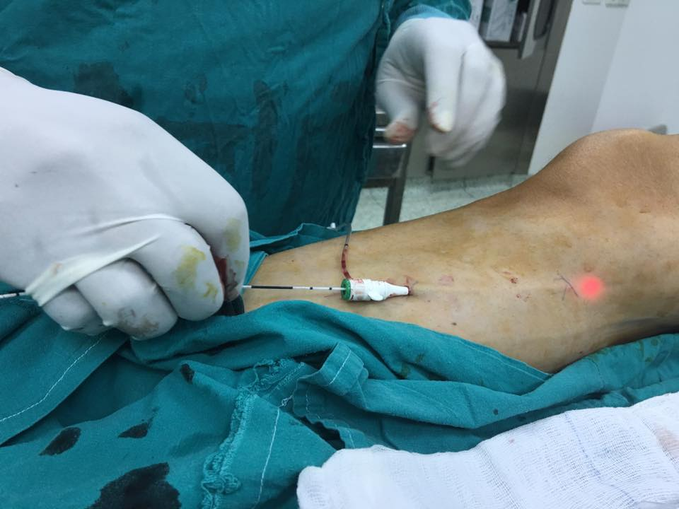
Figure (1): Introduction of the laser fiber through the sheath
Recent Publications

The relative roles of power, linear endovenous energy density, and pullback velocity in determining short-term success after endovenous laser ablation of the truncal saphenous veins. Journal of Vascular Surgery: Venous and Lymphatic Disorders- 15 November 2018

A Comparison of Concomitant Tributary Laser Ablation and Foam Sclerotherapy in Patients Undergoing Truncal Endovenous Laser Ablation for Lower Limb Varicose Veins- Journal of Vascular and Interventional Radiology- June 2018

Catheter-based endovenous laser ablation of saphenous veins in the treatment of symptomatic venous reflux: Early results- Cor et Vasa
Volume 59, Issue 6, December 2017, Pages e525-e529

Day surgery versus Outpatient setting for endovenous laser ablation treatment. A prospective cohort study - International Journal of Surgery
Volume 51, March 2018, Pages 180-183

Recanalization After Endovenous Thermal Ablation- Annals of Vascular Surgery October 2018
Volume 52, October 2018, Pages 158-162

Biography
Ahmed M Morshed is 28 year old vascular surgeon who has a special interest in the field of management of venous diseases and vascular trauma. He is an assistant lecturer of vascular surgery at Mansoura University in Egypt, and he has been working in the firled of different vascular procedures for more than 5 years.
Email: a.mosaad@mans.edu.eg

Notes/Comments:

