NARA Socks Project aiming at a spread of compression therapy and a revival of local industry
Takahiro Imai, MD, Department of Vascular Surgery, Nara, JAPAN

Abstract
BACKGROUND: In japan " Monozukuri " stands for the manufacturing industry and its spirituality and culture. It is not only making things but also Japanese traditional technique in pursuit of advanced production by the craftsmen. Nara with a population of 30 thousand called "Town of Socks" is the largest producer of socks traditionally here in Japan (Fig.1). These manufacturers are highly reputed for their technical skills and capabilities, and supply products to such overseas luxury brands. However, due to the large quantity of imported products to Japan, the production volume has dropped greatly from the peak period. And Japan is a country with many disasters because of island. It is necessary to enlightenment to prevention of thrombosis at the time of disaster to the people. I asked medical institutions, stocking manufacturers, and university students in local for cooperation (Fig.2,3). As a result, one elastic stocking was completed (Fig.4). The purpose of the activity is enlightenment of prevention of thrombosis and reconstruction of local industry. METHODS: The research period is from January 2017 to March. There are 30 objects (M14/F16, 34.5±9.3). We investigated changes in the circumference of the leg below the knee and improvements in the blood circulation of the legs before and after using the compression stockings with sonogram and investigated a compression pressure while wearing the stockings(Fig.5). RESULTS: The results revealed that the circumference of the leg below the knee showed a decreasing tendency after wearing the compression stockings. The peak velocity of the popliteal vein tended to increase 20 min after wearing the compression stockings (Table 1). CONCLUSION: The compression stockings seemed to be effective for promoting venous return and preventing deep vein thrombosis of the lower limbs in healthy people. I am hoping to reduce the suffering caused by human thrombosis and revive the local industry.

Image
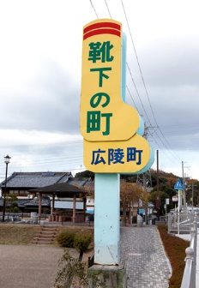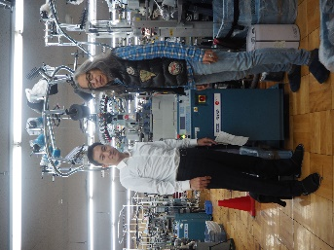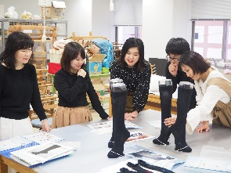
Fig. 1 Fig. 2 Fig. 3

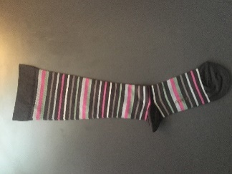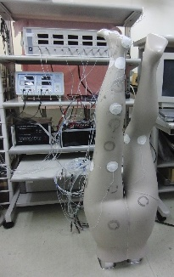
Fig. 4 Fig. 5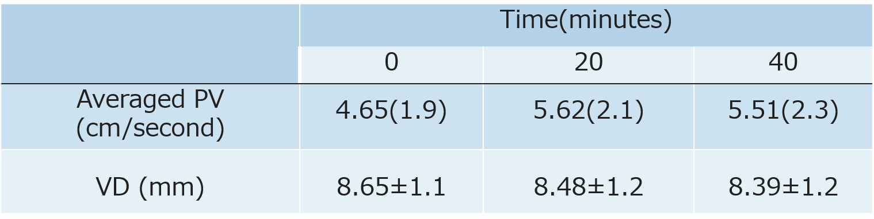
Table 1
Recent Publications
- Geerts WH, Pineo GF, Heit JA et al (2004) T Prevention of venous thromboembolism: The Seventh ACCP Conference on antithrombotic and thrombolytic therapy. Chest 126:338-400.
- Stein PD, Matta F, Yaekoub AY, et al (2010) Effect of compression stockings on venous blood velocity and blood flow. Thromb Haemost 103:138-144.

Biography
Takahiro Imai, MD is a graduate of Saitama Medical School in 1999. Dr. Imai trained at the Hokkaido University Graduate School of Medicine in Sapporo, Sapporo at the Department of Cardiovascular Surgery during his residency. Japan is a nation of many islands prone to a lot of natural disasters. The Great East Japan Earthquake struck in 2011. The 9.0 magnitude earthquakes caused a huge tsunami and the death is reported to be over 16,000. Each time a disaster occurs, the importance of wearing compression stockings is taken up. Those events triggered and now he is directing the `NARA Socks Project` aimed at enlightening the prevention of thrombosis to Japanese citizens and restoring the local industry.
Email: my-fists@cello.ocn.ne.jp

Notes/Comments:

