Percutaneous Artery Embolization in the treatment of bleedings. State-of-the-art.
Dr Fatima El Hajj, MD, Clinica AnaliaMed, Brazil
Dr Neiva Marícia Pereira Jacques, MD, HSPM, Brazil
Dr Sergio Belczak, MD, Belczak Institute, Brazil

Abstract

Embolization consists in to introducing in a blood vessel, agent or material that led into the bloodstream, will occlude a vessel in the distance. Percutaneous arterial embolization (PAE) is a treatment method sedimented worldwide and renowned as the gold standard for diagnosis and treatment of haemorrhage. In Brazil is being increasingly indicated, either emergency or elective, to avoid major surgery or the removal of an organ, total or segmentar.

This paper describes the state of the art of the indications of PAE in haemorrhage, the most modern techniques, illustrating the application of this therapeutic modality.

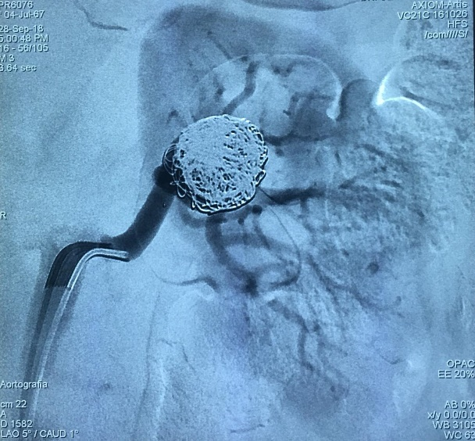
Image

Recent Publications
- Mohamad El Hajj, F.; Neiva Marcia Pereira Jacques; Percutaneous arterial embolization in the treatment of bleeding. State-of-the-art. 2013 Medical Residency Committee of the Municipal Public Server Hospital of São Paulo – HSPM.
- Brunno Cezar Framil Sanchez; Lineu Amaro Rodrigues Junior; Felipe Trentin Neves; Thiago Correa Tambelli; Fernando Eduardo Paulatti Frederico; Fatima Mohamad El Hajj; Juliana Monteiro de Abreu; Tatiana Milunovic Lobo Rosa; Alexis Iury Framil Sanches; Antônio Alberto Ramos Argento. Giant condyloma. Journal of the Faculty of Medical Sciences of Sorocaba (Printed), v.13, p.25-27, 2011. ISSN 1984-4840.3
- Mohamad El Hajj, F; Neiva Marcia Pereira Jacques Percutaneous arterial embolization in the treatment of refractory digestive hemorrhage in a patient with von Willenbrand disease. Case report. 40th Brazilian Congress of Angiology and Vascular Surgery.
- Mohamad El Hajj, F.; Clariana Casali Rodrigues Fernandes; Andréia Esteves de Lima; Diego Caetano da Silva Varella; Fábio Yamada; Neiva Marcia Pereira Jacques Percutaneous arterial embolization of renal artery intraparenchymal aneurysm in single kidney. Case report.2013. 40th Mohamad El Hajj, F . Carotid endarterectomy can only be indicated by Doppler ultrasonography?, 2015. 41th Brazilian Congress of Angiology and Vascular Surgery.

Photograph

Biography
Brazilian – Lebanese Vascular Surgeon. MD in Pontifical Catholic University of São Paulo – PUCSP. General Surgery degree in Municipal Public Server Hospital of São Paulo – HSPM. Vascular Surgery Degree in Estadual Public Server of São Paulo – IAMSPE. Vascular Surgeon at AnaliaMed Health and Wellness. CEO AnaliaMed Diagnose Center.

Email: fatimamedlv@hotmail.co

