Can carotid endarterectomy only be indicated by Doppler ultrasonography?
Dr Fatima El Hajj, MD, IAMSPE, Brazil
Dr Christiano Stchelkunoff Pecego, MD, IAMSPE, Brazil

Abstract

Stroke is a disease of great health relevance due to its morbidity and high costs generated. Symptomatology varies from asymptomatic, fugitive amaurosis, transient ischemic attack (TIA) and direct manifestations of stroke. In view of this, prevention would be the best option to reduce costs secondary to morbidity and mortality due to stroke. Carotid endarterectomy (ACE) is the most common preventive procedure. ECA is a surgical technique consolidated 50 years ago. Large studies such as NASCET, VA, ECST, ACAS and ASCT have already analyzed and proven the indications, cost-effectiveness and limitations of the technique. Digital angiography is the gold standard for determining the degree of carotid stenosis, as methods of investigating carotid stenosis and defining the surgical indication of endarterectomy. Because it is an invasive examination, with a risk of major complications (TIA / stroke) of approximately 4%, it has been progressively replaced by tomography (Angio-CT) or resonance angiography (Angio-NMR). At the same time, Doppler ultrasonography (US) is a non-invasive, low-cost method of screening carotid stenosis. With the incessant progress of diagnostic methods, Doppler ultrasonography (US) has proven to be a method of choice for noninvasive evaluation of the carotid arteries. The degree of carotid artery stenosis is largely based on either a peak systolic velocity or final diastolic velocity analysis, or both, of the carotid artery. Doppler scanning in pulsed mode combined with B-mode ultrasound allows the diagnosis of carotid atheromatous lesions (> 70% stenosis), with sensitivity and specificity above 90%. The US adds comparative advantages to the other contrasted methods, since it is a lower cost procedure, it lacks complications and contraindications, it is easy to access, it does not require the use of contrast, it also has information about plaque morphology, stenosis percentage and topography of the carotid bifurcation.
Image
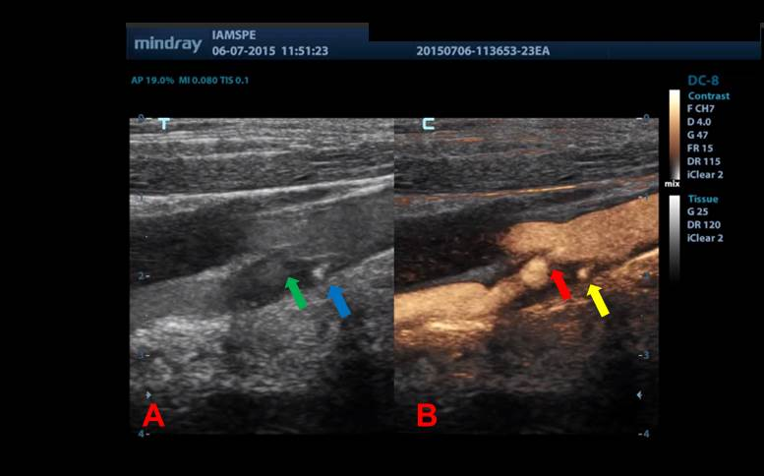
Diagnostic Complementation with CEUS technique

Recent Publications
- Mohamad El Hajj, F.; Neiva Marcia Pereira Jacques; Percutaneous arterial embolization in the treatment of bleeding. State-of-the-art. 2013 Medical Residency Committee of the Municipal Public Server Hospital of São Paulo – HSPM.
- Brunno Cezar Framil Sanchez; Lineu Amaro Rodrigues Junior; Felipe Trentin Neves; Thiago Correa Tambelli; Fernando Eduardo Paulatti Frederico; Fatima Mohamad El Hajj; Juliana Monteiro de Abreu; Tatiana Milunovic Lobo Rosa; Alexis Iury Framil Sanches; Antônio Alberto Ramos Argento. Giant condyloma. Journal of the Faculty of Medical Sciences of Sorocaba (Printed), v.13, p.25-27, 2011. ISSN 1984-4840.3
- Mohamad El Hajj, F; Neiva Marcia Pereira Jacques Percutaneous arterial embolization in the treatment of refractory digestive hemorrhage in a patient with von Willenbrand disease. Case report. 40th Brazilian Congress of Angiology and Vascular Surgery.
- Mohamad El Hajj, F.; Clariana Casali Rodrigues Fernandes; Andréia Esteves de Lima; Diego Caetano da Silva Varella; Fábio Yamada; Neiva Marcia Pereira Jacques Percutaneous arterial embolization of renal artery intraparenchymal aneurysm in single kidney. Case report.2013. 40th Brazilian Congress of Angiology and Vascular Surgery.
- Mohamad El Hajj, F . Carotid endarterectomy can only be indicated by Doppler ultrasonography?, 2015. 41th Brazilian Congress of Angiology and Vascular Surgery.

Photograph

Biography
Brazilian – Lebanese Vascular Surgeon. MD in Pontifical Catholic University of São Paulo – PUCSP. General Surgery degree in Municipal Public Server Hospital of São Paulo – HSPM. Vascular Surgery Degree in Estadual Public Server of São Paulo – IAMSPE. Vascular Surgeon at AnaliaMed Health and Wellness. CEO AnaliaMed Diagnose Center.

Email: fatimamedlv@hotmail.com

