A Case Report: Giant Popliteal Artery Aneurysm

Abstract
Statement of the Problem: PAAs are rare in general population (<0.1%) but represent the most common peripheral aneurysms (70%). They are more common in men (95-99%) with median age (60-69 years), and they are often associated with contralateral PAAs in 50%and coexisting with (AAA) in 30-50% of cases. Large aneurysms are at risk of serious complications such as distal arterial embolization , thrombosis that may cause acute limb-threatening ischemia , local compression manifestations, and less commonly ,rupture (2-5%).Open surgical repair remains the gold standard but the endovascular repair is being performed more commonly with acceptable results .Methodology: A 51-year-old , diabetic ,hypertensive and a heavy smoker male patient was admitted to our department with a huge pulsatile mass in his left popliteal fossa with severe local and claudication pain, and the condition started since 18 months. The ankle brachial index(ABI) for the left and right lower limbs was 0.7and >1, respectively .MRI revealed the presence of left popliteal mass 7x9x7cm.Color duplex ultrasonography and CTA demonstrated a giant PAA with mural thrombus inside, along with diminished flow of the tibial arteries, but no other associated aneurysms were depicted. We performed aneurysm resection through double medial and posterior approaches with arterial reconstruction, using a reversed saphenous vein as an interposition graft. Finding: During >3-year follow up period (operation done July, 2013), the patient was doing well and suffered no complications. Duplex scan showed excellent graft patency with good distal run-off. Conclusion: Open surgical repair is superior to endovascular repair. Although aneurysm resection is a very technically demanding procedure, it is superior to aneurysm exclusion and bypass for management of such a giant PAA with marked local pressure manifestations and an incidence up to 30% of aneurysm growth after the operation due to the anastmosing genicular arteries if aneurysm exclusion is used.
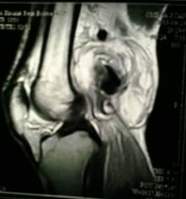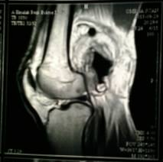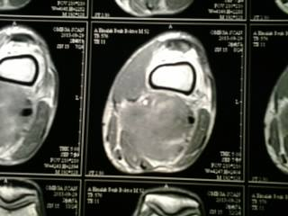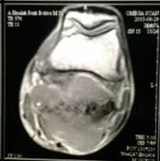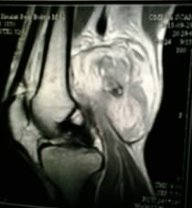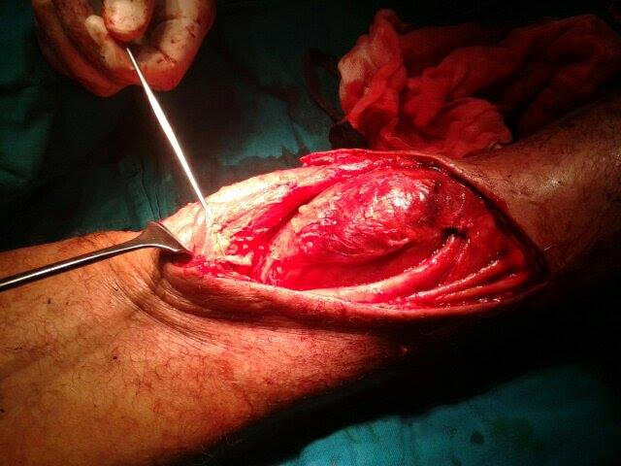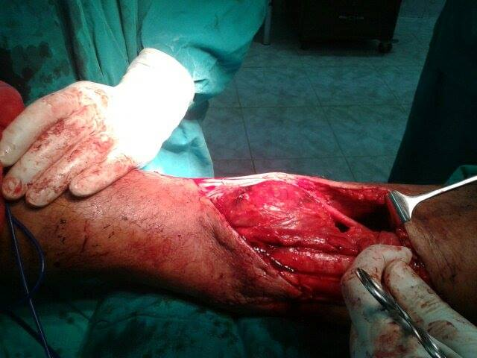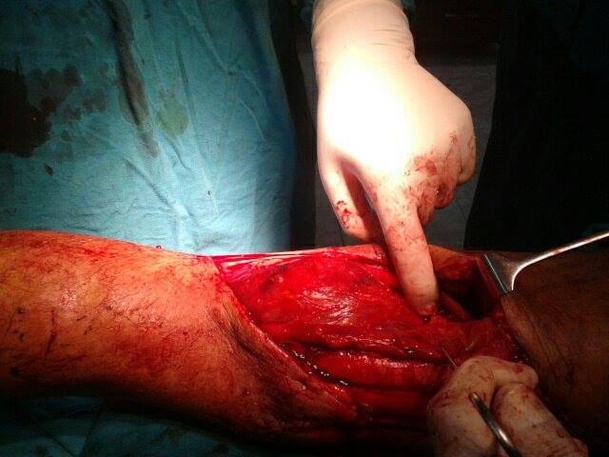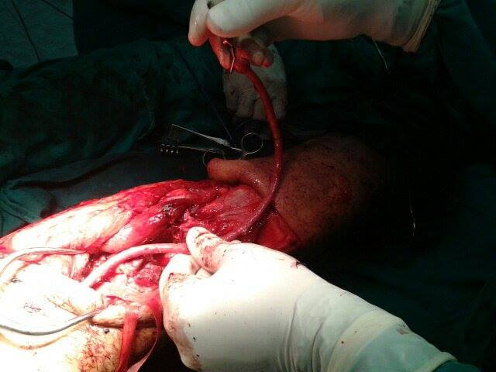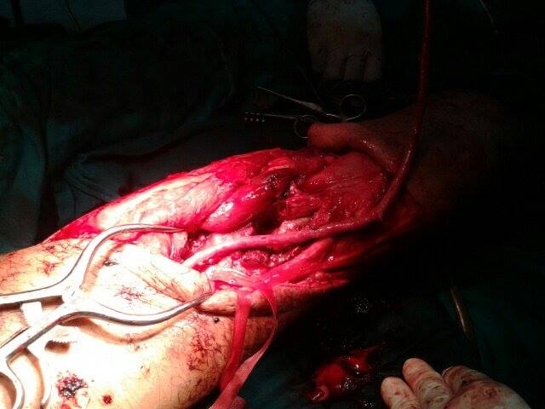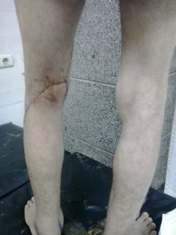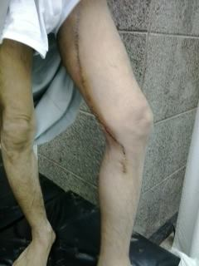

Reference:
- Christos Verikokos, Georgios Karaolanis, Mikes Doulaptsis et al. Giant Popliteal Artery Aneurysm: Case Report and Review of the Literature, Case Rep Vasc Med Vol. 2014; Article ID, 4 pages, 2014

- Tsilimparis N, Dayama A, Ricotta JJ., II Open and endovascular repair of popliteal artery aneurysms: tabular review of the literature. Annals of Vascular Surgery. 2013; 27(2):259–265.

- Mohan, I.V., Stephen, M.S. Peripheral arterial aneurysms: open or endovascular surgery?. Prog Cardiovasc Dis. 2013; 56:36–56.

- Minji Cho, MD, Sanghyun Ahn, MD, Sang-il Min, MD et al. Ruptured giant popliteal artery aneurysm. J Vasc Surg Cases Innov Tech December 2017; Volume 3, Issue 4, Pages 201–202

- Cervin Tjarnström, Ravn Acosta, Hultgren Welander et al. Treatment of popliteal aneurysm by open and endovascular surgery: a contemporary study of 592 procedures in Sweden. Eur J Vasc Endovasc Surg 2015;50:342–50.

Biography
Ayman Khalil as a consultant general and vascular surgery has his own expertise in management of the difficult cases that seek help. He believes that medicine is a gift from God that was bestowed upon us for the benefit of the human kind in the first place, not to collect money. He is interested in research work and development of new surgical techniques and operations. He keeps himself updated and well trained, doing his best to improve the quality of the medical service given to his patients. Ayman Khalil is also interested in charity work and helping the poor that cannot afford the high fees of the expensive operations. He carries the responsibility of teaching the junior staff and nurses to create generation of capable medical and paramedical personnel. He believes that doctors should keep good communication skills with the other medical staff team and also with the patients.
E-mail:
draymankhalil55@gmail.com

