A Challenging Surgery for Limb Salvage after Brachial Artery Injury
Abstract
Statement of the Problem: The brachial artery is the most frequently injured artery in the upper extremity (28% of all vascular injuries). There is a high incidence of associated nerve injuries with the brachial artery injuries, accounting for 27% to 44% rate of functional disability after operative procedure. Beyond a golden period of 6 to 8 hours of ischemia, ischemia-reperfusion injury will endanger the viability of the limb. It has been documented that the primary end-to-end anastmosis is superior to the saphenous vein interposition graft, and the later in turn is more preferable than repair with synthetic graft. Methodology: A 22-year-old male patient was admitted to our department with glass-lacerated wound at his left elbow with signs of brachial artery injury in the form of brisk bleeding, cold and cyanosed upper limb, absent radial and ulnar pulses and associated profound neurological deficits. The patient was significantly having severe rest pain, indicating severe arterial injury and presented to us more than 6 hours after the injury. An average brachial- brachial doppler index <0.5 was considered diagnostic for brachial artery injury. After patient resuscitation, exposure of the brachial artery at the elbow was done, primary end-to-end anastmosis was performed with difficulty due to >3cm gap, then repair of the associated nerve injuries (median and radial nerves). Findings: The patient had good arterial blood flow postoperatively assessed by clinical examination and duplex ultrasonography, and he was followed 1 month after the operation then every 3-month period. He had residual functional disability due to the associated nerve injuries in the form of wrist and finger drop. Conclusion: Limb salvage can be done even in cases of severe brachial artery injuries that may be repaired even beyond the golden time, but the residual functional disability due to associated nerve injuries may significantly affect the outcome.
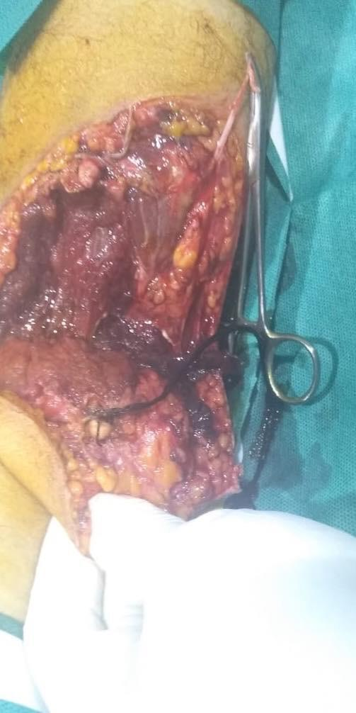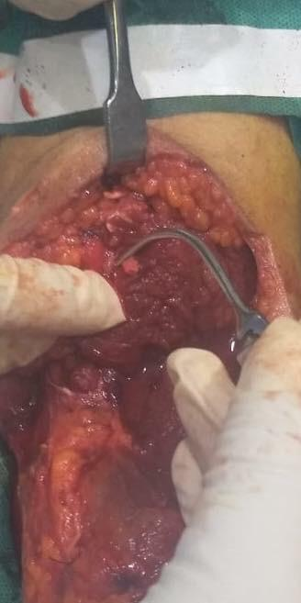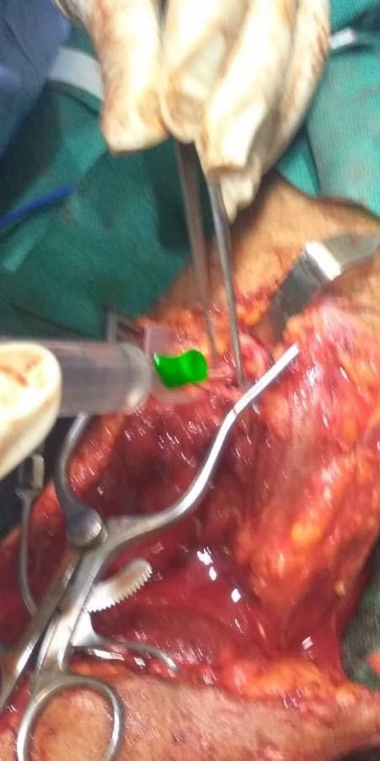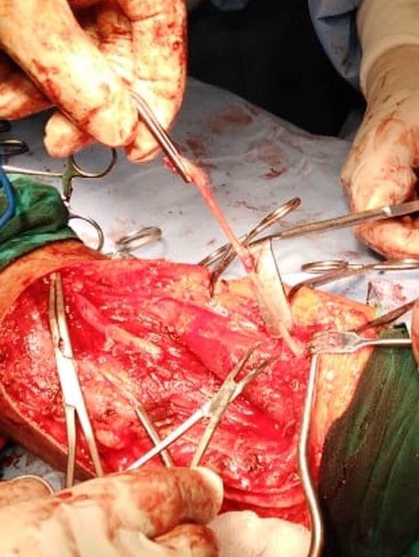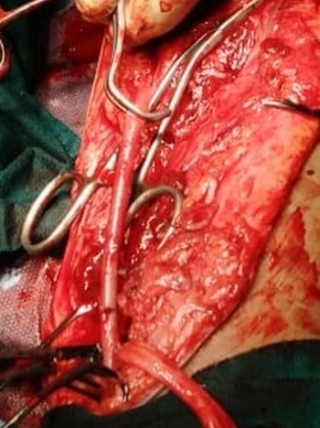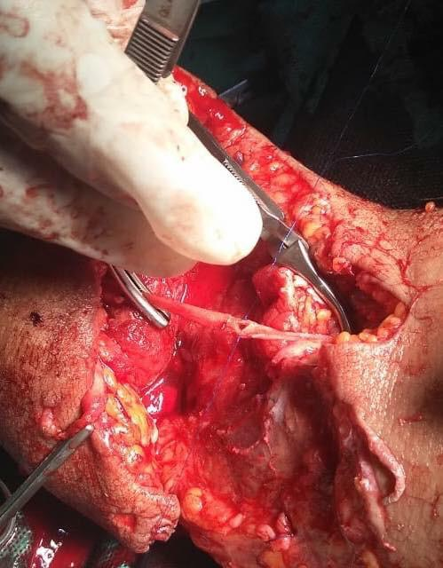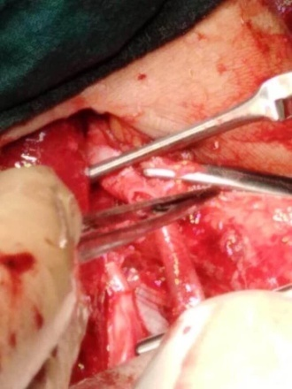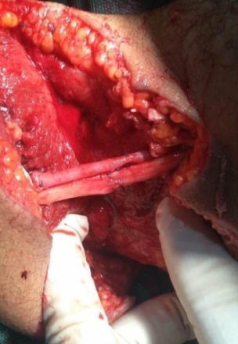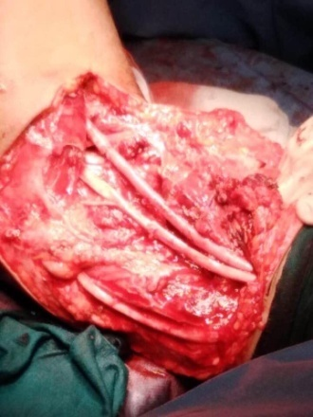

Reference:

- Ekim H, Tuncer M. Management of traumatic brachial artery injuries: A report on 49 patients. Ann Saudi Med. 2009;29(2):105-9. 2.

- Ergunes K, Yilik L, Ozsoyler I, Kestelli M, Ozbek C, Gurbuz A. Traumatic Brachial Artery Injuries. Tex Heart Inst J. 2006;33(1):31-4. 3.

- Franz RW, Goodwin RB, Hartman JF. Management of upper extremity arterial injuries at an urban level I trauma center. Ann Vasc Surg. 2009;23(1):8-16.

- Majid Moini, Kaveh Hamedani, Mohammad R.Rasouli and Mohsen Nouri. Outcome of delayed brachial artery repair in patients with traumatic brachial artery injury: Prospective study. International Journal of Surgery Volume 6, Issue 1, February 2008; Pages 20-22

- Sharma D, Yadav RK. A rare case of traumatic brachial artery injury. Int Surg J
2015;2:732-4.

Biography
Ayman Khalil as a consultant general and vascular surgery has his own expertise in management of the difficult cases that seek help. He believes that medicine is a gift from God that was bestowed upon us for the benefit of the human kind in the first place, not to collect money. He is interested in research work and development of new surgical techniques and operations. He keeps himself updated and well trained, doing his best to improve the quality of the medical service given to his patients. Ayman Khalil is also interested in charity work and helping the poor that cannot afford the high fees of the expensive operations. He carries the responsibility of teaching the junior staff and nurses to create generation of capable medical and paramedical personnel. He believes that doctors should keep good communication skills with the other medical staff team and also with the patients.
E-mail:
draymankhalil55@gmail.com

