An Easy Algorithm to Approach and Treat Vascular Anomalies, Experience in the Vascular Surgery Department of National Western Medical Center Pediatrics Hospital
Alejandro Celis, PhD, IMSS CMNO HPED, Mexico Alejandro Celis, PhD, IMSS CMNO HPED, Mexico
Abstract
Statement of the Problem: Vascular anomalies is a group of diseases that has been avoided by most of physicians of any specialty. They have been considered for many years as untreatable, and there are very few specialized centers in the world that take care of this patients. As a vascular surgeon we have been taught that these diseases are untreatable or that they can be your worst nightmare. The ISSVA has been the leading association classifying these diseases and having a biannual meeting to discuss and show advances in the field. Though, there are few members around the world, and data has not been rightly spread through involved physicians. Methodology & Theoretical Orientation: More than 100 patients have been treated in our Center by the Vascular Surgery Department with different vascular anomalies. Reviewing the results of the treated patients an algorithm has been developed to have an easy approach and treatment decision for most cases. Findings: An easy algorithm simplifies the way first contact doctors should approach a vascular anomaly. Most important concerns are to try to classify the anomaly according to ISSVA and detecting potentially complications on time. A good physical examination, basic laboratory tests, and Doppler Duplex Ultrasound are the basis to try to approach any vascular anomaly. Most complex cases will need a referral to specialist, and this specialist can use this algorithm to simplify the treatment decision. Conclusion & Significance: With the spread of an easy algorithm to approach and treat vascular anomalies, patients will benefit with a prompt diagnosis and start of treatment, which will decrease the risk of complications. This simple algorithm can be used by any physician or medical center and will also have a great cost/benefit in institutions, or private practice.

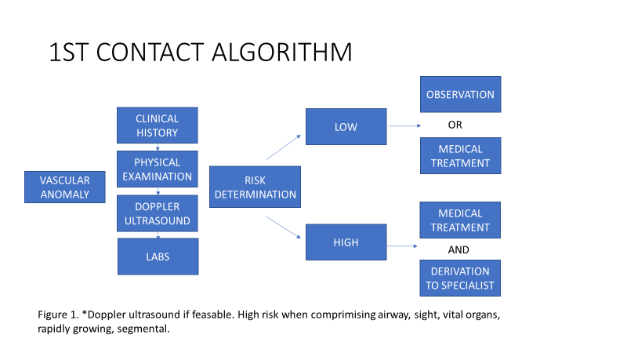
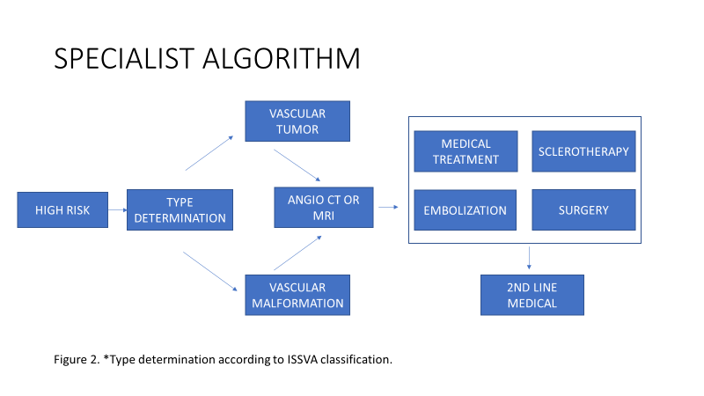
Image
Recent Publications
- Cox, J. A., Bartlett, E., & Lee, E. I. (2014). Vascular Malformations: A Review. Seminars in Plastic Surgery, 28(2), 58–63. http://doi.org/10.1055/s-0034-1376263
- McCafferty, I.J. et al. (2011) Imaging and management of vascular malformations. Clinical Radiology , Volume 66 , Issue 12 , 1208 – 1218. https://doi.org/10.1016/j.crad.2011.06.014
- Wassef, Mchel & Blei,et al. (2015). Vascular Anomalies Classification: Recommendations From the International Society for the Study of Vascular Anomalies. Pediatrics. 136. 10.1542/peds.2014-3673.
- Hammill, Adrienne et al. (2011). Sirolimus for the treatment of complicated vascular anomalies in children. Pediatric Blood & Cancer. Volume 57, Issue 6, 1018-1024. https://doi.org/10.1002/pbc.23124
- Adams, Denise M. et al. Efficacy and Safety of Sirolimus in the Treatment of Complicated Vascular Anomalies. Pediatrics. 2016 Feb; 137(2): e20153257. doi: 10.1542/peds.2015-3257
- Richter, Gresham T., Friedman, Adva B. (2012) Hemangiomas and Vascular Malformatios: Current Theory and Management. International Journal of Pediatrics. Article ID 645678, 10 pages doi:10.1155/2012/6456

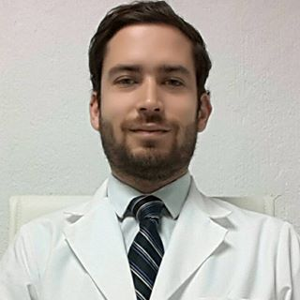
Biography
Alejandro Celis is a young Vascular Surgeon, trained in Guadalajara, Mexico as an adult surgeon, but since 2017, he has become the first Vascular Surgeon directly involved in the management of children in a Pediatrics Hospital. He has been applying his clinical, surgical and endovascular skills to treat mostly patients with vascular anomalies. Noticing there is very little experience about vascular anomalies among most physicians, he has decided to get deep in the field and develop the best strategies to treat the patients and share his experience with other physicians. Email: acelis@angiologia.mx

