MULTIPLE (CONCOMITANT) TRAUMATIC PSEUDOANEURYSMS OF THE SUPERFICIAL TEMPORAL ARTERY
ABSTRACT
We present a case with a 22-year-old man suffering from a two pseudoaneurysms at the temporal region following trauma. The second pseudoaneurysm was diagnosed through an astute use of digital subtraction angiography along with ultrasound to the right external carotid artery which was preferred due to the presence of a vascular pathology at the region of the trauma. During surgery, the distal and proximal ends of both aneurysms were ligated and resected. The concomitant pseudoaneurysms and the use of digital subtraction angiography should be kept in mind in such trauma patients in order to prevent additional surgical interventions.
Keywords: Superficial temporal artery, concomitant pseudoaneurysms, trauma

INTRODUCTION
A pseudoaneurysm refers to the traumatic origin of the aneurysms which is formed from the dilation of an artery that does not contain all three layers of the arterial wall unlike a true aneurysm (1, 2).
The superficial temporal artery (STA) is the terminal branch of the external carotid artery. It begins in the parotid gland at the level of the mandibular neck and crosses the zygomatic process of the temporal bone. It divides into anterior (frontal) and posterior (parietal) branches about 5 cm above the zygomatic process. The STA is palpable as it crosses the zygomatic process (3).
A pseudoaneurysm of the STA was described around mid-18th century by Thomas Bartholin (4,5) which is a rare lesion that usually presents with a pulsatile cystic mass in the frontotemporal region caused by blunt trauma to the overlying the STA (1, 6, 7, 8). The frontal branch of STA is commonly effected by this type of trauma (7). Although in the literature there is a multiple pseudoaneurysms occurring after craniotomy in a patient with hemophilia, STA pseudoaneurysms have mostly been reported as a solitary mass accompanied by headaches (9,10) However the concomitant traumatic pseudoaneurysms have not been reported in literature before.
In this report, we describe the use of digital subtraction angiography (DSA) along with ultrasound (US) to discover a second pseudoaneurysms which is not reported before, at the frontal branch of superficial temporal artery in a patient with a blunt head trauma.

CASE
A 22-year-old man was admitted to the neurosurgery department suffering from a pulsatile, painful, growing mass located at temporal region, located anteriorly and superiorly to his right ear. His history included a blunt head trauma during a football match. He was also hospitalized for five days due to a traumatic subarachnoid hemorrhage. He noticed the presence of the mass four weeks after the trauma. The mass was pulsatile, compressible and painful. Doppler ultrasound (US) revealed a pulsatile vascular lesion (for possible posttraumatic pseudoaneurysm), 15 mm in diameter, located on right superficial temporal artery. Because it was a vascular pathology, we also performed a digital subtraction angiography (DSA) of the right external carotid artery (ECA) and it revealed another pseudoaneurysm, 3 mm in diameter, located nearly 1 cm distal to the first one (Figure 1A).
The patient was operated on under general anesthesia. Distal and proximal ends of both aneurysms were ligated and both aneurysms were resected (Figure 1B and Figure 1C). Histopathological findings confirmed the diagnosis of pseudoaneurysm.

DISCUSSION
Pseudoaneurysm of the superficial temporal artery is an uncommon clinical entity that typically occurs following a blunt trauma to the frontotemporal region (2,9,11,12,13,14). This type of pseudoaneurysm is classified as an incidental traumatic type and it is the most common type of STA pseudoaneurysm (1). Other causes of the STA pseudoaneurysm include iatrogenic injury during cyst removal, temporomandibular arthroplasty, punch hair grafting, computed tomography–guided biopsy, and various neurosurgical procedures in this region including external ventricular drain placement (12,15). Gardner–Wells tongs application [16], and craniotomy for intracranial aneurysm clipping (11,17).STA pseudoaneurysm formation has also been described following a penetrating head trauma (18, 19).
The anterior branch of the STA is more effected by trauma (7) because of its superficial course and its proximity to the temporal arch (12). The only protective tissue or muscle for STA is the temporalis muscle (20).
Blunt trauma to the lateral forehead and temporal fossa gives rise to pseudoaneurysms (12). A trauma causes a damage in the arterial wall and blood extravasates from the damaged artery subsequently forming a hematoma. Following arterial injury, a weak perivascular organized fibrous capsule is formed around the hematoma which is responsible for its pulsatile property (17). The STA pseudoaneurysms could be asymptomatic. However, when symptoms do appear they include headache, ear discomfort, visual disturbance, dizziness, hemorrhage, cosmetic defects and neurologic deficits. Symptoms typically appear within 2 to 6 weeks of injury and in rare cases it may arise within 2 to 4 days (10, 21). In our case the patient noticed the presence of the mass four weeks after the trauma.
Many authors believe that superficial temporal artery pseudoaneurysm should be diagnosed clinically from the history and physical examination of the patient (2,11,13). Diagnostic modalities could include both invasive and non-invasive tests (11). Ultrasounds can provide detailed information about the vascular anatomy without having to worry about the risks of invasive methods or radiation. For most cases, duplex ultra-sound is currently the imaging method of choice (2,21). Use of CT Scans with contrast, CT Angiography and Digital Subtraction Angiography have been also reported in the literature (9).
Surgery is the preferred treatment for pseudoaneurysms (1, 8). Indications for surgery include cosmetic reasons, intractable headaches, and hemorrhage prevention (11, 13). Surgical management under local anesthesia is appropriate and may include ligation and excision of the aneurysm arterial segment or primary repair when the arterial injury is easily amenable to the closure with sutures (7). Other treatment options for STA aneurysm have been reported, including endovascular obliteration, percutaneous endo-obliteration using coils or glue (12). Percutaneous thrombin injection as a treatment has been described but there are some controversies regarding this techniques such as recanalization, systemic intravascular thrombosis, and an allergic reaction to thrombin (14). Recurrence of the pseudoaneurysm of STA after surgery has been documented as rare (12).
In this case, the pseudoaneurysm occurred due to a blunt head trauma and the patient noticed the mass four weeks after the trauma and Doppler US confirmed a pseudoaneurysm of the right frontal branch of STA. The course of events that lead to the formation of the pseudoaneurysm was in accordance with the literature. However, the US alone was not enough to reveal the second aneurysm. DSA which is a gold standard imaging method for aneurysms even smaller than 3 mm diameter, revealed the concomitant small aneurysms (9). If DSA was not performed, the second aneurysm could not have been found, therefore the patient could have undergone a second operation.

CONCLUSION
STA pseudoaneurysms are rare vascular pathologies, concomitant presentation of them has not been reported in the literature. Therefore, further radiological investigation such as DSA should be performed to show all the pseudoaneurysms, of which some can be missed with just the US alone. Although US can provide detailed information about vascular anatomy without incurring the risks of invasive methods we should be thoroughly investigating such cases with further radiological techniques such as DSA in order to fully reveal the all aneurysms in the whole damaged arteries. This approach could be crucial in preventing unnecessary surgeries in the patient.

Conflict of interest/funding statement:
There are no disclosures or conflicts of interest or funding.

REFERENCES
- Levisianos I, Sood V. Traumatic aneurysm (pseudoaneurysm) of the superficial temporal artery. Emerg Med J 2008, 25:239–240
- Ayling O, Martin A, Roche-Nagle G. Primary repair of a traumatic superficial temporal artery pseudoaneurysm: case report and literature review. Vasc Endovascular Surg 2014, 48(4):346–8
- Standring S. Cardiovascular System: Face and Scalp. In: Strandring S, ed. Gray’s Anatomy. 39th ed. London: Churchill-Livingstone; 2005: 1519
- Han K, Borah GL. Pseudoaneurysm of the anterior superficial temporal artery. Ann Plast Surg 1996, 37:650–653
- Conner WC 3rd, Rohrich RJ, Pollock RA Traumatic aneurysms of the face and temple: a patient report and literature review, 1644 to 1998. Ann Plast Surg 1998, 41:321–326
- Mann GS, Heran MK. Percutaneous thrombin embolization of a post-traumatic superficial temporal artery pseudoaneurysm. Pediatr Radiol 2007, 37:578–580
- Murphy M, Hughes D, Liaquat I, Edmondson R, Bullock P Giant traumatic pseudoaneurysm of the superficial temporal artery: treatment challenges and case review. Br J Neurosurg 2006, 20:159–161
- Quereshy FA, Choi S, Buma B Traumatic pseudoaneurysm of the superficial temporal artery in a pediatric patient: a case report. J Oral Maxillofac Surg 2008, 66:133–135
- Walker MT, Liu BP, Salehi SA, Badve S, Batjer HH. Superficial temporal artery pseudoaneurysm: diagnosis and preoperative planning with CT angiography. Am J Neuroradiol 2003, 24(1):147–50
- Choo MJ, Yoo IS, Song HK: A Traumatic pseudoaneurysm of the superficial temporal artery. Yonsei Medical Journal 1998, 39(2):180-183
- Hakan T, ErSahinM, SomayH, AkerF. Pseudoaneurysm of the superficial temporal artery following revision of a middle cerebral artery aneurysm clipping: case report and review of the literature. Turk Neurosurg 2011, 21(3): 430–4
- TouilL L, Gurusinghe ADR, Sadri A, Hunt D, Dhital SK. Superficial temporal artery aneurysm: beware of the lump with a thump. J Plast Reconstr Aesthet Surg 2014, 67(8):e210–1. doi: 10.1016/j.bjps.2014.02.006
- Nnadi MON, Bankole OB, Arigbabu TO. Superficial temporal artery pseudoaneurysm: a report of two ruptured cases and review of literature. East Cent Afr J Surg 2013,18(2):168–74
- Terterov S, McLaughlin N, Martin NA. Postcraniotomy superficial temporal artery pseudoaneurysm in the setting of triple H therapy: a case report and literature review. Surg Neurol Int 2012, 3:139
- Angevine PD, Connolly Jr ES. Pseudoaneurysms of the superficial temporal artery secondary to placement of external ventricular drainage catheters. Surg Neurol 2002; 58:258–60
- Lee HS, Jo KW, Lee SH, et al. Traumatic pseudoaneurysm of the superficial temporal artery due to gardner traction. J Korean Neurosurg Soc 2010;48:291–3
- Fukunaga N, Hanaoka M, Masahira N, Tamura T, Oka H, Satoh K, et al: Traumatic pseudoaneurysm of superficial temporal artery. American Journal of Surgery 2010, 199(1): e1–e2
- Lee SR, Metwalli ZA, Yevich SM, et al. Variability in evolution and course of gunshot injuries to the neck and impact on management. A case report. Interv Neuroradiol 2013; 19:489–95
- Pourdanesh F, Salehian M, Dehghan P, et al. Pseudoaneurysm of the superficial temporal artery following penetrating trauma. J Craniofac Surg 2013;24: e 334–7
- Cadamy AJ, McNaughton GW, Helliwell R: Traumatic pseudoaneurysms of the superficial temporal artery. European Journal of Emergency Medicine 2003, 10:236–237
- Park IH, Kim HS, Park SK, Kim SW: Traumatic pseudoaneurysm of the superficial temporal artery diagnosed by 3-dimensional CT angiography. J Korean Neurosurg 2000, 43:209-211

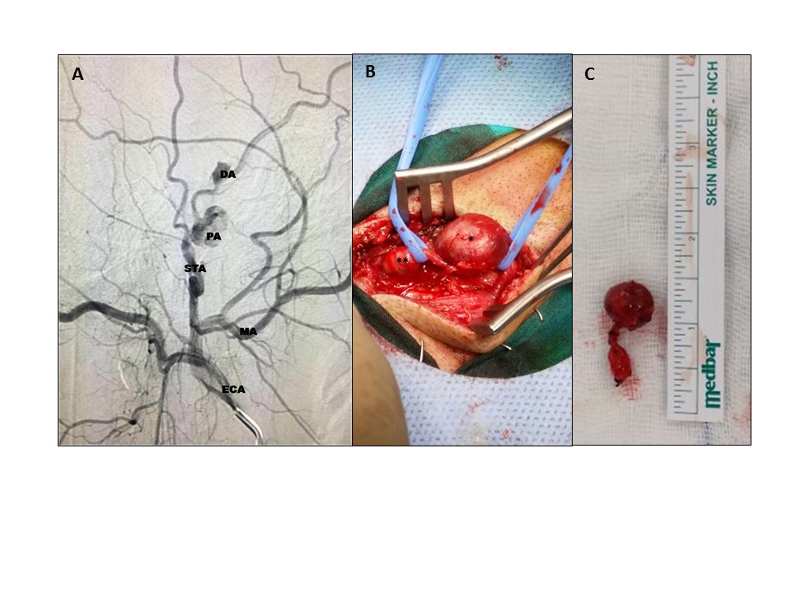
Figure 1A Legend: Digital subtraction angiography (DSA) imaging of the right external carotid artery (ECA). ECA: External carotid artery, MA: Maxillary artery, STA: Superficial temporal artery, PA: Proximal (main) aneurysm, DA: Distal aneurysm
Figure 1B Legend: The intraoperative photograph indicates the superficial temporal artery aneurysms. *: Proximal aneurysm, **: Distal aneurysm
Figure 1C Legend: The photograph of the postoperation material that shows the both aneurysms.

Supplemented digital complex: The intraoperative photograph shows both aneurysms.

The case-report is published at The Journal of Craniofacial Surgery _ Volume 28, Number 8, November 2017 as a Brief Clinical Studies

“MULTIPLE (CONCOMITANT) TRAUMATIC PSEUDOANEURYSMS OF THE SUPERFICIAL TEMPORAL ARTERY”
Manuscript Number - SCS-17-0438R1

