A New Perspective for The Treatment Of Infra-Renal Abdominal Aortic Aneurysm With A Congenital Pelvic Kidney

Barun Majumder¹, Ayesha Parera¹, Neil Browning¹, Mark McGregor², Alex Chapman³
Ashford and St Peter’s NHS Foundation Trust, Chertsey, KT16 0PZ, UK,¹Department of Vascular Surgery, ²Department of Anaesthesia, ³Department of Interventional Radiology

Corresponding Author: Barun Majumder

Abstract

The coexistence of Abdominal Aortic Aneurysm (AAA) and Congenital Pelvic Kidney (CPK) is infrequent. Various treatment modalities have been reported in literature for treatment of the above condition. We report a complete endovascular modality for the treatment of this association, especially for high-risk patients. Only one such treatment has been reported before. Compared to this previously reported case, we would like to share our experience with additional prototype testing, prior to surgery which provided us with more detailed information about the planning and deployment of the branched endograft.

An incidental 7 cm infra renal abdominal aortic aneurysm with presence of right pelvic kidney was detected on a MRI performed for back pain in a 75 years’ male patient with a history of two previous myocardial infarctions and a radical prostatectomy for prostate cancer. He was unfit for open surgery. We report a custom made fenestrated endograft with prior prototype information used for the repair of a large aneurysm with right pelvic kidney. This procedure is less invasive than any other reported treatment modalities such as open surgery or hybrid procedures. This procedure has an added advantage in that there is no renal ischemia and recovery is significantly faster.

Keyword: Abdominal Aortic Aneurysm, Pelvic Kidney, Fenestrated, Endograft, Prototype testing

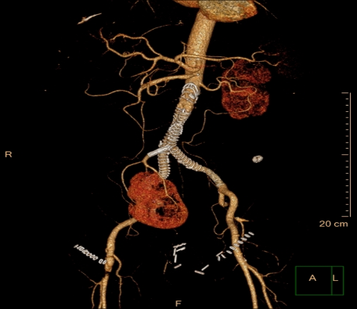

Recent Publications

- Baillie C (2017) Multidisciplinary Approach to the Management of Diabetic Foot Complications: Impact on Hospital Admissions, Limb Salvage and Amputation Rates. Endocrinology & Metabolism International Journal, Volume 5 Issue 2 :00119.

- Barun Majumder (2017). Fenestrated Endograft as a New Perspective for the Treatment of Infrarenal Abdominal Aortic Aneurysm with a Congenital Pelvic Kidney—A Case Report and Review of Literature. Annals of Vascular Surgery, Published online: July 13, In Press for full publication.

- B Majumder (2012). Early clinical experience with Anaconda re-deployable endograft in 106 patients with abdominal aortic Aneurysm: The West of Scotland Anaconda registry. Scott Med J 57(2):61-65.

- B Majumder (2011) Conjugated Linoleic Acids (CLA’s) regulate the expression of key apoptotic genes in human breast cancer cells. The FASEB J. 16 (11):1447-1449 and book by Lambert Publishing (ISBN NO: 978-3-8454-0918-4).

- “Technical development of endograft: Anaconda”- MEET Book 2010.

- LH Moyes (2007). An unusual case of aortic graft infection: a case report and review of the literature. Scott Med J, 52(4): 53;

- S Kettlewell (2006). Sentinel node status in melanoma is a highly significant prognostic factor: a prospective observational study. BMJ; 332:1423-5.



Biography Mr Barun Majumder graduated from Calcutta National Medical College, India and trained as Vascular and Endovascular Surgeon in the West of Scotland. He also gained a wide experience in open aortic, carotid, mesenteric ischaemia, lower limb reconstructive for claudication and critical limb ischaemia, minimally invasive vein treatment, diabetic limb salvage and redo vascular surgery. He also experienced in treating upper limb ischaemia and vasculitis disease.
Mr Majumder has also a special interest in teaching and research. He also has a certificate in educational supervision and teaching. He is also attended the Royal College “Training The Trainer Course”. He is a tutor for basic surgical skills & MRCS course at the Royal College of Physicians and Surgeons of Glasgow (RCPSG). He was spent 18 months as a Surgical Research Fellow at Aberdeen University leading to MD. Teaching. He has a keen interest in research and teaching. His enjoys cooking and plays Classical/Flamenco Guitar.

Email: barunmajumder@nhs.net

Notes/Comments:

