The aXurge© project. Feasibility of a mathematical platform for Abdominal Aortic Aneurism (AAA) sizing, risk assessment and surgical planning
Domanin M, Colciago C*, Riccobene C**, Deparis S*, Quarteroni A#, Schenone E**, Crivaro O**, Prati L$
Department of Clinical and Community Science University of Milan (I), * Ecole Polytechnique de Lausanne (CH), **Moxoff, Milan (I), #Mox - Politecnico di Milano (I), $ Yottacle, Milan (I)

Abstract

BACKGROUND Aortic Abdominal Aneurysm (AAA) management requires to deal with different tasks: clinical evaluation, analysis and forecast risk of rupture, analysis of radiological imaging, evaluation of the feasibility for endovascular repair (EVAR), sizing and planning.

OBJECTIVE aXurge© is the ultimate web platform for the treatment of AAA. Combining advanced mathematical techniques in the fields of imaging, numerical and statistical analysis, aXurge© provides an advanced valuable tool for:

• Vascular specialists, as it assists them during every step of the decision procedure: from the analysis of the DICOM images to an insightful and aware assessment of the patient condition, and the planning for EVAR configuration of the surgical operation.

• EVAR manufacturers, as it offers a dedicated space to interact with vascular specialists and to access a rich statistical database that will be continuously updated with new clinical cases.

MATERIAL AND METHODS

aXurge© web-platform provides the following features:

• Private case history database.

• Image processing and sizing. Our application guides clinicians to obtain from medical imaging AAA sizing and morphological characterization.

• Statistical classification and enhanced morphological and biomechanical assessment in order to produce a statistical classification of AAA.

• Patient-specific numerical simulations with haemodynamics and biomechanical models of the risk of rupture tailored on each case

• EVAR devices configuration planner through the catalogues of all the principal brands of EVAR manufacturers.

RESULTS Over a training set of 283 geometries, after the manual selection of solely 5 seed points, our algorithms are actually able to automatically perform AAA’s sizing in the 79% of the cases.

CONCLUSIONS The great value of aXurge© relies in the synergy of several individual high-level skills, needed to achieve an effective product. aXurge© aims not only at bringing innovation to vascular experts but also at interacting and collaborating with them to ensure continuous improvement in patients’ healthcare.

Image
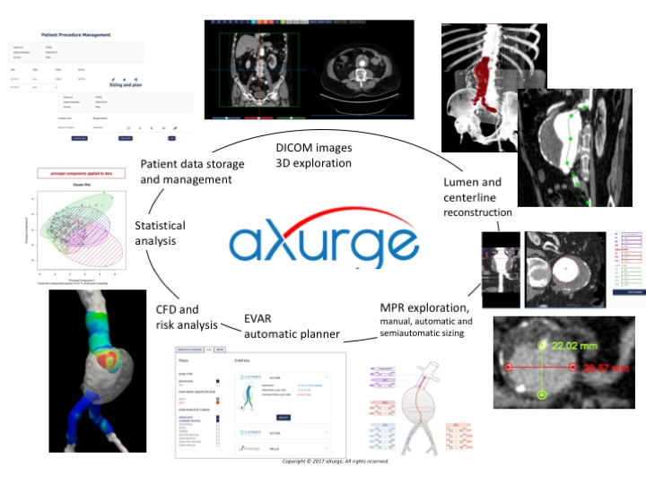
Recent Publications
- Piccinelli M, Vergara C, Antiga L, Forzenigo L, Biondetti P, Domanin M: Impact of hemodynamics on lumen boundary displacements in abdominal aortic aneurysms by means of dynamic computed tomography and computational fluid dynamics. Biomechanics and Modeling in Mechanobiology: 2013;12:1263-1276 DOI 10.1007/s10237-013-0480-5.
- MC Firetto, M Petrini, F Sala, M Domanin, G Terribile, PR Biondetti Thoracic Aortic Aneurysms, Fistula and Thrombus. in M Scaglione (ed.) Emergency Radiology of the Chest and Cardiovascular System. Medical Radiology pp 307-340.
- Vergara C, Le Van D, Quadrio M, Formaggia L, Domanin M. Large eddy simulations of blood dynamics in abdominal aortic aneurysms. Med Eng Phys

Biography
Degree in Medicine and Surgery, University of Milan and Specialist in Vascular Surgery. Assistant Professor in Vascular Surgery at the University of Milan since 1994
Field of interest: He is experienced in the diagnosis and treatment of all the aspects of vascular pathologies (in particular for carotid surgery, endovascular treatment of abdominal aortic aneurysm and varicose veins surgery). Author of numerous publication, he collaborates with Politecnico of Milan and Ecole Politechnique Federale de Lausanne for the development of bioengineering methods of analysis of Computational Fluid Dynamics (CFD) in vascular pathologies. He is the co-founder and designer of aXurge, a start-up dedicated to AAA endovascular treatment (www.aXurge.com).For these researches, he received grants from MIUR in 2005 and ERC in 2015.
Email: maurizio.domanin@unimi.it

Notes/Comments:

