Congenital absence of inferior vena Cava associated with lower limb and pelvic venous thrombosis.
Sanjay Singh, Consultant Vascular Surgeon, United Lincolnshire Hospitals NHS Trust
Asghar Butt, Speciality Doctor, United Lincolnshire Hospitals NHS Trust
Muhammad Usman Cheema, Speciality Doctor, United Lincolnshire Hospitals NHS Trust
Jayarama Mohan, Consultant Vascular Surgeon, United Lincolnshire Hospitals NHS Trust

Abstract

Background: Congenital absence of inferior vena cava (IVCA) is an extremely rare anomaly with an estimated prevalence of 1%. It is recognised to be associated with deep vein thrombosis (DVT) particularly in the young. There can be clues indicating the presence of such an anomaly from a young age. Patients with IVC anomalies usually develop compensatory circulation through the collateral veins; despite the compensatory circulation, the venous drainage of the lower limbs is often insufficient leading to venous stasis and thrombosis. We present two cases of young adult aged 17 and 28 years who presented with groin pain, swelling and lower limb DVT respectively. The clinical features, diagnostic and therapeutic options are discussed. Discussion: IVCA is an uncommon but well recognised anomaly. Most of the patients with IVCA are asymptomatic and detected incidentally during radiological procedures or abdominal surgery. Common symptoms are lower extremity pain, swelling, ulcers, and sometimes nonspecific pain in the lower back and abdomen. The most reliable non-invasive methods for diagnosing IVC anomalies are CT and MRI. There is no role of surgical correction in the management of these patients. There is no consensus regarding the duration of anti-coagulation but it would seem sensible for them to remain on life-long anticoagulation given the on-going risk of further DVT. Conclusion: All vascular surgeons should consider the possibility of IVC anomalies in a young adult presenting with unexplained, extensive, or bilateral DVT. The diagnosis can be challenging and requires detailed imaging studies. Further diagnostic workup and management should be considered for any coagulation abnormalities and long- term anticoagulation.

Image

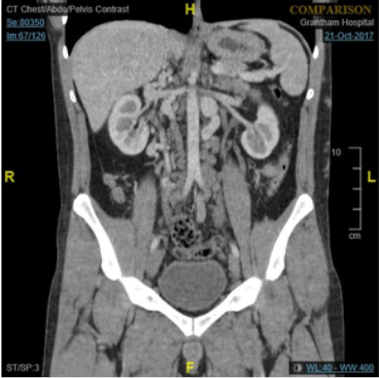

Recent Publications
- Sakellaris G, Tilemis S, Papakonstantinou O, Bitsori M, Tsetis D, Charissis G (2005) Deep venous thrombosis in a child associated with an abnormal inferior vena cava. Acta Paediatr 94: 242 – 244.
- Gayer G, Luboshitz J, Hertz M, Zissin R, et al (2003) Congenital anomalies of the inferior vena cava revealed on CT in patients with deep vein thrombosis. AJR Am J Roentgenol 180: 729 – 732.
- Iqbal J, Nagaraju E (2008) Congenital absence of inferior vena cava and thrombosis: a case report. J Med Case Reports 2: 46.
- Koc Z, Oguzkurt (2007) Interuption or congenital stenosis of the inferior vena cava: prevalence, imaging and clinical findings. Eur J Radiol 62: 257 – 266.
- Koppisetty S, Smith A G, Dhillon R K (2015) Incidental finding of inferior vena cava atresia presenting with DVT following physical assertion. Case Reports in Emergency Medicine , Article ID 146304.

 Biography
Sanjay Singh has expertise and passion in vascular and endovascular surgery. He has done complex aortic endovascular fellowship and is a vascular consultant working in United Kingdom. His open and contextual surgical techniques are based on researched and practiced models which help create new pathways for innovation. He has achieved this aptitude after years of experience in research and teaching in University hospitals and institutions. The ever-responsive and adapting field of endovascular surgery has improved the survival rates of high risk patients.
Email: dr_sanjaysingh@hotmail.com

Notes/Comments:

