Does duplex surveillance after femoro-popliteal bypass grafting affect long term graft patency?
Sanjay Singh, MS, FRCS, Senior Endovascular Fellow, Heart of England NHS Foundation Trust
Rushmi Purmessur, Core Trainee 1, Heart of England NHS Foundation Trust
Arun Nair, Foundation year 1, Heart of England NHS Foundation Trust

Abstract

Introduction: Duplex scanning is currently the best method to detect stenotic lesions that threaten bypass graft patency. The correction of these lesions may improve long term patency of grafts and limb salvage rates. The aim of this study is to investigate the effects of duplex surveillance post femoro-popliteal bypass graft for chronic limb threatening ischaemia (CLTI) in terms of graft patency and limb salvage. Methodology: A retrospective analysis of 59 patients who had underwent femoro-popliteal bypass graft for CLTI between Jan 2009 and April 2014. Data was collected from the electronic computer record and analysed using SPSS v24. Results: Of 59 patients; 49 (83.1%) had autologous vein graft, 8 (13.6%) prosthetic vein grafts and 2 (3.4%) composite graft. Mean follow up was 13.6 (0-64) months. Mean age was 77 (58-96) years. Duplex scan surveillance was performed in 35 (71.4%) patients at 3,6,9,18 and 24 months post operatively; 27 in autologous vein, 7 in prosthetic graft and 1 in composite. Positive findings of occluded graft were noted in 10 duplex scans; all blocked grafts were autologous vein grafts. Out of the 17 patent vein grafts, stenosis was noted in 9 veins requiring angioplasty. Two patients needed amputation after angioplasty. Primary patency at 1 & 2yr for duplex surveillance group was 71.4% and no surveillance group was 54.2%. Within 2 years 21 patients needed major amputation. Total amputation rate was 35.5%. 10 amputations in patient who were on surveillance (28.5%) and 11 who had no surveillance (45.8%). At 7 years amputation free survival (AFS) was 48.6% vs 16.7% in no surveillance group (HR 0.52 95% CI 0.28 - 0.99 p=0.047); Limb Salvage was 71.4% vs 54.2% (HR 0.57 95% CI 0.24 - 1.35 p=0.203) and overall survival was 71.4% vs 33.3% (HR 0.37 95% CI 0.168 – 0.817 p=0.14. Conclusion: In our cohort the important clinical outcomes following bypass surgery for chronic limb threatening ischaemia are far better if patients were enrolled in a local graft surveillance protocol.

Image

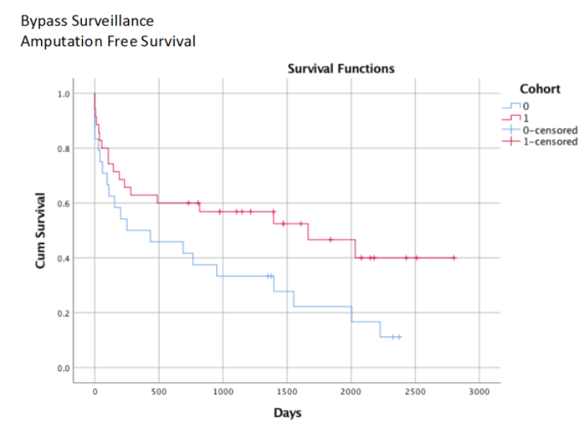

Recent Publications
- Davies A H, Hawdon A J, Sydes M R, Thompson A G (2005) Is Duplex surveillance of value after leg vein bypass grafting? Circulation 112: 1985 – 1991.
- Hawdon A J, et al (2003) Vein graft surveillance: is the yield worth the effort? Acta Chir Belg 103: 379 – 382.
- Baril D T, Marone L K (2012) Duplex evaluation following femoropopliteal angioplasty and stenting: criteria and utility of surveillance. Vasc Endovascular Surg 46: 353 – 357.
- Bui T D, Mills J L Sr, et al (2012) The natural history of duplex detected stenosis after femoropopliteal endovascular therapy suggests questionable clinical utility of routine duplex surveillance. J Vasc Surg 55: 346 – 352.
- Abu Dhabri A M, Mohammed K, et al (2017) Systemic review and meta-analysis of duplex ultrasound surveillance for infrainguinal vein bypass grafts. J Vasc Surg 66: 1885 – 1891.

 Biography
Sanjay Singh has expertise and passion in vascular and endovascular surgery. He has done complex aortic endovascular fellowship and is a vascular consultant working in United Kingdom. His open and contextual surgical techniques are based on researched and practiced models which help create new pathways for innovation. He has achieved this aptitude after years of experience in research and teaching in University hospitals and institutions. The ever-responsive and adapting field of endovascular surgery has improved the survival rates of high risk patients.
Email: dr_sanjaysingh@hotmail.com

Notes/Comments:

