Endovascular Management of Mycotic Abdominal Aortic Aneurysm Secondary to Streptococcal Pneumoniae
Sanjay Singh, Consultant Vascular Surgeon, United Lincolnshire Hospitals NHS Trust
Muhammad Usman Cheema, Speciality Doctor, Vascular Surgery, United Lincolnshire Hospitals NHS Trust
Asghar Butt, Speciality Doctor, United Lincolnshire Hospitals NHS Trust
Nityanand Arya, Consultant Vascular Surgeon, United Lincolnshire Hospitals NHS Trust

Abstract

Mycotic abdominal aortic aneurysm (MAAA) is a rare but life-threatening condition with an incidence of about 0.65-2% of all aortic aneurysms. MAAA have poor prognosis as they have tendency to grow rapidly and rupture and the patients often have severe comorbidities and coexisting septic conditions. Conventional surgical treatment is open surgery but is associated with high morbidity and mortality and can be very demanding or even impossible. Endovascular aneurysm repair (EVAR) is a less invasive but controversial alternative to conventional open repair of MAAA. A major disadvantage of EVAR is that the infected tissue, including the aneurysm itself, is not resected, which may facilitate reinfection, recurrent sepsis, and infection of the endoprosthesis. Methodology: Three cases of MAAA are described; all treated with endovascular stent graft with variable configurations (2 cases treated with EVAR and 1 with surgeon modified Fenestrated EVAR). The clinical diagnosis of MAAA, was made by clinical presentation, results of hematologic tests and culture, and CT findings. All cases grew streptococcus pneumoniae on blood culture. All patients underwent successful placement of stent grafts for their aneurysms. All patients were given antibiotics preoperatively and postoperatively, initially with broad-spectrum antibiotics intravenously and later, when discharged from the hospital, oral treatment guided by culture results, when available. Antibiotic therapy was administered after consultation with infectious disease specialists. No 30-day postoperative mortality was observed. Conclusion: Our short- term review shows that repair of MAAA can be accomplished with endovascular repair. This may be a safer alternative to open repair particularly in patients who are not suitable for conventional open repair.
Image

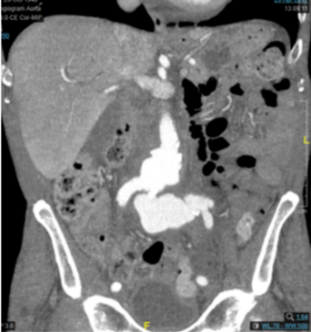

Recent Publications
- Reddy D J, Shepard A D, Evans J R, Wright D J, Smith R F, Ernst C B (1991) Management of infected aortoiliac aneurysms. Arch Surg 126: 873 – 879.
- Muller B T, Wegener O R, Grabitz K, Pillny M, Thomas L, Sandmann W (2001) Mycotic aneurysms of the thoracic and abdominal aorta and iliac arteries: experience with anatomic and extra anatomic repair in 33 cases. J Vasc Surg 33: 106 – 113.
- Fillmore A J, Valentine R J (2003) Surgical mortality in patients with infected aortic aneurysms. J Am Coll Surg 196: 435 – 441.
- Hsu R B, Chen R J, Wang S S, Chu S H (2004) Infected aortic aneurysm: clinical outcome and risk factor analysis. J Vasc Surg 40: 30 - 35
- Sorelius K, Mani K, Bjorck M, Nyman R, Wanhainen A (2009) Endovascular repair of mycotic aortic aneurysms. J Vasc Surg 50: 269 – 274.

 Biography
Sanjay Singh has expertise and passion in vascular and endovascular surgery. He has done complex aortic endovascular fellowship and is a vascular consultant working in United Kingdom. His open and contextual surgical techniques are based on researched and practiced models which help create new pathways for innovation. He has achieved this aptitude after years of experience in research and teaching in University hospitals and institutions. The ever-responsive and adapting field of endovascular surgery has improved the survival rates of high risk patients.
Email: dr_sanjaysingh@hotmail.com

