Affecting factors of residual stenosis after carotid artery stenting

Yang Hua^{1*}, MD,Yunlu Tao¹, MD, Lingyun Jia¹, MD,Liqun Jiao², MD, Lili Wang¹, MD, Beibei Liu¹ MD,Weihong Hou¹, MD
1:Department of Vascular Ultrasonography, Xuanwu Hospital of Capital Medical University, Beijing 100053, China
2:Department of Neurosurgery, Xuanwu Hospital of Capital Medical University, Beijing 100053, China
*:Corresponding author: Yang Hua, Email: dryanghua99@163.com

Abstract (300 word limit)
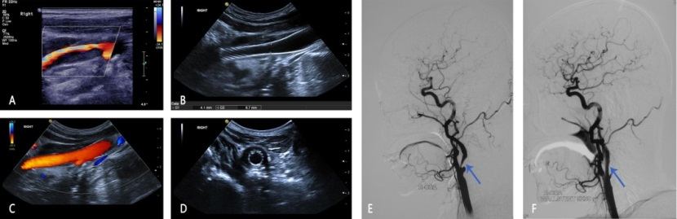
ObjectiveTo study the relevance between the incidence of residual stenosis and carotid artery stent (CAS) characteristics by color duplex flow imaging(CDFI) .Methods 572 cases (576 stents, open or closed-cell stents) who underwent CAS from January 2013 to December 2015 were retrospective enrolled in this study. The location of carotid stenosis (common carotid artery or internal carotid artery), characteristics of plaques (regular morphology or not; with calcification or not), the length of stent, types of carotid stent (closed or open cell), rate of stent expansion (ratio of radial expansion and axial expansion) were detected 1 month ago and 1 weekafterstenting by CDFI. Residual stenosis is defined asthe stenosis rateis equal toorgreater than
30% by DSA immediately after stenting.Results All of 576 stents, the incidence of residual stenosis was significantly higher in group of closed loop stent (28.3%, 46/163) than in group of open loop stent (20.4% ,84/413) (χ2=4.15,P=0.04).There were positive correlation between the occurrence rate of residual stenosis and closed-cell stent (odd ratios, 1.54; 95% confidence interval,1.02-2.23)and negative correlation with the radial expansion rate (odd ratios, 0.02; 95% confidence interval,0.01-0.06). The location of carotid stenosis and the lengths of stents were not affecting the incidence of residual stenosis. Irregularly shaped plaques (odd ratios, 9.72; 95% confidence interval, 5.65-16.76) and the plaques with calcification (odd ratios, 5.21; 95% confidence interval, 3.32-8.17)were the independent risk factors of residual stenosis after CAS. Conclusions This study suggest that choosing a more adaptable stent based on the types of stents and the characteristics of plaques and trying to increasing the radial expansion of stenting may further decrease incidence rates of residual stenosis.

Image

Figure 1: A: CDFI showed a severe(70-99%) stenosis at the proximal internal carotid artery; B&D: 2-D images of longitude view and cross-section view showed residual stenosis after CAS; C: CDFI showed the blood flow within the stent was smooth; E: DSA before CAS showed a severe stenosis at the proximal internal carotid artery (blue arrow);
F. DSA immediately after CAS showed a residual stenosis of the stent (blue arrow).

Recent Publications
1. Csobay-Novak C, Barany T, Zima E, et al. Role of stent selection in the incidence of persisting hemodynamic depression after carotid artery stenting [J]. J EndovascTher. 2015,22(1): 122-129.
2. Fujii K, Carlier SG, Mintz GS, et al. Stent underexpansion and residual reference segment stenosis are related to stent thrombosis after sirolimus-eluting stent implantation: an intravascular ultrasound study [J]. J Am CollCardiol. 2005,45(7): 995-998. 3. Tsutsumi M, Kodama T, Aikawa H, et al. Fragmentation of calcified plaque after carotid artery stenting in heavily calcified circumferential stenosis [J]. Neuroradiology. 2010,52(9): 831-836.
4. Itami H, Tokunaga K, Okuma Y, et al. Novel 3D-CT evaluation of carotid stent volume: greater chronological expansion of stents in patients with vulnerable plaques [J]. Neuroradiology. 2013,55(9): 1153-1160.
5. Katano H, Mase M, Nishikawa Y, et al. Surgical treatment for carotid stenosis with highly calcified palques. J Stroke Cerebrovasc Dis. 2014,23(1):148-154.
6.Misaki K, Uchiyama N, Mohri M, et al. Prediction of carotid artery in-stent restenosis by quantitative assessment of vulnerable plaque using computed tomography[J]. J Neurotadiol, 2016,43(1): 18-24

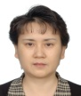Biography
Professor Yang Hua has worked in the field of vascular ultrasound for more than 30 years and has good expertise in carotid artery ultrasound, transcranial color-coded sonography (TCCS) and transcranial doppler(TCD). Her research focuses on the following areas: 1) Systemical evaluation of the vessel structures and hemodynamics in intracranial artery and extracranial artery by multiple-modes of ultrasound in patients with ischemic cerebrovascular diseases. 2) Evaluation of the vessel structures and hemodynamic alterations before and after carotid artery stenting and carotid endarterectomy, TCD blood flow monitoring during the operation of CEA. She and her study group also performed a series of studies in the risk factors for residual stenosis and restenosis after carotid artery stent and vertebral artery stent. She has published almost 200 articles in the above areas. She has gotten the honor of outstanding contributions to the China cerebrovascular ultrasound awarded by professor Aslid. Email: dryanghua99@163.com

