Insight into single-nucleotide polymorphisms of Toll-like receptors and the risk of abdominal aortic aneurysm formation
Agnieszka Jabłońska, Institute of Medical Biology of the Polish Academy of Sciences, Poland

Abstract
Statement of the problem: Toll-like receptors (TLRs) are a family of highly conserved, transmembrane proteins that recognize a wide spectrum of pathogen-associated molecular patterns (PAMPs) and activate innate immune response. It was recently shown that TLR2, TLR3, and TLR4 signaling contributes to abdominal aortic aneurysm (AAA) formation and development. However, there are no studies regarding the association between single nucleotide polymorphisms within TLR genes and the incidence of AAAs. The aim of this study was to determine the prevalence of TLR2, TLR3, and TLR4 polymorphisms, and investigate the relationship between these polymorphisms and AAA risk. Methodology & Theoretical Orientation: The presence of the seven TLR SNPs was studied using polymerase chain reaction-restriction fragment length polymorphism (PCR-RFLP), whereas a selected cytokine levels were quantified by enzyme-linked immunosorbent assays (ELISAs). Findings: The heterozygous genotype of the SNP rs121917864 of TLR2 was detected more frequently in patients with AAA and was associated with an almost six-fold increased risk of AAA (P < 0.001) and larger aneurysm size (P =0.037). In contrast, a relationship between the heterozygous CA genotype of TLR3 SNP rs3775296 and diminished risk of AAA formation and development was found (P < 0.001). Conclusion & Significance: The heterozygous genotype of TLR2 SNP rs121917864 may be a predictor of AAA formation, while TLR3 SNP rs3775296 seems to exert an independent protective effect. It is therefore essential to identify the host determinants of aneurysm formation in humans and understanding the role of the selected TLRs SNPs in the pathogenesis of AAA.

Image
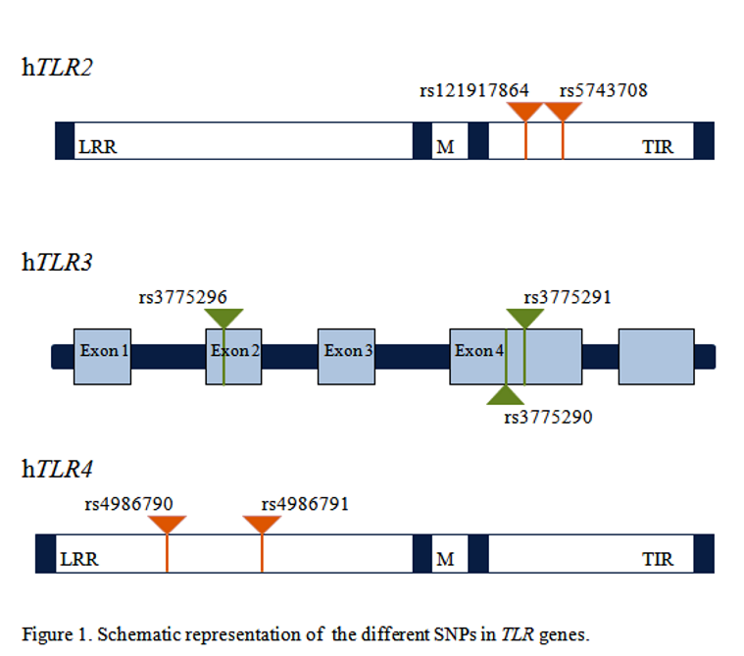
Figure 1: Schematic representation of the different SNPs in TLR genes.
Recent Publications (minimum 5)
- Lai CH, Wang KC, Lee FT, Tsai HW, Ma CY, Cheng TL, Chang BI, Yang YJ, Shi GY, Wu HL (2016) Toll-Like Receptor 4 Is Essential in the Development of Abdominal Aortic Aneurysm. PLoS One 11:e0146565.
- Vorkapic E, Lyrundberg AM, Mäyränpää MI, Eriksson P, Wågsäter D (2015) TRIF adaptor signaling is important in abdominal aortic aneurysm formation. Atherosclerosis 241:561-568.
- Yan H, Cui B, Zhang X, Fu X, Yan J, Wang X, Lv X, Chen Z, Hu Z (2015) Antagonism of toll-like receptor 2 attenuates the formation and progression of abdominal aortic aneurysm. Acta Pharm Sin B 5:176-187.
- Aoyama N, Suzuki J, Ogawa M, Watanabe R, Kobayashi N, Hanatani T, Ashigaki N, Sekinishu A, Izumi Y, Isobe M (2013) Toll-like receptor-2 plays a fundamental role in periodontal bacteria-accelerated abdominal aortic aneurysms. Circ J 77:1565-1573.
- Koch A, Pernow M, Barthuber C, Mersmann J, Zacharowski K, Grotemeyer D (2012) Systemic inflammation after aortic cross clamping is influenced by Toll-like receptor 2 preconditioning and deficiency. J Surg Res 178:833-841.

Biography
Agnieszka Jabłońska of the Institute of Medical Biology of the Polish Academy of Sciences has an experience in molecular virology. In her studies, she is aiming to understand the detailed molecular mechanism of viral infection and the host-pathogen interactions. Elucidation of biological significances of pattern-recognition receptors (PRRs) signaling pathways in which viruses are implicated is also one of her goals. Furthermore, she has tried to reveal the associations between the PRRs expression, single nucleotide polymorphism within TLR genes and the predisposition for abdominal aortic aneurysm development.

Email: ajablonska@cbm.pan.pl

Notes/Comments:

