Lack of transcriptional activity of Nrf2 affects TGFb1 expression and alters collagen I and III localization within mice aortic aneurysm
Aleksandra Piechota-Polanczyk¹, Ewa Werner^{1,2}, Karolina Hajduk¹, Aleksandra Kopacz¹, Damian Kloska¹, Anna Grochot-Przeczek¹, Ihor Huk³, Alicja Jozkowicz¹, ¹Department of Medical Biotechnology, Faculty of Biochemistry, Biophysics and Biotechnology, Jagiellonian University, ²Department of Animal Reproduction and Anatomy, Faculty of Animal Science, University of Agriculture Krakow, Poland; ³Department of Surgery, Div. Vascular Surgery, Medical University of Vienna, Austria

Abstract
Statement of the Problem: Nuclear factor (erythroid-derived 2)-like 2 (NRF2) is a global antioxidant gene inducer whose activity may regulate metabolism of extracellular matrix proteins including collagen. It was shown that human abdominal aortic aneurysm has increased deposition of collagen I and reduced of collagen III in tunica media and adventitia. The synthesis of collagen I is controlled by transforming growth factor beta 1 (TGFb1). Therefore, the purpose of this study was to describe localization of structural collagens within the aorta and aortic aneurysm in transcriptional knockouts of Nrf2 and to verify the mechanism behind those changes.
Methodology & Theoretical Orientation: We used a model of angiotensin II (Ang II)-induced abdominal aortic aneurysm in old adult mice (6 mo.) with transcriptional knockout of Nrf2 (Nrf2 -/-) and with normal activity of Nrf2 (Nrf2 +/+). Mice were administrated with Ang II (1000 ng/kg/min) or saline (sham group) for 28 days via osmotic minipumps placed subcutaneously. After 28 days tissue specimens were collected for immunofluorescence and analysis of gene expression.
Findings: Ang II-treatment caused a significant increase of collagen I mRNA expression in tunica adventitia and a strong increase of collagen III expression in tunica media. The observed upregulation of collagen type I and III was significantly higher in mice lacking transcriptional Nrf2. An increase in collagens was associated with significantly higher TGFb1 only in the Nrf2 -/- mice.
- Conclusion & Significance: Transcriptional factor Nrf2 may play a significant role in collagen deposition during abdominal aortic aneurysm formation and excessive collagen synthesis may be associated with TGFb1 activation in the Nrf2-/- mice.

Image
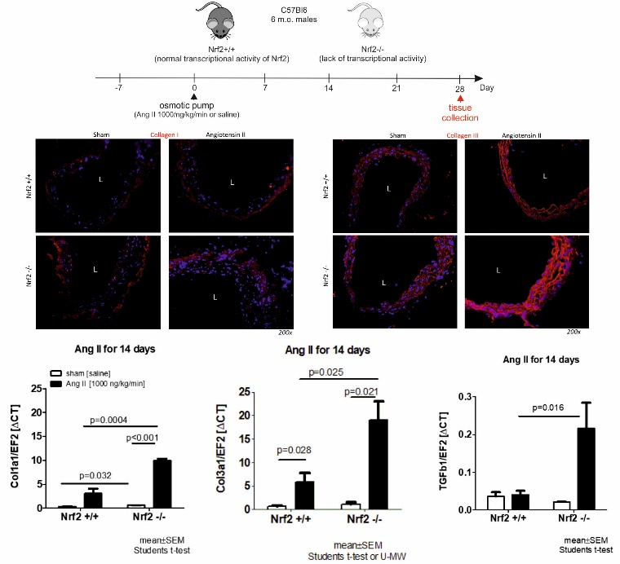
Altred localisation of collagen I and collagen III within the aortic aneurysm of transcriptional knockouts of Nrf2 mice. L-lumen.
Recent Publications
- Loboda (2017) Role of Nrf2/HO-1 system in development, oxidative stress response and diseases: an evolutionarily conserved mechanism. Cell Mol Life Sci 73(17): 3221-47
- Rodella (2016) Abdominal aortic aneurysm and histological, clinical, radiological correlation. Acta Histochem 118(3):256-62.
- Song (2015) Molecular hydrogen stabilizes atherosclerotic plaque in low-density lipoprotein receptor-knockout mice. Free Radic Biol Med 87:58-68.
- Fiaschi (2014) Hyperglycemia and angiotensin II cooperate to enhance collagen I deposition by cardiac fibroblasts through a ROS-STAT3-dependent mechanism. Biochim Biophys Acta 1843:2603-10.
- Florczyk (2014) Nrf2 regulates angiogenesis: effect on endothelial cells, bone marrow-derived proangiogenic cells and hind limb ischemia. Antioxid Redox Signal 20(11): 1693-708.

 Biography (150 word limit)
Dr. Piechota-Polanczyk is currently employed as an Associate Professor at the Department of Medical Biotechnology, at the Jagiellonian University in the frame of the project entitled “Role of heme oxygenase 1 in the development and progression of abdominal aortic aneurysm”. Dr Aleksandra Piechta-Polanczyk received her PhD in medicine with specialty of medical biology z in 2011. She was a leading researcher in Prof. Ihor Huk research group (VASLAB) at the Medical University of Vienna (Austria) with whom she is now cooperating. Her research interests focuses on finding of new anti-oxidative and anti-inflammatory proteins that could be potential markers and/or targets in treatment of gastrointestinal and cardiovascular diseases, as well as the role of Nrf2 and heme oxygenase 1 in cellular adaptation to oxidative stress and inflammatory reactions.
mail:piechota.aleksandra@gmail.com

Notes/Comments: Supported by the Fuga-IV program of the National Science Centre (DEC-2015/16/S/NZ4/00040 to APP).

