CASE REPORT
Iatrogenic Superior Mesenteric Arteriovenous Fistula
Josel Rey Aguelo, MD, FPATACSI, Department of Surgery, Davao Doctors Hospital
Frances Jeannifer R. Tongcos, M.D., Department of Surgery, Davao Doctors Hospital
ABSTRACT:
Superior Mesenteric arterio-venous fistula is an extremely rare complication and late complication of abdominal surgeries. We report as case of a 50 year old male, who presented with vague abdominal pain, 23 years after jejunal resection-anastomosis for Jejunal diverticulosis. A superior mesenteric arteriovenous fistula was detected on work up and treated surgically with excision of arteriovenous fistula. The patient had an uneventful recovery.

BACKGROUND:
Arteriovenous fistula between superior mesenteric artery and vein is a rare complication of injury to these vessels. As of 2008, there were only 40 reported cases in the English Literature. The development of these fistulas is commonly associated with trauma and iatrogenic injury. This complication can arise as early as few months after abdominal surgery or as late as several years after. Most patients with this fistula remain asymptomatic for long period of time but others may complain of weight loss, nausea, vomiting, abdominal pain, ascites, diarrhea, and signs of portal hypertension. Abdominal bruits that can be palpated in the periumbilical or epigastric region just left of the midline with systolic accentuation on auscultation is the most consistent physical finding.
CASE REPORT:
This is a case of a 50 year old male who underwent Exlap, resection-anastomosis of Jejunum for Jejunal Diverticulosis 23 years ago, with no complaints until 8 months prior to admission in which he complained of vague abdominal pain. At the time of examination, patients vital signs were within normal limits, abdomen was soft with no tenderness noted, presence of bruit at right periumbical area was appreciated. Ultrasound of whole abdomen was done and showed thinned walled aneurysm measuring 6.8 cm x 4.2 cm x 6.1 cm in the right abdomen but origin could not be ascertained with no noted leaks. On CT scan of whole abdomen, noted an arteriovenous fistula measuring 0.7cm bridging the inferior portion of the superior mesenteric artery and vein, with an
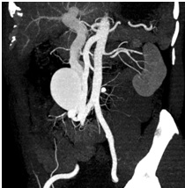
Figure 1: Sagittal CT image with contrast showing arteriovenous fistula (arrow) from superior mesenteric artery to vein with aneurysmal dilatation of the SMV.

identified dilatation at the superior mesenteric vein measuring 6.1cm x 5.4 cm x 4.6 cm approximately 5.5 cm from the splenoportal junction (Figure 1).
Routine hematologic and biochemical studies were done including liver function and coagulation tests which were are within normal limits.
Patient then underwent Exlap, Excision of superior mesenteric arteriovenous fistula, and adhesiolysis on January 2012. Intraoperatively noted an dilatation within the superior mesenteric vein 10cm x 5 cm in size with superior mesenteric arteriorvenous fistula just parallel to the previous anatomotic site, 90 cm from Ligament of Treitz and 120 cm from Ileocecal valve. The patient had an uneventful recovery and discharged in good condition on the fourth post-op day.
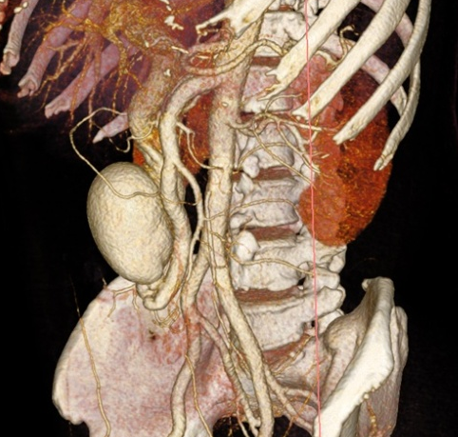
Figure 2: 3-dimensional reconstruction of the CT better demostrating the SMAVF (arrow) and aneurysmal dilation at SMV.

Repeat CT scan of whole abdomen taken six months after operation no longer showed the superior mesenteric arteriovenous fistula and dilatation at superior mesenteric vein (Figure 2).
DISCUSSION:
Superior mesenteric arteriovenous fistula (SMAVF) is extremely rare and most of these cases (50%) are iatrogenic¹ (from abdominal trauma, abdominal surgery following bowel resection and tumors of the small intestine).²⁻³ According to Xu et al (2006), previous history of bowel resection is the most common cause in 69% of the cases.⁴ Appearance of SMAVF can be as early as 3 days to as late as several decades after injury or surgery¹. Immediate SMAVF is described as recognition of the fistula within 24 hours after injury, early SMAVF between second to third day post- surgery, delayed SMAVF between second to sixth months post-surgery and late SMAVF (most common) is recognized after the sixth month post-surgery⁵. Overall mortality rate for SMAVF is 25% and due to high flow these fistulas may result to portal hypertension³.
According to Wong et al (2007), most SMAVF are asymptomatic but can present with abdominal pain, nausea, vomiting, weight loss and signs of portal hypertension (jaundice, ascites, upper gastrointestinal bleeding secondary to variceal bleeding, hepato- and splenomegaly). Presence of abdominal bruit appreciated at periumbilical or epigastric area is the most consistent finding in patients with SMAVF⁶.
The use of duplex scan can be the initial modality in assessing pathoanatomy and flow characteristic of the mesenteric vessel. Its main advantage is being non-invasive, can be repeated several times, both pre- and postoperatively⁷. Lau et al (2009), MDCT, is a non-invasive imaging modality and useful for prompt evaluation and accurate diagnosis of abdominal pathology.
Eiberg et al (2009), there are several options in treating SMAVF. The most commonly used is surgical excision of SMAVF^{1,9}, covered stent implantation¹⁰, coil embolization¹¹, and Amplatzer vascular plug (AVP)³.
In our patient, surgical excision of SMAVF was done by ligating connection from the artery and vein using ligaclips.
REFERENCES:
- Francois et al. SMAVF after Ileal Resection. Ann Vasc Surg 1992.6:370-372
- Eiberg, JP et al. Endovascular Repair of Iatrogenic Superior Mesenteric AVF. EJVES (2009) 17, 21-23
- Lau KY et al Emergency transcatheter embolisation of SMAVF complicated by recurrent hematemesis.Singapore Med J. (2009); 50:e1
- Xu C.E. et al. A Rare case of Superior Mesenteric AVF causing jejunal varices And recurrent GI bleed. EJVES Extra 1(2006) 2. 35-37
- Vedran R et al. Advances in Diagnostics and Successful Repair of post-traumatic SMAVF.J ournal of Trauma:Injury, Infection, Critical care(1995), 305-312
- Wong et al. SMAVF: An unusual cause of ascites. J HK Coll Radiol.2007; 10;77-80
- Vedran R et al. Advances in Diagnostics and Successful Repair of post-traumatic SMAVF.J ournal of Trauma:Injury, Infection, Critical care(1995), 305-312
- Van Way CW 3rd, Crane JM, Riddell DH, Foster JH. Arteriovenous fistula in the portal circulation. Surgery 1971, 70:876-90
- Kato S, Nakagawa T, Kobayashi H, Arai E. Superior mesenteric arteriovenous fistula: report of a case and review of the literature. Surg Today 1993;23:73e7.
- Chun-gen W, Yong-Dong L, Ming-Hua L. Post-traumatic superior mesenteric arteriovenous fistula: Endovascular treatment with a covered stent. J. Vascular Surgery. (2008) 47: 654-656.
- de Gregorio MA, Gimeno MJ, Medrano J, Schonholz C, Rodriguez J, D’Agostino H. Ileocolic arteriovenous fistula with superior mesenteric vein aneurysm: endovascular treatment. Cardiovasc Intervent Radiol 2004;27:556e9
A
B

