Rare novel CYP2U1 and ZFYVE26 variants identified in two Pakistani families with spastic paraplegia.

FARAH BIBI, PhD, PMAS Arid Agriculture University, PAKISTAN
Dr GHAZALA KAUKAB RAJA, PMAS Arid Agriculture University, PAKISTAN
Dr HENRY HOULDEN, UNIVERSITY COLLEGE LONDON, UK

Abstract
Hereditary Spastic paraplegias (HSPs) are a clinically and genetically heterogeneous group of degenerative disorders characterized by progressive spasticity and weakness of the lower limbs. They are caused by genetic defects that primarily affect the upper motor neurons in the brain and spinal cord, disrupting the normal transmission of neuronal signals to muscles and often associate degeneration of the pyramidal tracts, mainly resulting mainly in progressive spasticity of the lower limbs and walking difficulties. This study aimed to identify causative gene variants in two unrelated consanguineous Pakistani families presented with two different forms of HSP. Whole exome sequencing (WES) was performed in the two families and variants were validated by Sanger sequencing and segregation analysis. In family A, a homozygous pathogenic variant in ZFYVE26 was identified in one family. While in family B, a frameshift variant in CYP2U1 was identified in 4 affected individuals presented with clinical features of SPG56. Our study is the first report of ZFYVE26 mutations causing HSP in the Pakistani population and the second report of CYP2U1 in a Pakistani family. Our finding indicates that founder ZFYVE26 mutations could also be present in the South Asian-Punjab area, resulting in a more worldwide distribution of SPG15. This highlights the importance of considering SPG15 as a possible diagnosis of AR HSP, irrespectively of the individuals’ ethnic background. Our findings enhance the clinical and genetic variability associated with two rare autosomal recessive HSP genes, highlighting the complexity of HSPs. These findings further emphasize the usefulness of WES as a powerful diagnostic tool.

Image

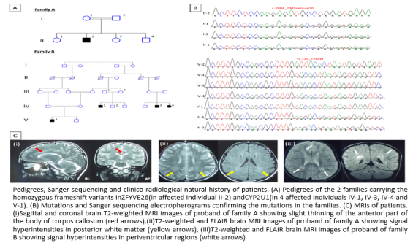

Recent Publications
- Vantaggiato, C., Panzeri, E., Castelli, M., Citterio, A., Arnoldi, A., Santorelli, F. M., ... & Clementi, E. (2019). ZFYVE26/SPASTIZIN and SPG11/SPATACSIN mutations in hereditary spastic paraplegia types AR-SPG15 and AR-SPG11 have different effects on autophagy and endocytosis. Autophagy, 15(1): 34-57.
- Zulfiqar, S., Tariq, M., Ali, Z., Fatima, A., Klar, J., Abdullah, U., ... & Khan, A. (2019). Whole exome sequencing identifies novel variant underlying hereditary spastic paraplegia in consanguineous Pakistani families. Journal of Clinical Neuroscience, 67: 19-23.
- Denton, K. R., Xu, C., Shah, H., & Li, X. J. (2016). Modeling axonal defects in hereditary spastic paraplegia with human pluripotent stem cells. Frontiers in biology, 11(5), 339-354.
- Masciullo, M., Tessa, A., Perazza, S., Santorelli, F. M., Perna, A., & Silvestri, G. (2016). Hereditary spastic paraplegia: novel mutations and expansion of the phenotype variability in SPG56. european journal of paediatric neurology, 20(3), 444-448.
- Kariminejad, A., Schöls, L., Schüle, R., Tonekaboni, S. H., Abolhassani, A., Fadaee, M., ... & Gleeson, J. G. (2016). CYP2U1 mutations in two Iranian patients with activity induced dystonia, motor regression and spastic paraplegia. European Journal of Paediatric Neurology, 20(5), 782-787.

Photograph

Biography
Dr has her expertise in evaluation and passion in improving the health and wellbeing. She is carrying out a research programme of genetic and pathological investigations into human neurodegeneration. These genetic and neuropathological studies integrating functional in vitro research will translate this research into disease modifying treatment for human diseases.
.
Email: farah.bibi88@gmail.com

Notes/Comments:

