Hands on – Contrast Enhanced Ultrasound (CEUS) technique for Carotid Artery Disease
Dr Fatima El Hajj, MD, AnaliaMed H&W, Brazil

Workshop

Doppler ultrasonography (US) is a non-invasive, low-cost method of screening carotid stenosis. With the incessant progress of diagnostic methods, Doppler ultrasonography (US) has proven to be a method of choice for non invasive evaluation of the carotid arteries.

CEUS technique – Contrast Enhanced Ultrasound is a modern feature to differentiation between carotid occlusion x suboccusion and identification of lesion neovascularization (unstable board markle).

Practice Workshop: hands on in CEUS technique for Carotid Artery Disease.

Image
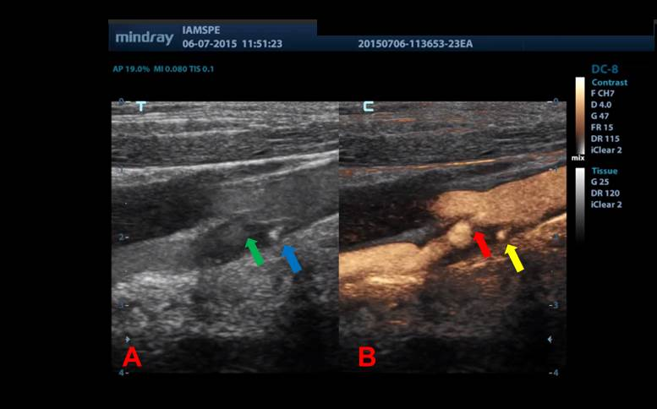
Diagnostic Complementation with CEUS technique

Recent Publications
- Mohamad El Hajj, F.; Neiva Marcia Pereira Jacques; Percutaneous arterial embolization in the treatment of bleeding. State-of-the-art. 2013 Medical Residency Committee of the Municipal Public Server Hospital of São Paulo – HSPM.
- Brunno Cezar Framil Sanchez; Lineu Amaro Rodrigues Junior; Felipe Trentin Neves; Thiago Correa Tambelli; Fernando Eduardo Paulatti Frederico; Fatima Mohamad El Hajj; Juliana Monteiro de Abreu; Tatiana Milunovic Lobo Rosa; Alexis Iury Framil Sanches; Antônio Alberto Ramos Argento. Giant condyloma. Journal of the Faculty of Medical Sciences of Sorocaba (Printed), v.13, p.25-27, 2011. ISSN 1984-4840.3
- Mohamad El Hajj, F; Neiva Marcia Pereira Jacques Percutaneous arterial embolization in the treatment of refractory digestive hemorrhage in a patient with von Willenbrand disease. Case report. 40th Brazilian Congress of Angiology and Vascular Surgery.
- Mohamad El Hajj, F.; Clariana Casali Rodrigues Fernandes; Andréia Esteves de Lima; Diego Caetano da Silva Varella; Fábio Yamada; Neiva Marcia Pereira Jacques Percutaneous arterial embolization of renal artery intraparenchymal aneurysm in single kidney. Case report.2013. 40th Brazilian Congress of Angiology and Vascular Surgery.
- Mohamad El Hajj, F . Carotid endarterectomy can only be indicated by Doppler ultrasonography?, 2015. 41th Brazilian Congress of Angiology and Vascular Surgery.

Photograph

Biography
Brazilian – Lebanese Vascular Surgeon. MD in Pontifical Catholic University of São Paulo – PUCSP. General Surgery degree in Municipal Public Server Hospital of São Paulo – HSPM. Vascular Surgery Degree in Estadual Public Server of São Paulo – IAMSPE. Vascular Surgeon at AnaliaMed Health and Wellness. CEO AnaliaMed Diagnose Center.

Email: fatimamedlv@hotmail.com

