Case report

Stenting Angulated Aortic Aneurysm Neck before Endovascular Aortic Repair : a case report
Mohamed El-Farok*, Karem Abdeltawab
Address: General Organization of Teaching Hospitals and Institutes , Cairo , Egypt
Email: Mohamed El-Farok* - helliopolis@gmail.com ;
* Corresponding author
Prof Karem Abdeltawab , Professor of Radiology Ain Shams University

WHAT THIS PAPER ADDS

. To the best of my knowledge this is the first time to report a prophylactic self expandable nitinol stent in severe angulated neck for remodeling , Palmaz and Ev3 Max balloon expandable stents has been reported before but not self expandable one (1) , We think this technique lower the aortic neck angulation and decrease the secondary intervention rate in short term results

Abstract

Background: The angulation of the proximal aneurysm neck is considered one of the most important morphologic characteristics with major negative effects on the results of EVAR, including type I endoleaks
Case presentation: we present an 81 Year old man with 65 infrarenal AAA ,with severe angulated neck where a self expandable nitinol stent E-XL was used to remodel the proximal neck and E-Vita Device was deployed after the angle has immediately reduced

Conclusion: this case report demonstrate the value of prophylactic self expandable stent in severely angulated neck to modulate the aorta before deployment of EVAR device ,which can be used in similar situations

Introduction
Increasing number of patients with angulated abdominal aortic aneurysm (AAA) neck are being treated with endovascular aneurysm repair (EVAR). And more patients with unsuitable or high risk anatomy defined in the instructions for use (IFU) for endografts are being referred to centers with high volume (2) . In this case report , we discuss specific problems that can be encountered during preoperative planning in relation to periprocedural stent graft deployment in patients with angulated AAA necks and offer potential solutions for these problems . The aorta can angulate in several directions (dimensions)
simultaneously. Two neck angles are evaluated in
the preoperative evaluation. Suprarenal neck angulation refers to an angle measured between the long axis of the immediate suprarenal aorta and the infrarenal aorta (α.) .The second angle is aortic neck angulation which measured between the long axis of the infrarenal neck to the long axis of the AAA ( β.).

Case presentation
An 81 year old man presented to his general practitioner with chronic lower back pain. , and pulsatile abdominal mass , patient referred to vascular clinic and a diagnosis of AAA was made , Risk factors include Diabetes , hypertension and dysliaedemia , CT scan was done which showed 65 mm AAA infrarenal by 15 mm with a severely angled aortic neck as show in fig 1 . The alpha angle was 89 Degree and the Betal angle was 90 Degree .
We planned to deploy self expandable nitinol aortic stent E-XL at the angled neck before the Device to remodel the proximal aorta and then to deploy the device from bilateral femoral cutdowns . We have found that both angles have decrease by 15% as shown in Fig 2 , patient discharged 3 days later with no endoleak .
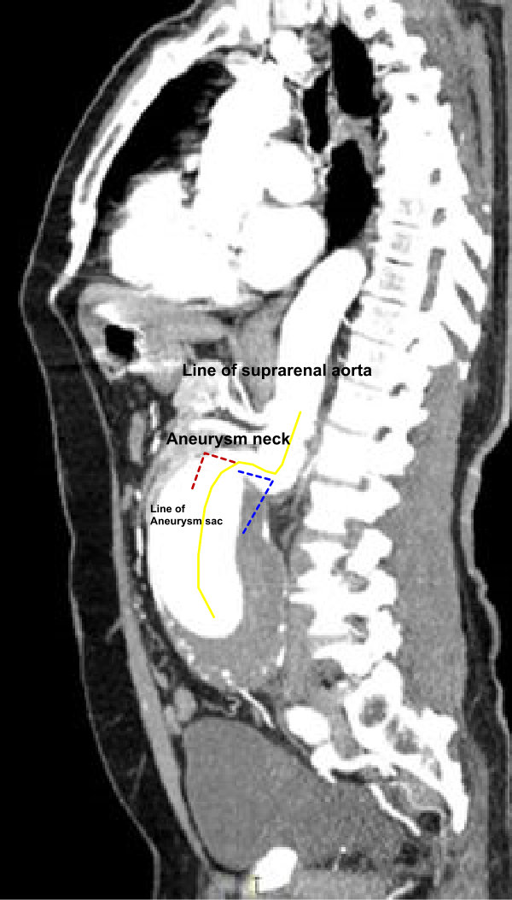
Figure 1oelns demonstrating the dissection at the level of the CT scans demonstrating the two angels of the aortic neck . angle α in blue and of 89 Degree and angle β of 90 Degree in red , yellow line is the center lumen line .

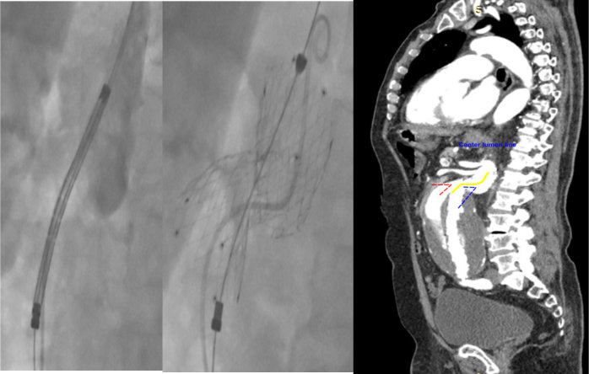
C
B
A
Fig 2 , Intraoperative image of the case , A E-XL stent before deployment , B After deployment , C, CT angiogram after E vita deployment

Discussion
Strangely enough, there is currently no consensus on how to measure and quantify the aortic neck angulation exactly. We have used the commonest one of two aortic angles Alpha and Beta , the transrenal E-XL stent was preferred to the giant Palmaz stent because of the need to remodel a long section of the abdominal aorta and the presence of severe angulation. The E-XL stent has enhanced flexibility because of its hybrid nitinol configuration (open cell in the middle, closed at the two edges, with a constant outward radial force of 0.4 N/mm along the length of the device).

In contrast, the shorter closed-cell stainless-steel Palmaz stent does not have an outward radial force and should be positioned along the axis of the infrarenal aortic seal zone to correct and improve the orientation of the proximal aspect of the stent-graft, creating more graft-to-aorta contact.(3,4,5)

Self-expanding stent-grafts continue to expand with the degenerating aorta in one third of patients (6) and a recent paper (7) has reported a loss of apposition of the Palmaz stent to the stent-graft and a loss of proximal seal zone (>5 mm) in 35% of patients because of this neck enlargement. On the contrary, as the E-XL stent has a proper outward radial force, it should constantly accommodate the neck enlargement, guaranteeing good graft apposition and sealing.

There are other important steps in dealing with angulated neck as the C arm position , the use of superstiff wire to straighten the angulations and the through and through wire technique

Conclusion :
The use of self expandable E-XL stent in severely angulated necks before EVAR offer an advantage in lowering the aortic angle to around 15 % less and decrease the secondary interventions in these cases .

Competing interests
The author(s) declare that they have no competing interests.

Authors' contributions
The original idea was that of Dr.Mohamed Elfarok and Dr.Amr Fathey (consultant in charge of the case). The manuscript was written Dr.Andrew Choong and revised by Prof. Peter Brennan .

Consent
The authors confirm that written informed consent was obtained from the patient for publication of the manuscript.

-NB , The angiographic run of the case can be watched on the internet on the following linc https://www.youtube.com/watch?v=ZB3KE3HOD2U&feature=youtu.be

References
1- Daniel E. Cox, MD, Donald L. Jacobs, MD, Raghunandan , Outcomes of Endovascular AAA Repair in Patients with Hostile Neck Anatomy Using Adjunctive Balloon-Expandable Stents, Vascular and Endovascular Surgery Volume 40, Number 1, 2006
2. Prinssen M, Verhoeven EL, Buth J, Cuypers PW, van Sambeek MR,
Balm R, et al. A randomized trial comparing conventional and endovascular
repair of abdominal aortic aneurysms. N Engl J Med 2004;351:
1607-18.
3. Farley SM, Rigberg D, Jimenez JC, Moore W, Quinones-Baldrich W.
A retrospective review of Palmaz stenting of the aortic neck for
endovascular aneurysm repair. Ann Vasc Surg 2011;25:735-9.

4. Arthurs ZM, Lyden SP, Rajani RR, Eagleton MJ, Clair DG. Long-term
outcomes of Palmaz stent placement for intraoperative type Ia endoleak
during endovascular aneurysm repair. Ann Vasc Surg 2011;25:
120-6.

5. Rajani RR, Arthurs ZM, Srivastava SD, Lyden SP, Clair DG,
Eagleton MJ. Repairing immediate proximal endoleaks during
abdominal aortic aneurysm repair. J Vasc Surg 2011;53:1174-7.
6. Cao P, Verzini F, Parlani G, Rango PD, Parente B, Giordano G,
et al. Predictive factors and clinical consequences of proximal neck
dilatation in 230 patients undergoing abdominal aorta aneurysm
repair with self-expandable stent grafts. J Vasc Surg 2003;37:
1200-5
7. Arthurs ZM, Lyden SP, Rajani RR, Eagleton MJ, Clair DG. Long-term
outcomes of Palmaz stent placement for intraoperative type Ia endoleak
during endovascular aneurysm repair. Ann Vasc Surg 2011;25:
120-6.

