Imaging and analysis of the Vascular System of mice by Intravascular contrast in microCT

Riedlová Jitka¹, Mrzílková Jana¹, Michenka Petr¹, Patzelt Matěj¹, Šeremeta Martin^{1,3}, Křemen Jan¹, Musil Vladimír², Dudák Jan⁴, Žemlička Jan⁴, Zach Petr¹

¹Departement of Anatomy, Third Faculty of Medicine, Charles University, Prague
²Centre of Scientific Information, Third Faculty of Medicine, Charles University, Prague
³Centre of Nuclear Medicine, Ltd., Prague
⁴Institute of Theoretical and Experimental Physics, Czech Technical University, Prague

Abstract
Introduction
CT scanner Bruker 1275 can detect and visualise samples with resolution up to 5 μm when using various X-ray substances. Vascular system visualisation is using in general iodine intravascular contrast or metals nanoparticles. Anatomical investigation of the vascular network, with the high extravasation levels of iomeprol can be exploited for perfusion analysis even in in-vivo condition (Zambrano et al., 2019). Lumen areas of the common carotid arteries (CCA) in the ApoE-/- partial carotid artery ligation mouse model was documented in Schürmann et al., 2015. For spinal cord myelogram was shown effective using contrast-enhanced digital subtraction protocols (Nebuloni et al., 2013).
Materials and methods
Experiment was done on experimental male mice (strain C57BL/6J) routinely used in basic research. Experimental animals were overdosed with ether anesthesia. Then they were injected into the tail vein with intravascular matter Aurovist 15 nm nanoparticles of Aurum. This way was stained whole vascular system of the mouse. Then was performed analysis of parenchymatous organs according to their blood supply. The lungs, liver and kidneys were analysed by CT Analyser software suit by Bruker. Experienced anatomists then performed manual delineation of blood supply of these organs. In the software envirnoment we were able to analyse blood vessels caliber, diameter, space orientation and the length of separate vessels and percentage of their appearance in organs. This way we estimated metabolic activity of organs.
Discussion
Analysis of the heart was not successful because Aurovist accumulated in the heart’s atrias (Kolesová et al., 2018). This caused the distortion of vessels diameter and percentage of their appearance. This work may help in detection of tumors blood supply and/or other malformations.

Image
Kidney Trabecular thickness distribution
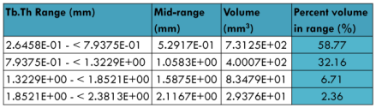
Standard deviation of trabecular thickness, SD(Tb.Th) 3.8347E-01mm
Lunas Trabecular thickness distribution
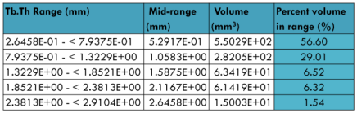
Standard deviation of trabecular thickness, SD(Tb.Th) 5.0623E-01mm
Liver Trabecular thickness distribution
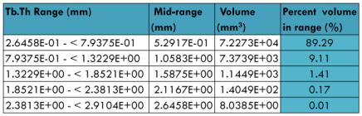
Standard deviation of trabecular thickness, SD(Tb.Th) 2.0445E-01 mm
Recent Publications
- Nebuloni L, Kuhn GA, Müller R (2013) A comparative analysis of water-soluble and blood-pool contrast agents for in vivo vascular imaging with micro-CT. Acad Radiol 20:1247-55.
- Schürmann C, Gremse F, Jo H, Kiessling F, Brandes RP (2015) Micro-CT Technique Is Well Suited for Documentation of Remodeling Processes in Murine Carotid Arteries. PLoS One 10:e0130374.
- Zambrano-Rodríguez PC, Bolaños-Puchet S, Reyes-Alva HJ, García-Orozco LE, Romero-Piña ME, Martinez-Cruz A, Guízar-Sahagún G, Medina LA (2019) Micro-CT myelography using contrast-enhanced digital subtraction: feasibility and initial results in healthy rats. Neuroradiology 61:323-330.
- Kolesová H, Bartoš M, Hsieh WC, Olejníčková V, Sedmera D (2018). Novel approaches to study coronary vasculature development in mice. Dev Dyn 247:1018-1027.
- Epah J, Pálfi K, Dienst FL, Malacarne PF, Bremer R, Salamon M, Kumar S, Jo H, Schürmann C, Brandes RP (2018). 3D Imaging and Quantitative Analysis of Vascular Networks: A Comparison of Ultramicroscopy and Micro-Computed Tomography. Theranostics 8:2117-2133.

Photograph

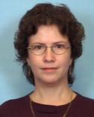 Biography
Jitka Riedlova RNDr., Ph.D. Dr. is anthropologist working at the Institute of Anatomy, Third Faculty of Medicine, Charles University. She is focused on micro CT imaging of soft tissues, especially vasculate and blood supply of visceral organs.

Email: jitka.riedlova@lf3.cuni.cz

Notes/Comments:

