Usefulness of the platelet-to-lymphocyte ratio in predicting long-term cardiovascular mortality in patients with peripheral arterial occlusive disease
Fatih Uzun¹, Anil Sahin¹, Mehmet Erturk¹, Huseyin Altug Cakmak², Ali Kemal Kalkan¹, Ibrahim Faruk Akturk¹, Ahmet Arif Yalcin¹, Begum Uygur¹, Umit Bulut¹, Kursat Oz¹
¹ Istanbul Mehmet Akif Ersoy Thoracic and Cardiovascular Surgery Training and Research Hospital, Istanbul, Turkey
² Mustafakemalpasa State Hospital, Bursa, Turkey

Abstract
Introduction: Inflammation and increased platelet activation play a crucial role in the initiation and progression of atherosclero- sis. Platelet-to-lymphocyte ratio (PLR) has recently been reported as a new independent predictor for major adverse cardiovascular events in cardiovascular diseases. Aim: To investigate the relation between PLR and cardiovascular mortality in patients with intermittent claudication or critical limb ischemia (CLI) or both. Material and methods: In our retrospective study, 602 consecutive patients who were admitted to a large tertiary hospital with the diagnosis of symptomatic peripheral arterial occlusive disease (PAOD) were included. Patients were divided into two groups according to their PLR as follows: high PLR (PLR > 142) and low PLR (PLR ≤ 142) groups. Results: During the follow-up period (median: 33.8 months (interquartile range: 21–45)), 131 deaths occurred out of 602 (21.8%) patients. Cardiovascular mortality was found to be significantly higher in the high PLR group compared to the low PLR group (31.6% vs. 17.2 %; p < 0.001). Even after adjustment for various risk factors, PLR > 142 and age were found to be independent pre- dictors of long-term cardiovascular mortality in Cox regression analysis (hazard ratios (95% confidence interval): 1.03 (1.01–1.04) and 1.04 (1.02–1.06), p < 0.001 and p < 0.001, respectively). Conclusions: Platelet-to-lymphocyte ratio, which is one of the parameters of routine complete blood count, reflects increased inflammatory status, platelet activation and aggregation. PLR is a cheap and readily available marker that has the ability to improve risk stratification provided by conventional risk scores in predicting long-term cardiovascular mortality in PAOD.

Biography
Dr. Uzun has experience in evaluation and passion in improving the cardiovascular diseases. He is highly experienced in interventional cardiology and atherosclerotic vascular diseases. He has built this experience in years of training in cardiovascular diseases and interventional cardiology and shared his knowledge in research, evaluation, teaching and administration both in hospital and educational institutions. He is also a member of Turkish Society of Cardiology and European Society of Cardiology. He has active participation in researches and clinical experiences. His special field of interest includes, coronary interventions, especially chronic total occlusions, peripheral artery diseases, structural heart diseases.
Email: fatihuzun28@gmail.com

Image
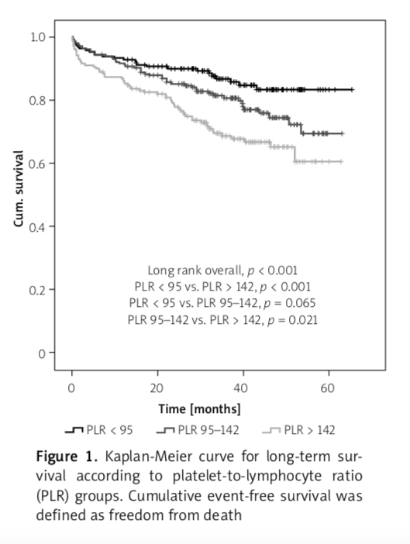
Recent Publications (minimum 5)
- Zencirkiran Agus H, Kahraman S, Arslan C, Babur Guler G, Kalkan AK, Panc C, Uzun F, Erturk M, Yildiz M. Characterization, epidemiological profile and risk factors for clinical outcome of infective endocarditis from a tertiary care centre in Turkey. Infect Dis (Lond). 2019 Jul 31:1-7. doi: 10.1080/23744235.2019.1646431.
- Kalkan AK, Cakmak HA, Erturk M, Kalkan KE, Uzun F, Tasbulak O, Diker VO, Aydin S, Celik A. Adropin and Irisin in Patients with Cardiac Cachexia. Arq Bras Cardiol. 2018 Jul;111(1):39-47. doi: 10.5935/abc.20180109.
- Uzun F, Biyik I, Akturk IF, Yalcin AA, Erturk M, Oner E, Kalkan AK, Yalcin B, Atmaca H. Serum copeptin levels in predicting nondippers in newly diagnosed hypertension. Blood Press Monit. 2015 Aug;20(4):199-203. doi: 10.1097/MBP.0000000000000123.
- Uzun F, Biyik I, Akturk IF, Erturk M, Yalcin AA, Surgit O, Oner E, Pusuroglu H, Birand A. Antiplatelet resistance and the role of associated variables in stable patients treated with stenting. Postepy Kardiol Interwencyjnej. 2015;11(1):19-25. doi: 10.5114/pwki.2015.49180.
- Surgit O, Erturk M, Akgul O, Pusuroglu H, Korkmaz AF, Isiksacan N, Gul M, Uzun F, Ozal E, Eksik A. Assessment of mean platelet volume and soluble CD40 ligand levels in patients with non-dipper hypertension, dippers and normotensives. Clin Exp Hypertens. 2015;37(1):70-4. doi: 10.3109/10641963.2014.897725.

Notes/Comments:

