Stabilizing Gas Lift Systems by Reducing initial Gas Bubble Sizes

6th International Conference on Petroleum Engineering
June 29-30, 2017 Madrid, Spain

Abstract— During oil production, gas lift methods can be affected by two-phase (gas and liquid) flow instability within the production tubing. This problem is caused by two main phenomena; the casing heading pressure and the flow perturbation due to the development of the flow regimes and its density wave oscillation. This paper presents a novel technique reduces gas bubbles sizes, pressure drop long pipe and flow instability. A laboratory-scale two-phase flow experiment was designed and built to investigate the effects of flow perturbation and flow instability. The rig consisted of a 2 m long by 66 mm ID transparent PVC pipe, with an air injection point situated at 0.1 m above the base of the test section. The generated air bubbles within the two-phase flow were captured using a digital camera and the images were analysed using an image processing package to obtain bubbles velocities, sizes and number long the test pipe. A novel air injection technique was then developed that reduced the overall bubbles sizes. As a result of this, the overall average air bubbles sizes were reduced by 22%, the big bubbles (Taylor bubbles) by 8.22% .In addition, the number of small bubbles was increased significantly and well the distributed in the whole pipe area even near to the pipe wall (wall peaking), instead of (core peaking) the centre of the pipe. In comparison to (sharp edge) normal orifice gas lift valve with the same port size area and operating conditions, and also the lifting performance (production rate) was increased by 7.5%.

Keywords — Gas lift flow instability, reducing bubble sizes, minimising pressure drop, image processing (shadow sizing).
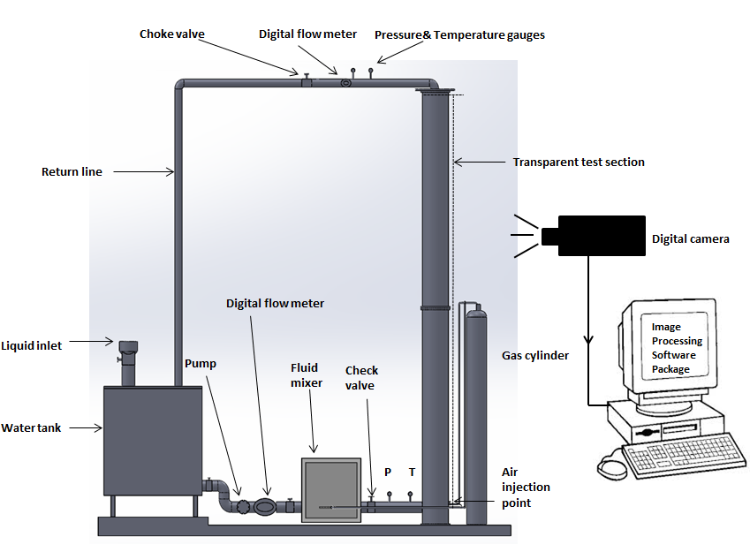
Figure: Schematic diagram of experiment

- Alhanati, F. J. S., Schmidt, Z., Doty, D. R. & Lagerlef, D. D. 1993. Continuous Gas-Lift Instability: Diagnosis, Criteria, and Solutions. Society of Petroleum Engineers
- Asheim, H. 1988. Criteria for Gas-Lift Stability
- Faustinelli, J., Cuauro, A. & Bermúdez, G. 1999. A Solution to Instability Problems in Continuous Gas-Lift Wells Offshore Lake Maracaibo. Society of Petroleum Engineers.
4. Hu, B. 2005. Characterization of gas-lift instabilities. PhD Thesis, Norwegian University of Science and Technology.
5. Bordalo, S. N. & Gaspari, E. F. 1997. Stability Parameter for Two-Phase Vertical Annular Flow. Society of Petroleum Engineers.


Khalid.M.O.Elmabrok, M.L.Burby and G.G. Nasr .School of Computing, Science and Engineering ,Petroleum and Gas Engineering Department, Petroleum Technology Research Group (PTRG), University of Salford, Manchester. United Kingdom, M5 4WT. Phone: 00447460286674 ; email:k.m.o.elmabrok.@edu.salford.ac.uk

Notes/Comments:

