Situation Case Analysis Of Diphtheria In Jakarta
Verry Adrian ; Inggariwati ; Laili Nur Hidayati ; Etrina Eriawati ; Widyastuti
Jakarta Provincial Department of Health

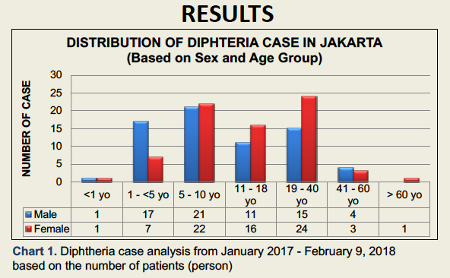
Abstract
Diphtheria is an infectious disease caused by infections of Corynebacterium diphtheriae. Diphtheria is still endemic in Indonesia with 342 cases reported in 2016 just lower than India and Madagascar with 3380 and 2865 cases respectively. In 2017, a surge of diphtheria cases happened in the country with 591 cases reported from January to November across 20 provinces and 95 districts. Jakarta is one of the provinces undergoing the surge of diphtheria cases. During the period of 2014-2016, there were only 31 reported cases in Jakarta province. Until the end of 2017, there were 120 reported cases of diphtheria with 17 of them were laboratory confirmed. There were 23 new cases reported since the turn of the year until the end of the first week of February 2018. We found that the disease spread across the 5 out of 6 districts (only Thousand Island district reporting zero cases), and 39 out of 44 sub-districts. The disease affected people of all age with children in the 5-10 year old age group and adults in 19-40 year old group contributing the majority of the cases with 43 and 39 cases respectively. Overall, there is no significant difference in total number of cases between men and women. The majority of the cases (45%) were found to have received complete basic three-course of DPT immunization during their first year of life even though the proportion of those with unknown basic immunization status is also quite high (39%). The proportion of cases who received booster vaccination is 12%. 22% of the cases did not receive any booster vaccination while the other 66% have unknown booster vaccination status.

Image

Recent Publications
- Adrian, V; Eriawati E ; Widyastuti (2018); "Situation Case Analysis of Thypoid in Jakarta".
- Margaretha Febriany, L; Ayu Anggreni, L; Adrian, V; et all (2018). "Disease Prevention and Control to make Jakarta Free from Cervical Cancer".
- Adrian, V. (2013). “Elimination of Malnutrition through Therapeutic Feeding Center (TFC)".
- Adrian, V. (2012). “To Actualize a Safe and Convenient Jakarta through Elimination of Malaria”.
- Latief, A; Adrian, V; Hapsari, A; et all (2001). “Effect of Kapok Leaf Extract Against Vesicolithiasis In Wistar Rats".

Photograph


Biography
Verry Adrian was born in Jakarta, Indonesia, in 1980. He received the MD degree in Medical Faculty from University of Sebelas Maret Surakarta, Indonesia, in 2005. Nearly 5 years he worked in private hospitals, until in 2010 he joined the Jakarta Provincial Department of Health. He received award as Most Honorable Doctor in 2013 for his work in Malaria Migration Surveillance and Jakarta Provincial Government received Malaria Elimination Certificate from WHO in 2014. After getting the award, He now responsible as Surveillance Epidemiology Officers for Infectious diseases and Immunization Program Manager for Jakarta Provincial Department of Health.

Email: dr.verry@gmail.com

Notes/Comments:

