Cold chain failure stability and immunogenicity studies of a live veterinary vaccine
GUKTUR, RE Pharm, University of Jos/NVRI, Nigeria
DR NEP, EI PhD, University of Jos, Nigeria
DR ASALA, O PhD, NVRI Vom, Nigeria
DR OLORUNFEMI, PO PhD, University of Jos, Nigeria
PROF NGWULUKA, NC PhD, University of Jos, Nigeria
PROF OCHEKPE, NA PhD, University of Jos, Nigeria
PROF SAGAY, AS PhD, University of Jos, Nigeria

Abstract
Statement of the Problem: Veterinary vaccine production in Nigeria is dependent on importation of excipients. This is costly and a challenge to achieving production targets that meet vaccine demand. Despite the stabilizers currently in use for vaccine production, vaccines still require storage at prescribed cold chain conditions from manufacture to administration. Once vaccines leave the custody of the manufacturer, adherence to cold chain requirements right to the point of administration is not certain. This results in a reduction or loss of potency of the vaccines, culminating in immunization failure post-administration and massive loss of animals and poultry. Inconsistency in power supply at the levels of the distributors and providers, poor maintenance of the cold chain, inadequate equipment, poor personnel management, etc. result in cold chain failure and vaccine wastage. The purpose of this study is to evaluate the stability of live Newcastle Disease (LaSota) vaccines stabilized with modified starch in cold chain failure and their immunogenicity in vaccine naïve broilers in comparison to peptone. Methodology & Theoretical Orientation: Carboxymethylated and acetylated xerogel derivatives of starch extracted from tubers of Plectranthus esculentus were assessed as freeze-dried Newcastle Disease (ND) LaSota vaccine stabilizers. Their efficiency (in comparison with peptone) when exposed to cold chain compliance (one month at 5±2°C) followed by failure (96 hours at 37±1°C) was assessed using the mean embryo infective dose (EID50) titration as the stability-indicator. Their immunogenicity (HI>2³) was evaluated in broilers using haemagglutination inhibition (HI) titration. Findings: Cold chain failure affected peptone stabilized vaccines (1.2 LogEID50 loss) significantly more than the starch stabilized vaccines (0.2-0.4 LogEID50 loss). The vaccines evoked immune responses (HI > 2³) in vaccinates devoid of maternally derived antibodies. Conclusion & Significance: These starch derivatives have promise as vaccine stabilizers in situations where there is a breach in the cold chain.
Image
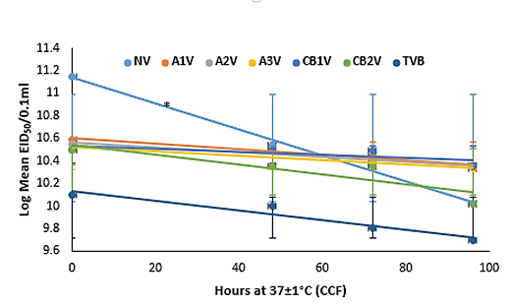
Figure 1: Stability profile of peptone (NV) and starch (A1-3V, CB1-2V) stabilized vaccines in cold chain failure (CCF)

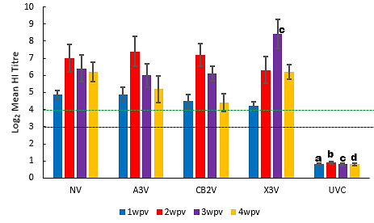
Figure 2: Serum antibody titres (± SEM) of broilers (n = 10) after a single dose vaccination with vaccines subjected to cold chain failure for 96 h. Green broken line = protective level. Black broken line = immunogenic level. UVC=unvaccinated control

Recent Publications
- Guktur RE, Nep EI, Kemas CU, Olorunfemi PO, Ngwuluka NC, Ochekpe NA, Sagay AS (2022) Effects of Autoclaving and Freeze-drying on Physicochemical Properties of Plectranthus esculentus Starch Derivatives. AAPS PharmSciTech, 23:172 https://doi.org/10.1208/s12249-022-02300-1

- Guktur RE, Nep EI, Asala O, Olorunfemi P, Ngwuluka NC, Ochekpe NA, Sagay AS (2021) Carboxymethylated and acetylated xerogel derivatives of Plectranthus esculentus starch protect Newcastle Disease Vaccines against cold chain failure. Vaccine, 39 (2021):4871-4884 https://doi.org/10.1016/j.vaccine.2021.06.062

- Kemas CU, Guktur RE, Ochekpe NA, Ngwuluka NC, Nep EI (2020) Physicochemical, rheological and functional properties of modified starches from the tubers of Plectranthus esculentus. British Journal of Pharmacy, 4(2):684 https://doi.org/10.5920/bjpharm.684

- Guktur RE, Olorunfemi P, Nwosuh C, Asala O, Ochekpe NA (2013) Effects of temperature on stability of haemmagglutination titers of stabilized Newcastle Disease vaccines. World Journal of Pharmacy and Pharmaceutical Sciences, 2(6): 4168 -4176
Photograph

Biography
Ruth Guktur is a production pharmacist with expertise in veterinary viral vaccines production media and vaccine production. She has interest in improving vaccine stability in developing countries from bio-friendly and bio-renewable sources. Her stability studies of freeze dried Newcastle disease vaccines using different excipients as stabilizers especially the use of starch derivatives has recently shown their potential as vaccine excipients in countries prone to cold chain failure. She has built her knowledge base on vaccine excipients after years of experience in live veterinary viral vaccines (Newcastle Disease- LaSota, Komorov, I2, Hitchner B1; Antirabies; fowl pox; Gumboro; Peste des Petit Ruminants ) production, research into and preparation of virus propagating, maintenance and stabilizing media, evaluation and monitoring of their stability and efficacy both in-process and post production. The potential use and efficacy of the starch derivatives have been demonstrated (Guktur et al., 2021) with live Newcastle Disease LaSota vaccine.
Email: enayi88ic@gmail.com

Notes/Comments:

