EFFICACY ASSESSMENT
OF THE AGAVAC VACCINE
DESTINED FOR CONTAGIOUS
AGALACTIA PROPHYLAXIS
IN SMALL RUMINANTS, ON
GUINEA PIG
POPA V., CULCESCU M., BOTUȘ D.,
FLOAREA A., POPA M., DINU H., DANEȘ M.

Abstract

Contagious Agalactia (CA), an infectious disease of small ruminants is caused by several species of Mycoplasma, among which Mycoplasma agalactiae is constantly isolated. Disease prophylaxis focuses on the use of vaccines, in European Union only those inactivated being accepted. Agavac is an inactivated vaccine, manufactured by the Pasteur Institute for several decades, based on the Mycoplasma agalactiae AG6 strain (Mag AG6). Different models of experimental infections in the target species have been published, with inoculation of the M. agalactiae vaccine / homologue strain by nasal, oral, ocular or intramammary route. In the aim of establishing an alternative model for efficacy assessment of the Agavac vaccine destined for the prophylaxis of CA in small ruminants, the vaccine immunogenicity and the colonization ability of Mag AG6 strain were tested on guinea pigs. Guinea pigs were immunized with Agavac commercial series, by s.c. administration of two doses of 0.5 ml, at 21 days interval. At 4.5 months after the booster, the Mag AG6 strain, was administered in concentration of 0.8 mg/ml protein in the control animals (0.2 ml, by ocular instillation) or of 4.5 mg/ml protein in vaccinated animals (0.2 ml, by ocular or nasal instillation, or 1ml, intramammary). Antibodies titers were evaluated by an in house made ELISA kit, and the presence of the Mag AG6 strain in the organism of the guinea pigs was detected by a rPCR test, based on the p40 gene, applied to samples/fingerprints of organ, milk and ocular and nasal secretions. The antibody titers expressed as EU showed statistically significant differences (p <0.05) between vaccinated and unvaccinated groups, at all the tested moments. The results suggested that the vaccine has given protection (was effective). Agavac vaccine has been shown to be effective (potent / immunogenic and protective) for laboratory animals. Our results proved that the assessment of the efficacy of the Agavac vaccine can also be carried out on laboratory animals (guinea pigs).

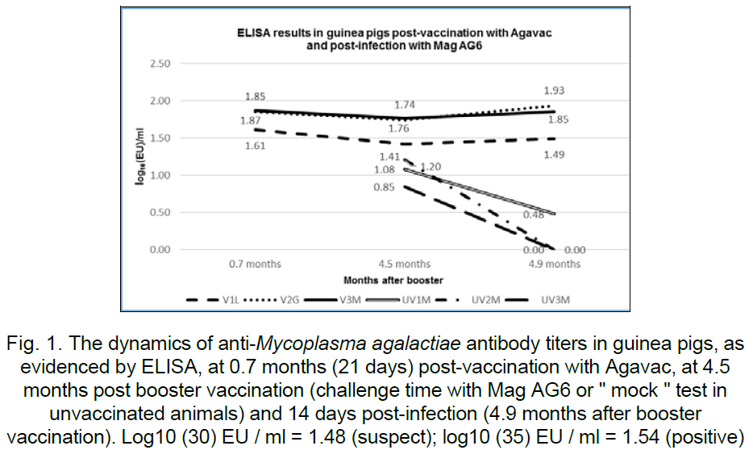
- Botuș Daniela, Ene, G., Culcescu, M., Popa, Virgilia, Daneș, M., (2017) Evaluation of immune response in sheep after vaccination against contagious agalactia, Lucrari stiintifice Medicina veterinara Timisoara L1, 30-38.
- Buonavoglia, D., Greco, Grazia, Corrente, Marialaura, Greco, Maria Fiorella, D’Abramo, Maria, Latronico, Francesca, Fasanella, A., Decaro, N., (2008) An oil-emulsion vaccine induces full-protection against Mycoplasma agalactiae infection in sheep, New microbiologica, 31, 117-123.
- Campos, A.C., Azevedo, E.O., Alcântara, M.D.B., Silva, R.B.S., Cordeiro, A.A., Mamede, A.G., Melo, M.A., Rosendo Nascimento, E., Castro, R.S., (2013) Efficiency of inactive vaccines against contagious agalactia in Brazil, Arq. Bras. Med. Vet. Zootec., 65, 5, 1394-1402.
- Chopra-Dewasthaly, Rohini, Spergser, J., Zimmermann, Martina, Citti, Christine, Jechlinger, W., Rosengarten, Renate, (2017) Vpma phase variation is important for survival and persistence of Mycoplasma agalactiae in the immunocompetent host, PLoS Pathog, 13, 9.
- Hedge, S., Zimmermann, Martina, Flöck, Martina, Brunthaler, R., Spergser, J., Rosengarten, Renate, Chopra‑Dewasthaly, Rohini (2016) Genetic loci of Mycoplasma agalactiae involved in systemic spreading during experimental intramammary infection of sheep, Vet Res., 47, 106.

