Transient sensory symptoms among first-dose recipients of the BNT162b2 mRNA COVID-19 vaccine: A case-control study
Miguel García-Grimshaw, Santa Elizabeth Ceballos-Liceaga, Gustavo Reyes-Terán, Antonio Arauz, and Sergio Iván Valdés-Ferrer, on behalf of the Mexican COVID-19 vaccines adverse events surveillance group (MexCOVae)

Abstract (300 word limit)
Vaccines are the single most effective mechanism to control the ongoing COVID-19 global crisis. However, in part due to their relatively recent incorporation into the preventive armamentarium, hesitancy towards mRNA-based COVID-19 vaccines is high despite evidence of efficiency. Hesitancy is partly due to a misperception of their potential adverse events. Non-specific sensory symptoms (NSSS) following immunization are thought to be mediated by stress-related responses. In this case-control study, we evaluated NSSS from a cohort of 7,812,845 BNT162b2 first-dose recipients, of whom 10,929 reported an adverse event following immunization (AEFI). We found an overall frequency of 3.4% (377 cases) or 4.8 cases per 100,000 doses administered. Anatomically, the arms (61%) and face/neck region (36.2%) were the most commonly affected sites. The control group had significantly higher rates of reactogenicity-associated symptoms, suggesting that NSSS are reactogenicity-independent; in multivariable analysis, healthcare workers reported sensory symptoms less frequently (aOR 0.54; 95% CI 0.40–0.72; p<0.001). This is the first study describing the topography and associated factors for developing NSSS among BNT162b2 recipients. The benign nature of these symptoms may help dissipate hesitation towards this vaccine.

Table
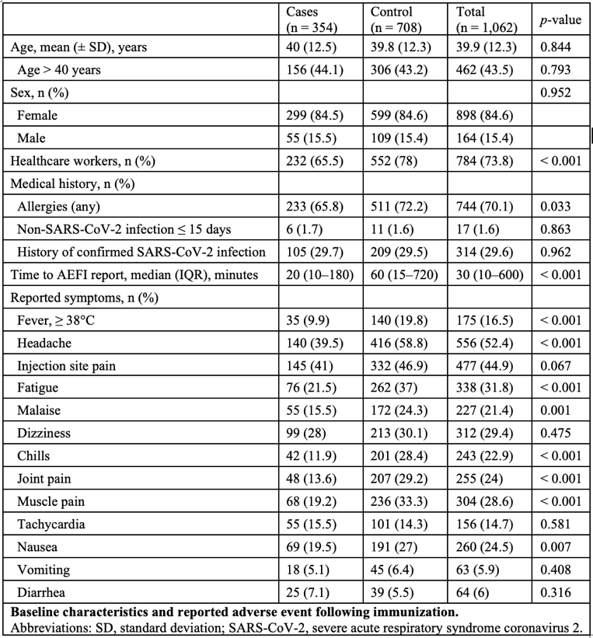
Recent Publications
- García-Grimshaw M, et al. Guillain-Barré syndrome is infrequent among recipients of the BNT162b2 mRNA COVID-19 vaccine. Clin Immunol. 2021 Aug 4;230:108818. doi: 10.1016/j.clim.2021.108818
- García-Grimshaw M, et al. Neurologic adverse events among 704,003 first-dose recipients of the BNT162b2 mRNA COVID-19 vaccine in Mexico: A nationwide descriptive study. Clin Immunol. 2021 Aug;229:108786. doi: 10.1016/j.clim.2021.108786.
- Flores-Silva, et al. Neurologic manifestations in hospitalized patients with COVID-19 in Mexico City. PLoS One. 2021 Apr 8;16(4):e0247433. doi: 10.1371/journal.pone.0247433
- Nuñes I, et al. Common hematological values predict unfavorable outcomes in hospitalized COVID-19 patients. Clin Immunol. 2021 Apr;225:108682. doi: 10.1016/j.clim.2021.108682
- Fragoso-Saavedra, et al. A parallel-group, multicenter randomized, double-blinded, placebo-controlled, phase 2/3, clinical trial to test the efficacy of pyridostigmine bromide at low doses to reduce mortality or invasive mechanical ventilation in adults with severe SARS-CoV-2 infection: the Pyridostigmine In Severe COvid-19 (PISCO) trial protocol. BMC Infect Dis. 2020 Oct 16;20(1):765. doi: 10.1186/s12879-020-05485-7

Biography
Dr Valdes-Ferrer’s lab is broadly interested in the interactions between nervous and immune systems in health and disease. We are actively exploring the role of cholinergic agonists in HIV-induced immune dysfunction. For the past year we are interested in finding new therapeutic agents to treat severe COVID-19. We also have a vested interest in understanding vaccine safety beyond the controlled setting of randomized clinical trials. The lab is funded by the National Council of Science and Technology of Mexico. Dr. Valdes-Ferrer has no conflicts of interest to declare. Email: Sergio.valdesf@incmnsz.mx.

