Supine versus prone PCNL - which, when and where? A single surgeon experience on 332 procedures.
Dr Deerush Kannan, Apollo Hospitals, Chennai, India
Dr Nitesh Jain, Apollo Hospitals, Chennai, India

Abstract (300 word limit)
Introduction: PCNL (Percutaneous nephrolithotomy) is considered the gold standard treatment for renal calculus more than 2 cm. Though there are multiple prospective studies comparing supine versus prone PCNL, literature lacks a comparison based on experience of a songle surgeon. The aim of the study was to evaluate the safety and efficacy of supine versus prone PCNL based on a single surgeon experience.
Methods and materials: A prospective randomised study done in Apollo Hospitals, Urology department between October 2017 and October 2022. A total of 332 with stone size measuring less than 3 cm were included in the study.
Results: The mean total operative time from induction was 45.1 min in supine group and 57.7 min in prone group (p value < 0.001) whereas the time from puncture was 32.2 and 28.4 minutes in supine and prone respectively. The pain score was higher in prone group. Hospital stay and complications (early and late) were comparable between the groups. Puncture was made with ease in prone group (p value < 0.001) and prone PCNL had good results in diverticular stones, bilateral stones and previous pyelolithotomies. Though ECIRS was handy in supine PCNL, the need for additional punctures for residual fragments was more in supine group (statistically insignificant).
Conclusion: Supine PCNL is feasible, comparable to prone PCNL in respect to operative parameters with relatively higher stone migration rates requiring need for ancillary punctures or procedures though it is statistically insignificant.

Image (Intra operative parameters)

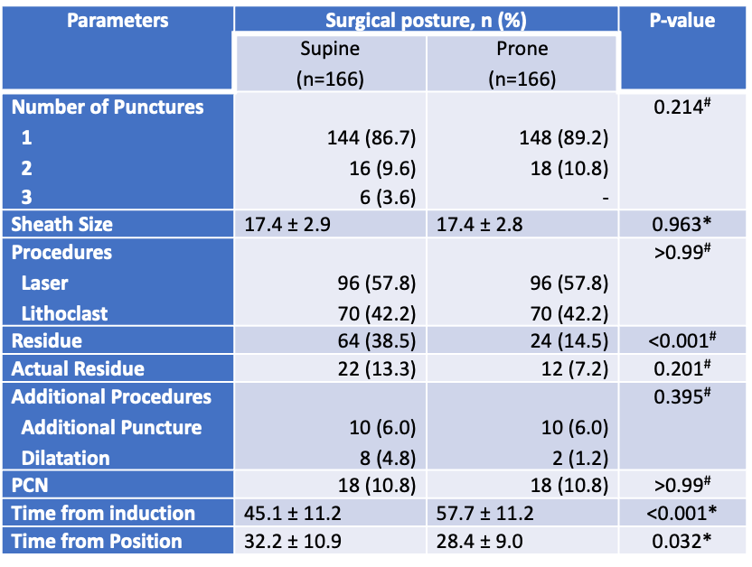

Photograph

Biography
Dr Deerush Kannan is an enthusiastic Urology registrar completing his three years course in Urology in a couple of months at Apollo hospitals, Chennai, India. He has been trained by eminent Urologists who have expertise in all areas of Urology not only limited to stones, transplant, andrology, reconstruction and uro oncology including robotics. He is also a faculty in training surgeons across the globe to ace in MRCS exams. He has presented more than 30 papers, videos and posters in national and state conferences across the country with a handful of prize-winning presentations. His areas of interest include innovation in stone disease and artificial intelligence in robotic urology. This study was conducted by him under his mentor and guide Dr Nitesh Jain, senior consultant Urologist at Apollo hospitals, Chennai.
Email: deerush92@gmail.com

