Cell-free DNA (cfDNA) methylation of MIR145 promoter in predicting muscle-invasive bladder cancer progression

Katerina-Marina Pilala¹, Konstantina Panoutsopoulou¹, Georgios Kotronopoulos², Panagiotis Levis², Georgios-Christos Giagkos², Konstantinos Stravodimos², Dido Vassilacopoulou¹, Andreas Scorilas¹, Margaritis Avgeris^{1,3,*}

¹ Department of Biochemistry and Molecular Biology, Faculty of Biology, National and Kapodistrian University of Athens, Athens, Greece
² First Department of Urology, “Laiko” General Hospital, School of Medicine, National and Kapodistrian University of Athens, Athens, Greece
³ Laboratory of Clinical Biochemistry - Molecular Diagnostics, Second Department of Pediatrics, School of Medicine, National and Kapodistrian University of Athens, "P. & A. Kyriakou" Children's Hospital, Athens, Greece.
Email: margaritis.avgeris@gmail.com ; mavgeris@med.uoa.gr

Abstract (300 word limit)
The lack of personalized management of bladder cancer (BlCa) resulted in patients’ lifelong post-treatment monitoring with regular invasive interventions, underlying the urgent need for tailored and minimally invasive healthcare services. Based on our previous findings on MIR145 core promoter methylation imprinting in bladder tumors, we have evaluated its clinical significance in pre-treatment circulating cell-free DNA (cfDNA) of BlCa patients. Methylation analysis was performed in our screening cohort, consisting of 100 BlCa patients by bisulfite-based pyrosequencing. Tumor recurrence and progression for non-muscle invasive (NMIBC; TaT1), as well as progression and death for muscle-invasive (MIBC; T2-T4) patients, were used as clinical endpoint events in survival analysis. Bootstrap analysis was applied for internal validation of Cox regression models, and decision curve analysis for the assessment of clinical benefit on disease prognosis. Decreased methylation of MIR145 promoter in pre-treatment cfDNA was associated with short-term disease progression and poor overall survival of MIBC patients. Multivariate models incorporating MIR145 promoter methylation in cfDNA with established disease markers clearly ameliorated patients’ risk-stratification accuracy, highlighting superior clinical benefit in BlCa prognostication. Overall, reduced pre-treatment cfDNA methylation of MIR145 core promoter was markedly correlated with increased risk for inferior survival outcome of MIBC patients, supporting modern personalized and non-invasive prognosis and monitoring decisions.

Acknowledgments
This research was cofinanced by the European Regional Development Fund of the European Union and Greek national funds through the Operational Program Competitiveness, Entrepreneurship and Innovation, under the call RESEARCH-CREATE-INNOVATE (project code: T2EDK-02196) to the National and Kapodistrian University of Athens (KE17358).

Image
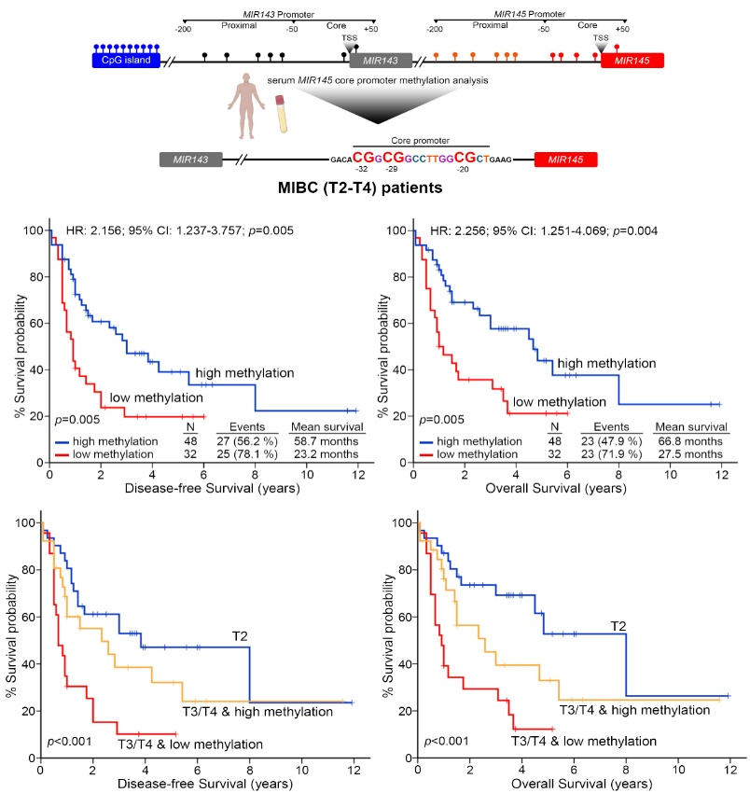
Recent Publications (minimum 5)
  - Papadimitriou MA, Levis P, Kotronopoulos G, Stravodimos K, Avgeris M*, Scorilas A*. Pre-operative cell-free DNA (cfDNA) in muscle-invasive bladder cancer treatment outcome. Clinical Chemistry 2023;69(4):399-410
  - Pilala KM, Papadimitriou MA, Panoutsopoulou K, Barbarigos P, Levis P, Kotronopoulos G, Stravodimos K, Scorilas A, Avgeris M. Epigenetic regulation of MIR145 core promoter controls miR-143/145 cluster in bladder cancer progression and treatment outcome. Molecular Therapy Nucleic Acids 2022;30:311-322.
  - Papadimitriou MA, Panoutsopoulou K, Pilala KM, Scorilas A, Avgeris M. Epi-miRNAs: Modern mediators of methylation status in human cancers. WIREs RNA 2022; 17:e1735
  - Panoutsopoulou K, Magkou P, Dreyer T, Dorn J, Obermayr E, Mahner S, Gorp VT, Braicu I, Magdolen V, Zeillinger R, Avgeris M*, Scorilas A*. tRNA-derived small RNA 3’U-tRF^{ValCAC} promotes tumor migration and early-progression in ovarian cancer. European Journal of Cancer 2022;180:134-145.
  - Papadimitriou MA, Avgeris M, Levis P, Papasotiriou EC, Kotronopoulos G, Stravodimos K, Scorilas A. tRNA‐derived fragments (tRFs) in bladder cancer: Increased 5’-tRF-LysCTT results in disease early-progression and patients’ poor treatment outcome. Cancers 2020, 12(12):3661.

