Predictors of microalbuminuria and its relationship with glycemic control among Type 2 diabetic patients of Jazan Armed Forces Hospital, southwestern Saudi Arabia
Hassan Ali Abdelwahid, Jazan Armed Forces Hospital, KSA
Hesham Mohamed Dahlan, Jazan Armed Forces Hospital, KSA
Gassem Maoudhah Mojemamy, Jazan Armed Forces Hospital, KSA
Gasem Hussein Darraj, Jazan Armed Forces Hospital, KSA

Abstract (300 word limit)
Statement of the Problem: Diabetic kidney disease (DKD) is highly prevalent among patients with diabetes mellitus. It affects approximately 20% of diabetic patients. The objectives of the present work were to assess patterns of albuminuria and determine microalbuminuria predictors among patients living with type 2 diabetes (T2D) who attended the family medicine department of Jazan Armed Forces Hospital. Methodology & Theoretical Orientation: The study participants were screened for albuminuria and classified into three categories or grades, A1, A2 and A3, based on the urine albumin/creatinine ratio (ACR). Category A1 included T2D with normal to mildly increased albuminuria (ACR <30 mg/gm; n, 532). The second category, A2, included those with microalbuminuria with ACR of 30-300 mg/gm; n, 202. The 3rd one, A3, was severely increased albuminuria with an ACR of >300 mg/gm; n, 30. A case-control design was used and included two groups (n, 202/group), one with microalbuminuria and the other with a normal urine (ACR). Data regarding patient history, glycosylated hemoglobin (HbA1c), lipid profile, renal function tests, ACR, ASCVD (atherosclerotic cardiovascular disease) risk, etc., were collected. Findings: The prevalence rates of microalbuminuria and macroalbuminuria were 26.4% and 3.9%, respectively. HbA1c was significantly higher in patients with microalbuminuria (9.3 ±2.2; P˂0.001) and macroalbuminuria (10.5±2.3; P˂0.001) than in those with normal ACR (8.3 ±1.9%). The predictors of microalbuminuria were poor glycemic control with HbA1c ≥ 7% {OR, 2.5 (95% C. I, 1.5-4.2)}; hypertension {(OR, 1.8 (95% C. I, 1.2-2.8)}; estimated glomerular filtration rate (eGFR) of ˂90 mL/min/1.73 m2 {OR, 2.2 (95% C. I, 1.4-3.6}; smoking {OR, 1.3 (95% C. I, 0.7-2.6}; and body mass index {OR, 1.05 (95% C. I, 1.01-1.09}. Conclusion & Significance: Microalbuminuria is highly prevalent among patients with type 2 diabetes and is associated with poor glycemic control and hypertension, necessitating aggressive and timely screening and treatment.
Image
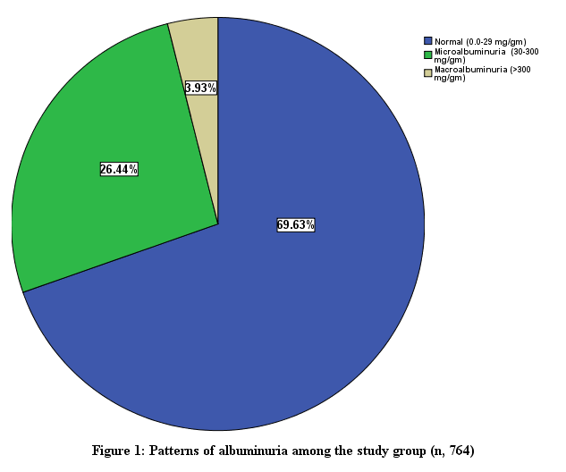

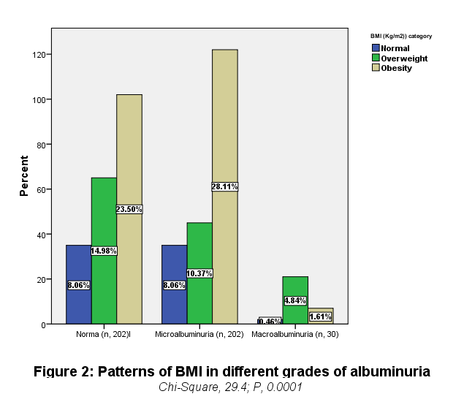

Recent Publications (minimum 5)
- Abdelwahid HA, Dahlan HM, Mojemamy GM, Darraj GH. Predictors of microalbuminuria and its relationship with glycemic control among Type 2 diabetic patients of Jazan Armed Forces Hospital, southwestern Saudi Arabia. BMC Endocr Disord. 2022 Dec 8;22(1):307. doi: 10.1186/s12902-022-01232-y. PMID: 36482350; PMCID: PMC9733223..
- Sameer Ahmed Ali Holal, Hassan Ali Elsayed Abdelwahid. Barriers Facing Primary Health Care Physicians in Jazan when Dealing with Emergency Cases. World Family Medicine. 2022; 20(4): 32-43. DOI: 10.5742/MEWFM.2022.
- Abdelwahid HA, Al-Shahrani SI, Elsaba MS, Elmorshedi WS. Patterns of referral in the Family Medicine Department in Southeastern Saudi Arabia. Saudi Med J. 2010 Aug;31(8):925-30. PMID: 20714694.5.
- Abdelwahid HA, Al-Shahrani SI. Screening of depression among patients in Family Medicine in Southeastern Saudi Arabia. Saudi Med J. 2011 Sep;32(9):948-52. PMID: 21894360.
- Abdelwahid, Hassan A.; Erwi, Saud M.; Alahmari, Firas S.; Ibrahim, Amani A. K.; Dahlan, Hesham M. Pattern and predictors of glycemic control among type 2 diabetics in Armed Forces Hospital of Jizan, southwestern Saudi Arabia. Middle East Journal of Family Medicine . 2017, 15 (1), 14-22.
- Zakri FKA, El-Wahid HAA, Sani M, Mahfouz MS. A body shape index in a small sample of Saudi adults with type 2 diabetes. J Family Med Prim Care. 2019 Oct 31;8(10):3179-3184. doi: 10.4103/jfmpc.jfmpc_532_19. PMID: 31742139; PMCID: PMC6857384.
- Abdelwahid HA, Zekry OA (2012) The Role of Multiple Micronutrients in Treatment of Iron Deficient Anemic Children. Family Med Medical Sci Res 1:102. doi:10.4172/2327-4972.1000102.
- Zekry OA, Abd Elwahid HA. The association between Helicobacter pylori infection, type 1 diabetes mellitus, and autoimmune thyroiditis. J Egypt Public Health Assoc. 2013 Dec;88(3):143-7. doi: 10.1097/01.EPX.0000437621.23560.de. PMID: 24374947.
- Nour-Eldein H, Abdelsalam SA, Nasr GM, Abdelwahed HA. Global Cardiovascular Risk Assessment by Family Physicians in Suez Canal University-Family Medicine Centers-Egypt. J Family Med Prim Care. 2013 Oct-Dec;2(4):365-70. doi: 10.4103/2249-4863.123919. PMID: 26664843; PMCID: PMC4649869.

Biography (150 word limit)
e your Logo here
Professor Doctor Hassan Ali Abdelwahid, Professor of Family Medicine, Suez Canal University. has completed his MD (Medical doctorate) in 2002. Egypt. Dr. Hassan also is a Consultant of family medicine in Jazan Armed Forces Hospital (JAFH), Saudi Arabia. He is interested in management of chronic diseases, ECG, anemia, Epidemiology, Health education, research and adult learning. Doctor Hassan is the Head of Institutional Research Board of JAFH. He is serving as a member of the faculty research committee, and as an editorial member or reviewer of several reputed journals like Elite Research Journal, International Blood Research & Reviews, American Journal of Clinical Medicine Research (http://www.sciepub.com/journal/AJCMR), American Journal of Public Health Research, British J. of Medicine and medical research (BJMMR), etc. Based on his research and CV, Dr. Hassan has been included in book of Who's Who in the World.
Email: hassan22220000@yahoo.com

Notes/Comments:

Presenting author details
Full name: Hassan Ali Abdelwahid
Contact number:00966543075421
Twitter account:
Linked In account:
Session name/ number: Innovating nursing through research and practice
Category: (Oral presentation)

