A Granular Analysis of Quality of Life in Children with Voiding Dysfunction: A Large-Scale Retrospective Study.
Rachel E Kaufman BS, Mary Mahaffey BSBE, Brittany Ange EdD, MS, Bradley A Morganstern MD
Medical College of Georgia at Augusta University, Augusta, GA USA

Abstract (285/300 words)
Introduction and Objective: Voiding dysfunction (VD) significantly impacts children and their family’s quality of life (QoL). The purpose of this large-scale study was to explore, in a more granular nature, the correlation between QoL measures and subjective symptoms by assessing responses to the Pediatric Urinary Incontinence (PINQ) and the Vancouver Non-neurogenic Lower Urinary Tract Dysfunction Elimination Syndrome (VNLUTD) questionnaires. Methods: A retrospective chart review extracted symptoms reported by patients with VD who completed PINQ and VNLUTD from 2018-2021. The first visit for all patients was included in this analysis. The dependent variables of interest were PINQ (N=288) and VNLUTD (N=270) scores. Independent variables were examined in a univariate model, and independent variables significant at the 0.1 alpha were used for multiple linear regression models. Results: The mean (SD) age was 9.6 (3.8) years old. The majority of patients were female (56%) and White (55%). PINQ and VNLUTD were statistically significantly positively correlated (r=0.3822, p<.0001) indicating that higher PINQ scores are associated with higher VNLUTD scores. Whites and patients with dysuria had lower PINQ scores (Table 1). Higher ages were associated with lower VNLUTD scores. Males, Whites, patients without constipation, and patients without UTIs had lower VNLUTD scores (Table 2). Conclusions: This study was internally validated as evidenced by the expected significant positive correlation between PINQ and VNLUTD, and offers one of largest studies to date. These surveys work well together to capture QoL in the pediatric population. This study determined which variables impacted PINQ and VNLUTD scores, and revealed that addressing modifiable variables such constipation and UTI symptoms may have a greater impact on improving QoL, while dysuria may be less efficacious. Non-modifiable variables such race and gender open discussion regarding social determinants of QoL.
.

Image
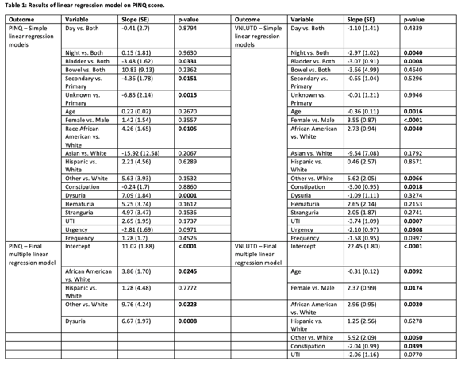
Recent Publications (minimum 5)
- Ates KM, Vaizer RP, Newton DC, Hao S, Mahoney K, Morganstern BA. Rare case: Ureteropelvic junction complication presenting with bilateral labial abscesses and urosepsis requiring nephrectomy. Urol Case Rep. 2021 May 7;37:101705. doi: 10.1016/j.eucr.2021.101705. PMID: 34036047; PMCID: PMC8136439.
- Nelwan D, Mount C, Morganstern B, Chan JT. Infant With Severe Penoscrotal Hypospadias: A Complex Case of Genital Ambiguity and Mistaken Identity. Cureus. 2021 May 23;13(5):e15191. doi: 10.7759/cureus.15191. PMID: 34178511; PMCID: PMC8218553.
- Vaizer RP, Benton JZ, Morganstern BA. First Case of a Term Male Born with Aphallia and Complete Urethral Atresia. Urology. 2021 Oct;156:e127-e130. doi: 10.1016/j.urology.2021.05.038. Epub 2021 Jun 1. PMID: 34087315.
- Fratino KM, Burton BR, Shukla M, Klaassen ZW, Morganstern BA. Non-seminomatous Germ Cell Tumor Causing an Inferior Vena Cava Thrombus in a Sixteen-Year-Old Male. Am Surg. 2021 Apr;87(4):655-657. doi: 10.1177/0003134820951485. Epub 2020 Nov 6. PMID: 33153271.
- Mistry PK, Morganstern BA, Ahmed H, Palmer LS. Attitudes towards child life specialists and their utilization within pediatric urology. Can J Urol. 2019 Dec;26(6):10022-10025. PMID: 31860418.

Photograph

 Biography (150 word limit)
Rachel Kaufman is a third year medical student at The Medical College of Georgia at Augusta University mentored by pediatric urologist Dr. Bradley A Morganstern, Chief of Pediatric Urology at Augusta University. His research interests include Health-Related Quality of Life issues and novel investigations in obtaining functional data from sonographic images in pediatric urology conditions.
Email: rkaufman@augusta.edu

