DITROVIE SCALE: TRANSLATION AND VALIDATION IN STANDARD ARABIC
Dr KSIBI IMENE, ASSOCIATE Pr in PMR , MILITARY HOSPITAL OF TUNIS
Dr BEN AMOR KAIS, RESIDENT in PMR, MILITARY HOSPITAL OF TUNIS

Abstract
Statement of the Problem: Idiopathic overactive bladder (OAB) is considered a true social disability [1]. Its management requires the evaluation of its impact on the quality of life [2]. The Ditrovie scale is a specific instrument, used for this purpose since 1996 [3-5]. However, we do not have until now an Arabic version. Our work aimed to translate this scale into Arabic and to verify its validity and reliability in the Tunisian population. Methodology & Theoretical Orientation: The translation-back translation method was the chosen translation method resulting in three versions. The committee of experts analyzed these versions and elaborated a pre-final version with validation of its appearance and content. A pre-test done on 20 patients allowed to study the acceptability and the feasibility of the scale. The Arabic version obtained was conducted on a sample of 100 patients with idiopathic OAB. The reliability of the scale was verified by Cronbach's alpha coefficient, intraclass correlation coefficient and Bland and Altman's graph. The validity of the construct was studied by exploratory factor analysis. Findings: The feasibility and acceptability of the scale was good. The Cronbach's alpha for the scale was 0.86. The reproducibility of our scale as well as of each domain was very good (intraclass correlation coefficient > 0.9) with a mean of the differences centered and homogeneous in the Bland and Altman graph. The inter-item correlations quality was good (Kaiser-Meyer-Olkin index equal to 0.856) with a satisfactory mean correlation (r=0.39). The factor analysis identified two significant factors explaining 61% of the total variance. The first factor represents the psyche, the second represents the activity. The Cronbach's alpha coefficient was 0.83 for the first factor and 0.82 for the second factor, affirming a good internal consistency of each of them. Conclusion & Significance: Our standard Arabic version of the Ditrovie scale is a reliable instrument with satisfactory psychometric properties that will facilitate the task of the Tunisian and Arabic physician in the management of patients with idiopathic overactive bladder. We propose that other scales be translated and validated in Arabic such as the Qualiveen scale.

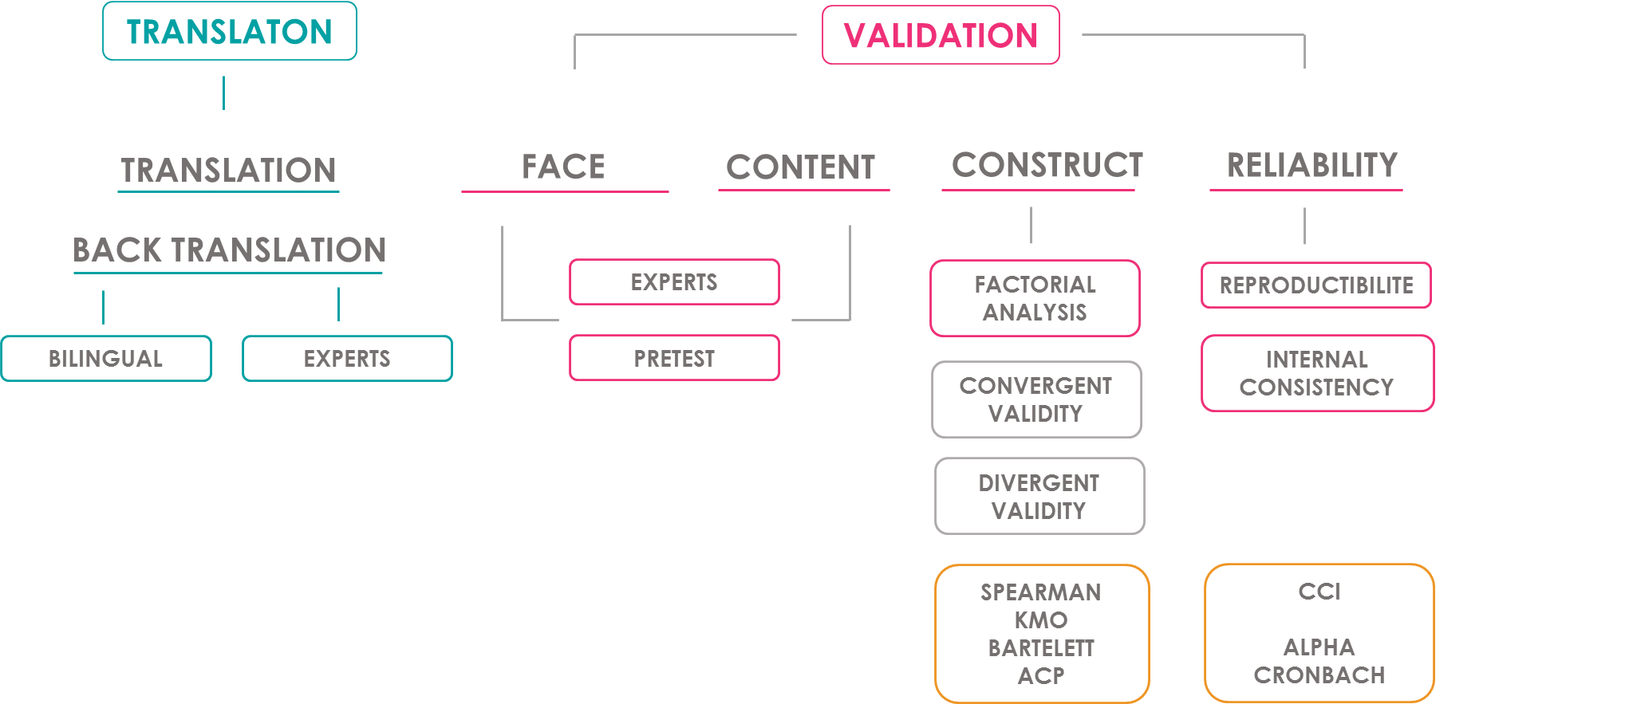
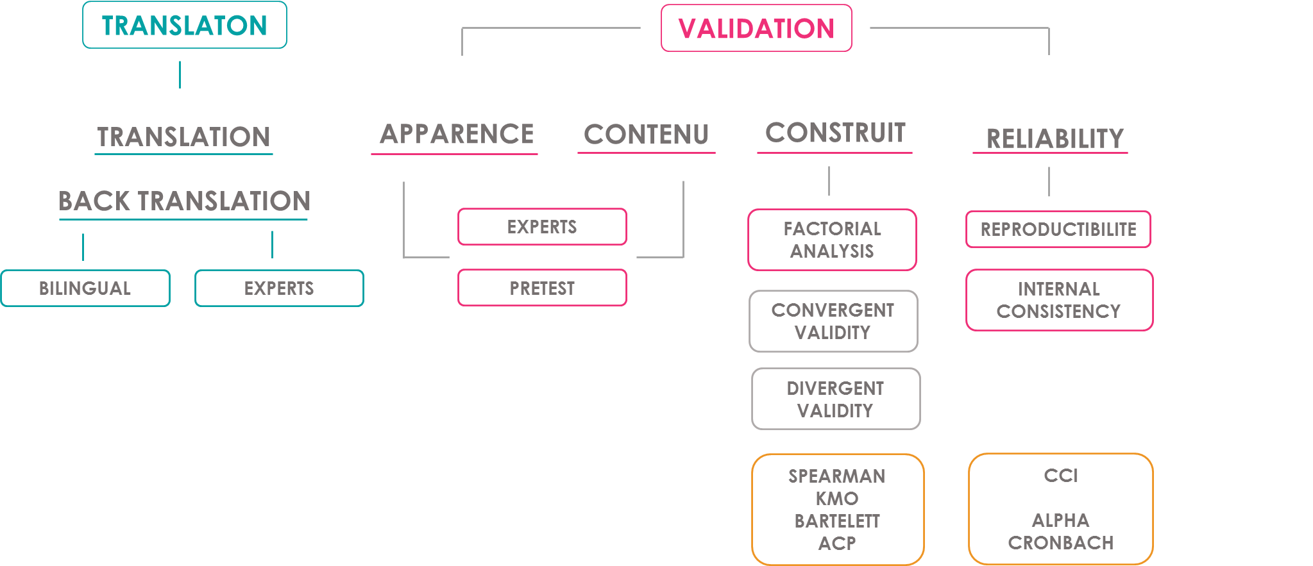

Figure 1: Scale Translation and validation Compounds

References :
1. Abrams P, Cardozo L, Fall M, Griffiths D, Rosier P, Ulmsten U et al. The standardisation of terminology of lower urinary tract function: report from the standardisation sub-committee of the International Continence Society. Neurourol Urodyn. 2002;21(2):167-78.
2. Gormley EA, Lightner DJ, Burgio KL, Chai TC, Clemens JQ, Culkin DJ, et al. Diagnosis and treatment of overactive bladder (non-neurogenic) in adults: AUA/SUFU guideline. J Urol. 2012;188:2455–63.
3. Amarenco G. Quantification de l’incontinence urinaire: scores de symptômes et de qualité de vie. In: Blanc B, Siproudhis L, dir. Pelvi-Périnéologie. Paris: Springer-Verlag; 2005. p. 107–12.
4. Amarenco G. Les scores de qualité de vie de l’incontinence urinaire de la femme. Correspondances en Pelvi-périnéologie. 2001;1(2):22-5.
5. Amarenco G, Marquis P, Leriche B, Richard F, Zerbib M, Jacquetin B. Une échelle spécifique d’évaluation de la perturbation de la qualité de vie autours des troubles mictionnels : l’échelle Ditrovie. Ann Readapt Med Phys. 1997;40(1):21-6.

