Circadian rhythm-related miR-6883-5p suppresses enzalutamide-resistant prostate cancer proliferation via inhibiting AR-V7 expression
Wenchang Yue, M.D. Ph.D. Candidate, Soochow University, Suzhou China
Dr. Ying Xu, Prof. Principal Investigator, Director of CAM-SU, Genomic Resource Center, Soochow University, Suzhou China
Dr. Jianquan Hou, M.D. Prof, President of Dushu Lake Hospital Affiliated to Soochow University, Suzhou China

Abstract
Prostate cancer is the second most prevalent cancer in men and the sixth leading cause of cancer death worldwide. Age, family history, race, tobacco use, obesity, diet, and circadian disruption are all risk factors for prostate cancer. Epidemiological studies of circadian disruption focus primarily on night shift work. The 2017 Nobel Prize in Physiology or Medicine was awarded to Jeffrey C. Hall, Michael Rosbash, and Michael W. Young for making it possible to study the molecular mechanisms underlying circadian rhythms. The molecular mechanisms between circadian rhythm genes and diseases, including prostate cancer, have been gradually revealed, and these studies hold promise for future clinical application .
However, the relationship between the molecular mechanism of circadian rhythm and the development of prostate cancer has not been fully clarified. We observed that a microRNA plays an important role in the regulation of circadian rhythms and prostate cancer proliferation. Our study shows that miR-6883-5p is associated with circadian rhythm and can inhibit AR-V7, thereby suppressing the growth of enzalutamide-resistant prostate cancer. Our research provides a potential therapeutic target for enzalutamide-resistant prostate cancer and expands the understanding of circadian clock regulation regulatory mechanisms.

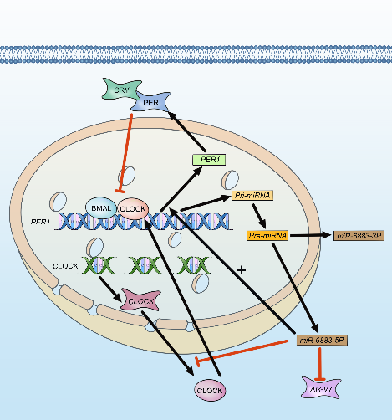
Image
Figure 1: Schematic diagram of miR-6883-5p regulatory mechanism

Publications
- Yue W, Du X, Wang X, et al. Prognostic values of the core components of the mammalian circadian clock in prostate cancer. PeerJ. 2021;9:e12539. Published 2021 Dec 9. doi:10.7717/peerj.12539
- Sun J, Yue W, You J, et al. Identification of a Novel Ferroptosis-Related Gene Prognostic Signature in Bladder Cancer. Front Oncol. 2021;11:730716. Published 2021 Sep 7. doi:10.3389/fonc.2021.730716
- Sun J, Wei X, You J, et al. STC1 is a Novel Biomarker Associated with Immune Characteristics and Prognosis of Bladder Cancer. Int J Gen Med. 2021;14:5505-5516. Published 2021 Sep 11. doi:10.2147/IJGM.S329723
- Yue W, et al. Circadian rhythm-related miR-6883-5p suppresses enzalutamide-resistant prostate cancer proliferation via inhibiting AR-V7 expression. ( Contributing)
- Yue W, et al. Important hub-RNAs in the development of prostate cancer identified by RIC-seq. ( Contributing)


Yue Wenchang, from the First Affiliated Hospital of Soochow University in China, has completed urology resident standardization training in China and is now a Ph.D. candidate in urology, Soochow University. The primary focus of research is the association between prostate cancer and circadian rhythm. In addition, Yue has worked on the Internet for many years to popularize medical science, and his content has been read hundreds of millions of times.

