Gut-kidney axis: the role of exercise and symbiotic as a non-pharmacological aids for patients with chronic kidney disease
Majid Mohabbat PhD, University of Guilan, Rasht, Iran.

Abstract

Patients with chronic kidney disease (CKD) experience significant reductions in muscle mass, physical function, individual independence, and overall quality of life. This lower physical function is associated with increased levels of inflammation through the gut-muscle axis, its relationship to tight junctions, and finally dysbiosis. Furthermore, renal failure leads to changes in the intestinal microbiome (Gut-kidney axis) via changes in nutrition and medication, which leads to leakage of bacterial metabolites, in particular uremic toxins into the bloodstream through changes in intestinal barrier properties that all involved in the progress of CKD. In addition, modification in intestinal microbial lines includes enrichment of Eggerthella lenta and depletion in Bacteroides eggerthii, Roseburia faecis, and Prevotella spp. Various therapeutic interventions have proposed to restore the coexistence of the intestinal microbiome which if approved, can remarkably impact the improvement and treatment management of CKD patients. Exercise and nutrition, especially probiotics, are among these interventions. Studies have demonstrated that exercise, mediates through, production of the anti-inflammatory metabolites of SCFA (acetate, propionate, and butyrate) via its effect on the gut microbiome and reduces lipopolysaccharides. In addition, several studies have examined the role of symbiotic in renal function. For example, Zhang et al investigated the protective influence of Shenqi Yanshen Formula against CKD and reported that SQYSF significantly reduced the rate of renal fibrosis in CKD mice, and remarkably down-regulated the expressions of inflammatory markers and even has more potential to change the composition in mice’s intestinal flora. However, it is worth noting that studies were carried out on animal models and their mechanisms of action are not fully understood. As a result, despite different exercise modalities and microbiome alteration methods, appears that identifying important variables such as consistent and appropriate exercise type, duration, intensity, frequency, and timing alongside the intestinal microbiome enrichment approach in humans is considerably needed.

Image

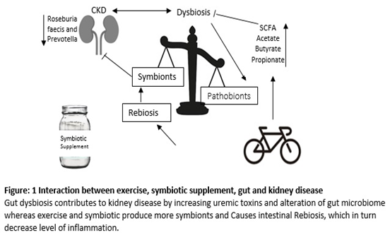
Recent Publications
- Clauss M, Gérard P, Mosca A and Leclerc M (2021) Interplay between Exercise and Gut Microbiome in the Context of Human Health and Performance. Front. Nutr. 8:637010
- Lohia, S.; Vlahou, A.; Zoidakis, J. Microbiome in Chronic Kidney Disease (CKD): An Omics Perspective. Toxins 2022, 14, 176.
- Ling Zhang, Tai-Jun Zhang, Ying Li & Wei-Jian Xiong (2022) Shenqi Yanshen Formula (SQYSF) protects against chronic kidney disease by modulating gut microbiota, Bioengineered, 13:3, 5625-5637
- Meijers B, Evenepoel P, Anders HJ. Intestinal microbiome and fitness in kidney disease. Nat Rev Nephrol. 2019 Sep;15(9):531-545.
- Przewłócka K, Folwarski M, Kaźmierczak-Siedlecka K, Skonieczna-Żydecka K, Kaczor JJ. Gut-Muscle Axis Exists and May Affect Skeletal Muscle Adaptation to Training. Nutrients. 2020; 12(5):1451.
- Stavropoulou E, Kantartzi K, Tsigalou C, Konstantinidis T, Romanidou G, Voidarou C and Bezirtzoglou E (2021) Focus on the Gut–Kidney Axis in Health and Disease. Front. Med. 7:620102.

Photograph



Biography
Dr has his expertise in evaluation and passion in improving the health and wellbeing by exercise training. His research studies are about chronic diseases as effect of a period of discontinues aerobic training of serum Hepcidin and ferritin and liver enzymes in adolescents with beta thalassemia major and thalassemia intermediate. On the other hand from microbiome view point other upcoming research studies focus on role of different exercise modality alongside with supplement to gut and body organs crosstalk.
Email: M67Mohabbat@gmail.com
Notes/Comments:

