Women, trauma and alcohol dependency: Connections and disconnections in alcohol treatment for women
Dr ABC, RN PhD, TLI Foundation, USA
Dr ABC, RN PhD, TLI Foundation, USA

Abstract (300 word limit)
Gonococcal resistance to first-line treatment for urethral discharge, ciprofloxacin, in Cameroon increased from 3.8% to 50% during 2009-2014. It is essential to strengthen the gonococcal AMR surveillance in African countries.
Background: Gonorrhea and antimicrobial resistance (AMR) in Neisseria gonorrhoeae are public health problems globally. Quality-assured AMR data from Africa, particularly Central-Western Africa, is mainly lacking. We investigated the resistance to therapeutically relevant and/or used antimicrobials in N. gonorrhoeae isolates from 2009 to 2014 in Yaoundé, Cameroon, and recommend revisions of the national STD treatment guideline in Cameroon.
Methods: Gonococcal isolates (n=193) cultured from outpatients, 129 (66.8%) males and 64 (33.2%) females, at different hospitals or health centers in Yaoundé, Cameroon from January 2009 to December 2014 were tested for susceptibility to seven antimicrobials using disc diffusion method (Etest to confirm suspected ceftriaxone resistance).
Results: High resistance to benzylpenicillin (93.3%), tetracycline (58.5%) and nalidixic acid that reflects ciprofloxacin (17.6%; increasing from 3.8% to 50% during 2009-2014) were observed. However, the resistance level to ceftriaxone, azithromycin, spectinomycin, and chloramphenicol were low, i.e. 0%, 2.6%, 3.1% and 7.3%, respectively. Overall, 80.3% of isolates were producing penicillinase.
Conclusions: Multi-drug resistant gonorrhea is a major public health concern internationally and quality-assured gonococcal AMR surveillance is crucial globally. In Africa, particularly Central-Western Africa, appropriate AMR surveillance for gonococci has mainly been lacking. Our current results will inform revisions of the National STD Treatment Guideline in Cameroon, i.e. to replace ciprofloxacin with ceftriaxone as the recommended first-line treatment of urethral discharge. It is essential to further strengthen the surveillance of N. gonorrhoeae AMR in Cameroon and most countries in the WHO African Region, which requires national and international support, including technical support, and political and financial commitment.
Keywords: Gonorrhea, antimicrobial resistance, ceftriaxone, azithromycin, Africa

Image
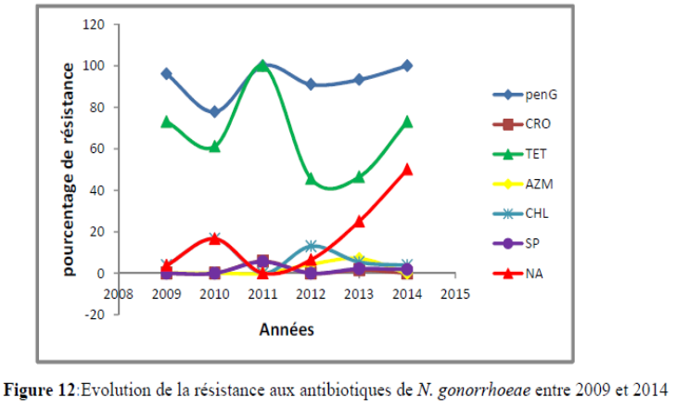
Recent Publications (minimum 5)
- Trends in Gonococcal Antimicrobial Resistance in Cameroon: Before and After the Launching of the Gonococcal Antimicrobial Surveillance Program. ISSN: 2319-7706 Volume 5 Number 12 (2016) pp. 182-194
- Strengthening surveillance in health facilities in Yaoundé, Cameroon through event-based surveillance

Photograph


Biography (150 word limit)
Mrs Carolle Yanique TAYIMETHA has completed his Master Degree at the age of 32 years from Catholic University of Central Africa and now I am PhD student in third year in Medical Microbiology at the faculty of Health Sciences at the University of Buea in Cameroon. I am working temporarily in the Molecular Biology Laboratory at the National Public Health Laboratory in Cameroon; because now I have a study leave. I have published 03 papers in reputed journal.
Email: taycurie@gmail.com

Notes/Comments:

