Tips and Tricks in Hair Tourniquet Syndrome (HTS)

El-Osh AM *, Elwan A**
* 6th year medical student, Damietta faculty of medicine, Al-Azhar University, Egypt
** Professor of general surgery, Damietta faculty of medicine, Al-Azhar University, Egypt

Abstract :

Hair tourniquet syndrome (HTS) is a rare clinical phenomenon. In this condition, a body appendage is tightly and circumferentially wrapped by hair or similar material. Commonly affected sites include fingers, toes and genitals. Prompt diagnosis and treatment of this condition is vital to attain good outcome and prevent even a catastrophic consequence of auto amputation in affected body part.

Objective : Talking about this topic to increase physician awareness of this syndrome and highlight the importance of early release of the tourniquet to remove the hair according to anatomical consideration to avoid iatrogenic injury of the neurovascular bundle in digits and structures in genitalia.

Aim of the work: HTS may lead to tissue loss if not recognized and intervened urgently. Making a wrong diagnosis like infection without a careful physical examination may lead to deterioration of the patient’s condition so; we wished to increase awareness of this syndrome.

Image
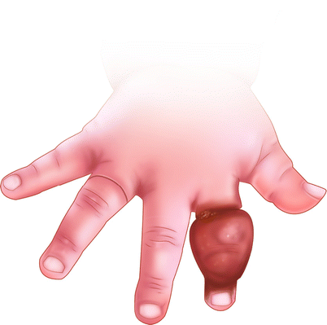
Recent Publications
- Kursad Zengin, Mustafa Yasar Ozdamar , Sebahattin Albayrak, Serhat Tanik, Muhittin Atar, Hasan Bakirtas , Muhammed Abdurrahim Imamoglu, andMesut Gurdal ,(2015), " hair coil penile tourniquet syndrome in an unusual age " , Case Rep Urol .
- Lucas J.K. (2016) " Removal of Hair/Thread Tourniquet" . In:Ganti L. (eds) Atlas of Emergency Medicine Procedures. Springer, New York, NY
- Nicola Bizzotto, Andrea Sandri, Dario Regis, Guillherme Carpeggiani , Franco Lavini, and BrunoMagnan(2014), " serious delayed hair toe tourniquet syndrome with bone erosion and flexor tendon lesion " , Case Rep Pediatr Room R, BaborT, Rehm J (2005) Alcohol and public health. Lancet
365: 519-530.

Sebaratnam DF , Hernández-Martín Á. (2018) , " Utility of ultrasonography in hair-thread tourniquet syndrome " , Pediatr Dermatol ; 35(2):e138-e139.
- Uygur E, Çarkçi E, Ünkar E (2017), Can washing socks without flipping inside out cause hair tourniquet syndrome? A claim with two case reports " , J Pediatr Orthop B. ; 26(2):193-194

Photograph

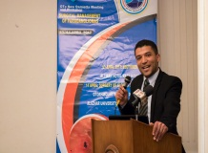Biography
Iam Abdullah El-Osh , experienced in emergency life support , I have taken courses in basic and advanced life support at American heart association , Health services in emergency training based on the IFRC toolkit at Egyptian red crescent , Iam instructor potential for basic life support in American heart association , I have taken many courses in research , My review was accepted to presented as an oral presentation in Damietta faculty of medicine , Al-Azhar university , Damietta , Egypt ( 3 times ) 2015 , 2019, and my review was accepted to presented as an oral presentation in international conference at Alexandria university at April , 2019 , Iam interested in public speaking and I would like to present this topic in your conference as it serious condition that we can face it in emergency department .

Email: Abdullah.elosh@gmail.com

Notes/Comments:

