Indian Regulatory Standards & Quality Control of Drugs Used in Homoeopathy

*Renu, Research Officer (Pharmacognosy), Central Council for Research in Homoeopathy, Ministry of AYUSH, Govt. of India.
Anil Khurana, Director General, Central Council for Research in Homoeopathy, Ministry of AYUSH, Govt. of India.

India has its own unique Health Care Delivery system. There is a provision of multiple systems of medicines for the promotion of health and prevention/cure of diseases with the integration of Alternative & Traditional Medicines in conventional system. The Homoeopathy Drug related issues are governed by the Drugs and Cosmetics Act (DCA), 1940 and Rules, 1945 by Central Drugs Standard Control Organisation (CDSCO) under the Drug Controller General of India, Ministry of Health and Family Welfare, Govt. of India. Homoeopathic medicines are defined under the Rule 2dd. The standards of identity, purity and strength to be compiled with Homoeopathic Pharmacopoeia of India (HPI) mentioned in Second Schedule (4a) under the act.
The Ministry of Ayurveda, Yoga & Naturopathy, Unani, Siddha, Sowa Rigpa and Homoeopathy, abbreviated as AYUSH, is a government body in India formed on 9th November 2014 to ensure the optimal development and propagation of AYUSH systems of health care purposed developing, education and research in the field of alternative medicine with research councils.
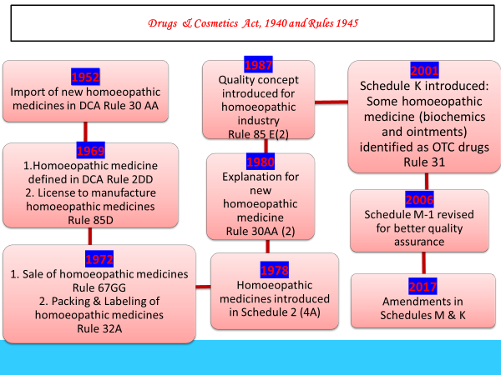
Fig.1 Regulatory framework of homoeopathic medicines in Drugs & Cosmetics Act, 1940 and Rules 1945 of India

Quality control is one of most fundamental prerequisites study for introduction of drug or formulation in clinical practice. Drug standardization study plays major role to ensure genuineness/authenticity, purity, quality, safety and efficacy with respect to pharmacognostical, physico-chemical & pharmacological studies of raw drugs as well as finished products. There are various sources of homoeopathic medicines viz. plants, chemicals & minerals, animals, sarcodes, nosodes and imponderabilia. Considering the diversity of source, quality control is quintessential for homoeopathic raw material, mother tinctures and potencies. Homeopathic drugs which works on the principle of high dilutions, it becomes even more important that quality of starting material depends on the method of preparation of mother tincture and potencies must be standardized and controlled. Success in homoeopathic prescribing is based upon the purity and quality of drugs.

In India, quality homoeopathic medicines are manufacturing by following Schedule M-1, Good Manufacturing Practices (GMP) ; Rule 85E (2) of D&C Rules 1945 with conditions specified including effective process controls, quality check on source materials & finished products, validated analytical methods, adequate buildings, good storage and sanitary conditions along with the standards to compile with HPI as well. It is high time that the available drugs should be of utmost quality and safe to consume.

References:-
- Anonymous. Drugs & Cosmetics Act, 1940 and Rules 1945; Universal Publication, New Delhi, India; 2018.
- Patel S, Biswas B, Rambabu K, Jhansi S, Potu R, Sundaram E N, Arya R. Pharmacognostic and physicochemical study of Urtica urens L.: A drug used in Homoeopathy. Indian J Res Homoeopathy 2019; 13:91-99
- Suneel Prajapati, Shilpi Singh, Mahima Sharma, Arun Kumar, Digvijay Verma , Pankaj Gupta , Renu Arya , Bineet Dwivedi , Bhopal Singh Arya Morphological Characterization of homoeopathic medicinal plants and evaluation of their biological effect against the microsporum canis. International journal of Pharmacognosy and Phytochemical Research 2019;11(3);122-128
- Rakhi Mishra, Manoj Kumar, Binit Dwivedi, B. S. Arya, Renu Arya, Anil Khurana and R. K. Manchanda, Chemoprofiling of homeopathic drug Coffea cruda, European Journal of Biomedical and Pharmaceutical Sciences, Nov.2018 Vol.5(11), 276-281
- Bibaswan Biswas, Shyaga Jhansi, Ramchander Potu, Satish Patel, M Nagaraju, Renu Arya, EN Sundaram, AK Khurana, Raj K Manchanda, Physicochemical study of the homoeopathic drug, Blatta orientalis. Indian Journal of Research in Homoeopathy, 2018;12(3); 125-131

BIOGRAPHY
Ms. Renu completed her post-graduation in Pharmaceutical Sciences with specialization in Pharmacognosy in 2009. She had 10 years experience in Teaching and Research in the field of Pharmaceutical Sciences. She had published & presented more than 50 research & review papers globally. She had 287 citation with 9 h- index & 9 i10-index at google scholar.

She has been served in teaching as Assistant Professor (Pharmacognosy) and
presently working with Central Council for Research in Homoeopathy (CCRH) as Research Officer (Pharmacognosy). She is working as co-ordinator, Drug Standardization Program of Council on homoeopathic medicines being carried out at 04 units of Council.
In a short span of her service in Council, she has made herself conversant with the entire work of Drug Standardization, regulatory issues pertaining to Homoeopathic drugs and has a zeal & conviction to work for development of Homoeopathic drug as a whole by addressing the identity, quality and safety issues with innovative ideas.

*Email id:- renu998@gmail.com



