Antipyretic effect of a polyherbal ayurvedic formulation: A randomized controlled clinical study following pharmacological evaluation in rodents
Dr. Amit K. Taraphdar, PhD, Department of Dravyaguna, Institute of Post Graduate Ayurvedic Education & Research, 294/3/1, Acharya Prafulla Chandra Road, Kolkata- 700 009, India
Dr. Arup Mukherjee, PhD, Department of Chemical Technology, University College of Technology, University of Calcutta, 92, Acharya Prafulla Chandra Road, Kolkata- 700 009, India
Dr. Mradu Gupta, PhD, Department of Dravyaguna, Institute of Post Graduate Ayurvedic Education & Research, 294/3/1, Acharya Prafulla Chandra Road, Kolkata- 700 009, India

Abstract
The ancient ayurvedic text Aṣṭāṅgahṛdaya of Vāgbhaṭa (7th Century A.D.) prescribes a specific formulation of four plants having antipyretic properties with minimal side-effects. This polyherbal ayurvedic standardized formulation contains whole plant of Solanum surratense, rhizomes of Zingiber officinale, stem of Tinospora cordifolia and fruits with bracts of Piper longum, exhibited significant antipyretic-analgesic properties without any toxicity during rodent experiments using yeast induced pyrexia method to assess antipyretic effect and hot plate, tail-flick and writhing test were used for determining the analgesic properties, which may be due to flavonoidic phenolic compounds in it. Randomized controlled clinical study in sixty eight patients was conducted with this polyherbal ayurvedic formulation using aspirin as standard drug for comparison. The primary outcome measured was reduction in body temperature, while the secondary outcomes measured were assessment of associated symptoms of fever and routine haematological parameters. A representative sample of patients was also studied for reduction in the level of prostaglandin (PGE₂). The clinical study showed that fever was rapidly and substantially reduced after oral administration of the test drug and this antipyretic effect was significant (p<0.01) when compared to placebo and more sustained in comparison to aspirin. Many associated symptoms of fever also exhibited significant reductions with this test drug. Prostaglandin levels also registered a substantial decrease during treatment with this polyherbal ayurvedic formulation.

Image
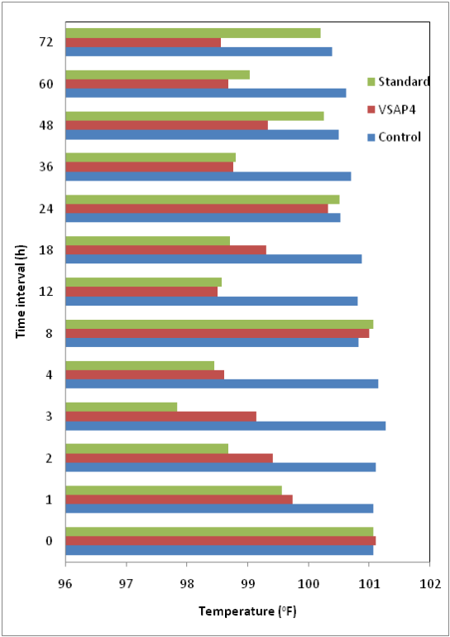
Figure 1: Temperature reading of patients in different groups from 0h to 72h in diverse time interval during treatment. (VSAP4: test drug; Standard: Aspirin; Control: rice powder).
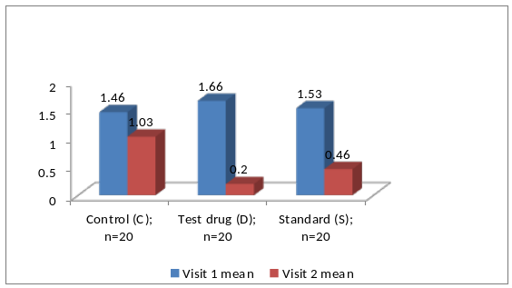
Figure 2: Individual mean secondary symptom score of the treatment groups calculated during visit 1 and visit 2.
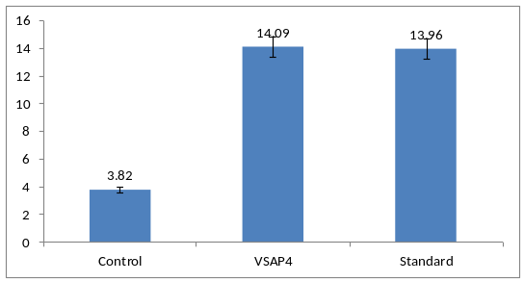
Figure 3: Percentage inhibition in PGE₂ level during treatment. (VSAP4: test drug; Standard: Aspirin; Control: rice powder)
Recent Publications
- Taraphdar AK, Mukherjee A, Gupta M (2018) Antipyretic effect of a polyherbal ayurvedic formulation: A randomized controlled clinical study. J Phytopharmacol 7(3):325-333.
- Taraphdar AK, Mukherjee A, Gupta M (2016) Pharmacological evaluation of antipyretic and analgesic effects of an ayurvedic polyherbal formulation in rodents. International Journal of current medical and pharmaceutical research 2(2):399-406.
- Chakraborty S, Roy M, Taraphdar AK, Bhattacharya RK (2004) Cytotoxic effect of root extract of Tiliacora racemosa and oil of Semecarpus anacardium nut in human tumour cells. Phytotherapy Research 18(8):595-600.
- Taraphdar AK, Roy M, Bhattacharya RK (2001) Natural products as inducers of apoptosis: Implication for cancer therapy and prevention. Current Science 80(11):1387-1396.
- Taraphdar AK, Shaw BP, Bhattacharya RK (2002) Role of Sharapunka (Tephrosia purpurea) in haemopoietic injury. The Antiseptic 99(8):302-304.

________________________________________________________
 Biography
Dr. Amit K Taraphdar has his expertise in evaluation and passion in improving the health and wellbeing as an academician and clinician. In his early carrier he started his research on anticancer drug development from ayurvedic herbs mainly in-vitro studies and performed research on apoptosis. His article on natural products as inducers of apoptosis and its implication in cancer therapy and prevention is already a widely referred article worldwide. Lately he started his works on evaluation of antipyretic-analgesic ayurvedic formulations through experimental and clinical studies. In evaluating the maximum possible analgesia in antinociceptive experimental methods his innovative measurement technique is valuable addition in this field. Clinical studies in a small population for antipyretic-analgesic drug evaluation is also a unique contribution of his recent research with minimum facilities or resources using block randomization method and also assessment of individual mean associated symptoms of fever (Taraphdar et al, 2018).
Email: mda_amitt@rediffmail.com

