Presentation on: Clustering and Classification Questionairs of Four Types for Uncontrolled Appetite Causes in Obesity Women

Jin, Senghee DKM(Doctor of Korean Medicine), L.Ac, Ph.D
Acupuncture Nara Clinic, USA
Southern California University School of Oriental Medicine and Acupuncture, USA
Member of American Association of Korean Medicine

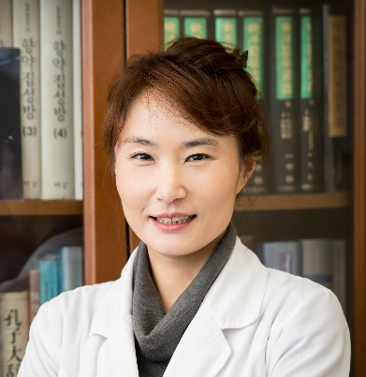

Abstract

About treatment of Obesity, there are many product to lose weight, but not many treatment before surgery. Traditional Asian medicine(which was located in Korea and China) will help to lose weight, this study was approched to lose weight through Traditional Asian Medical Theory. Commonly, two of main causes of Obesity are unable to control eating amount and lack of movement. Among these causes, poor eating habit is caused by internal organ issue based on the Traditional Korean Medicine. Prior research was to find how to control appetite through DongYiBoGam (which is representative book of Korean Medicine and it is Korean Medical dictionary: 東醫寶鑑). A questionnaire consisting of 38 items was constructed to decide which type an individual belonged to 212 females were requested to the complete the questionnaire. To verify that the cluster of four types of uncontollred appetite causes was acceptable, a cluster analysis and a factor analysis were conducted as well as an evaluation on the distinction of each type. Also a canonical discriminant analysis was done to categorize the individuals into one of four types. There are four types: Liver excess Spleen, Spleen and Stomach hyper function, Spleen and Stomach deficiency and Phlem in abdominal. Currently, established data apply to actual clinic setting in U.S.A., get effective result of losing weight using modified and compensated acupuncture treatment and herbal medicine for controlling each obesity type’s appetite.

Biography

Dr. Jin, Senghee has completed her Ph.D in 2002 from Kyung Hee University in South Korea and taught at University in Korea and U.S.A since 1999. She got her doctor of Korean license in 1994 and California Acupuncture license in 2003. She is the president of Biofunctional Diagnosis Association in U.S.A, professor of SCUSOMA, and a public relation committee director of American Association of Korean Medicine. She has published more than 12 papers in Korea and U.S.A. journals, 5 books and 1 Qi Exercise Video tape. She has been lecturing in this fields: Weight Loss, Facial Acupunture, Sports Medicine and Five Woon Six Gi.

Presenting Author Details
Full Name: Jin-Kim, Senghee
Contact Tel Number:1-858.243.7760
E-mail: dr.jinshee@gmail.com
Web Site:www.naraclinicusa.com
Session of Interest: Obesity
Category: (Oral presentation/ Poster presentation)

