Presentation on:
Jin, Senghee DKM(Doctor of Korean Medicine), L.Ac, Ph.D
Acupuncture Nara Clinic, USA
Southern California University School of Oriental Medicine and Acupuncture, USA
Member of American Association of Korean Medicine

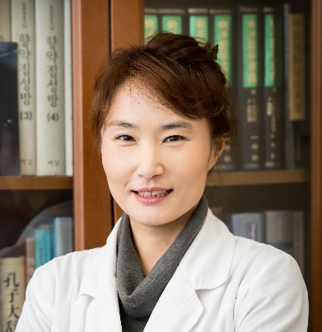

Abstract

About treatment of Obesity, there are many products to help loosing weight, but not many treatments before surgery. Traditional medicine will help to lose weight, this study was approched to lose weight through Traditional Medical Theory. Commonly, two of main causes of Obesity are unable to control eating amount and lack of movement. Among these causes, poor eating habit is caused by internal organ issue based on the Traditional Korean Medicine. Prior research was to find how to control appetite through DongYiBoGam(which is representative book of Korean Medicine and Korean Medical dictionary), as result, the discovery of the cause of uncontrolled appetite led to development of survey to uncover the cause of obesity. Causes of obesity able to grouping through the survey data, and resulting classify into four groups: Liver excess Spleen, Spleen and Stomach hyper function, Speen and Stomach deficiency and Phlem in abdominal. Established data for differentiated each type with developing questionnaire. Currently, established data apply to actual clinic setting in U.S, get effective result of losing weight using modified and compensated acupuncture treatment and herbal medicine for controlling each obesity type’s appetite.

Biography

Dr. Jin, Senghee has completed her Ph.D in 2002 from Kyung Hee University in South Korea and taught at University in Korea and U.S.A since 1999. She got her doctor of Korean license in 1994 and California Acupuncture license in 2003. She is the president of Biofunctional Diagnosis Association in U.S.A, professor of SCUSOMA, and a public relation committee director of American Association of Korean Medicine. She has published more than 12 papers in Korea and U.S.A. journals, 5 books and 1 Qi Exercise Video tape. She has been lecturing in this fields: Weight Loss, Facial Acupunture, Sports Medicine and Five Woon Six Gi.

Presenting Author Details
Full Name: Jin-Kim, Senghee
Contact Tel Number:1-858.243.7760
E-mail: dr.jinshee@gmail.com
Web Site:www.naraclinicusa.com
Session of Interest: Obesity
Category: (Oral presentation/ Poster presentation)

