Oral Presentation: Beyond Skin Deep: Treating Cystic Acne with homeopathy and nutritional supplements.
Dr. Vijay Nielsen, D.M.S., H.D.
Nielsen Clinic, Calgary, Alberta, T3H 2Y3, Canada
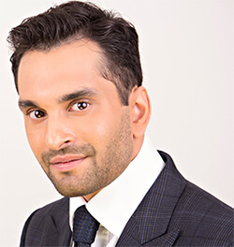

Abstract

Acne is one of the most common skin conditions. Treatment with-resistant cystic acne presents itself with several challenges and for those who are therapeutically resistant often struggle to find improvements from standardized acne therapies. Patients with therapeutically resistant cystic acne can receive therapy that targets inflammation, oxidative stress, androgen excess and excessive sebum production enhancing the improvement or remission of cystic acne. Through better education and learning to implement homeopathy and nutritional supplements, healthcare providers can help their patient's acne treatments improve significantly. Patients with moderate to severe cystic acne treatment that is tailored to the individual patient can yield better clinical results. Homeopathic medicines, as well as nutritional supplements, have shown to have a positive effect in the treatment of acne, especially of inflammatory cystic type.

Biography

Dr. Vijay Nielsen holds a diploma in homeopathic medicine from Dr. Nielsen’s Homeopathic Medical Education & Research Centre Inc (Winnipeg, Canada) and has completed his fellowship at Vinayaka Mission's Hospital (Salem, India). In 2005 opened his private practice, Nielsen Clinic, where he specializes in women’s health and dermatology, combining homeopathy and integrative medicine with a clinical approach and has won numerous awards. Dr. Nielsen was recently was selected as one of IMPACT Magazines Top Doctor for 2018. He is a published author in the Journal of Pharmacy & Pharmaceutical Sciences and has a #1 Amazon Best Seller co-authored book.
vnielsen@nielsenclinic.com

Presenting author details
Full Name which you wish to be printed: Dr. Vijay Nielsen, D.M.S., H.D.
Contact Tel Number: (403) 265-9730
Twitter account: -
Linked In account: drvijaynielsen
Session of Interest: Others
Category: Oral Presentation

