Therapeutic potential of carfilzomib, an irreversible
proteasome inhibitor, against acetaminophen-induced
hepatotoxicity in mice
Abdulrazaq Alanazi, Saleh G. Algfeley, Khaled A. Al-Hosaini, Hesham M. Korashy, Faisal Imam, Mahmoud N. Nagi

Abstract

Overdose of acetaminophen (APAP) is often associated with hepatotoxicity. Carfilzomib (CFZ) shows multiple pharmacological activities including anti-inflammatory potential. Therefore, this study was undertaken to evaluate the possible therapeutic effects of CFZ against APAP-induced hepatotoxicity. Hepatotoxicity was induced by administration of APAP (350 mg/kg, intraperitoneal). Mice were given CFZ (0.125, 0.25, or 0.5 mg/kg, intraperitoneal) 1.5 h after APAP administration. Animals were sacrificed on 6 h and blood and liver tissue samples were collected for analysis. In CFZ-post-treated group, there was significant and dose-dependent decrease in serum alanine aminotransferase levels. The level of tumor necrosis factor-𝛼 (TNF-𝛼), reactive oxygen species, and NO decreased, whereas glutathione increased significantly by CFZ post-treatment. Upregulated mRNA expression of COX-II and iNOS were significantly downregulated by CFZ post-treatment. CFZ may exert its hepatoprotective action by alleviating inflammatory, oxidative, and nitrosative stress via inhibition of TNF-𝛼, COX-II, and iNOS.
Image
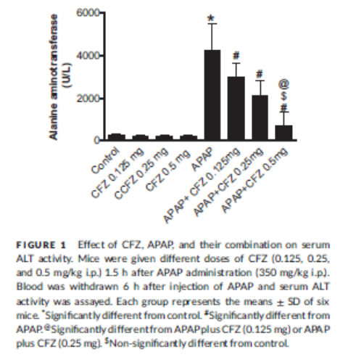
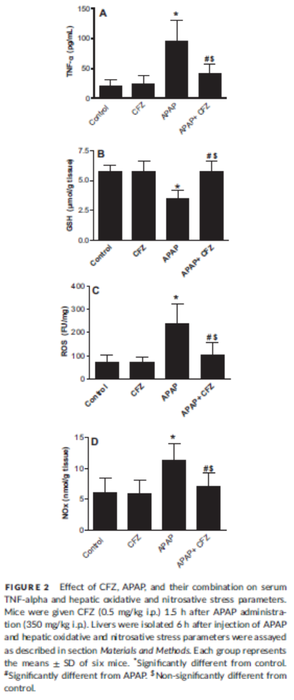

Recent Publications (minimum 5)
- Alanazi A (2016) Therapeutic potential of carfilzomib, an irreversible proteasome inhibitor, against acetaminophen-induced hepatotoxicity in mice J Biochem Mol Toxicol 2016; 00: 1–5.
- Salman A. Alotaibi (2015) Prophylactic and Therapeutic Potential of Acetyl-L-carnitine against Acetaminophen-Induced Hepatotoxicity in Mice; 00: 1–5.

Photograph

Biography
Abdulrazaq Alanazi has completed his MSc from Department of Pharmacology and Toxicology, College of Pharmacy, King Saud University, Riyadh. He is the director of toxicology center in MOI east part of Riysdh. I has published 2 papers in reputed journals.
Email: ph.abdulrazaq@gmail.com

